Chapter One

Introduction of AI
AI is a broad term that aims at using data to offer solutions to existing problems. It is the science and engineering of replicating, even surpassing human level intelligence in machines. That means observe or read, learn, sense, and experience.
Artificial Intelligence (AI) is a branch of Science which deals with helping machines to find solutions to complex problems in a more human-like fashion. This is generally involves borrowing characteristics from human intelligence, and applying them as algorithms in a computer friendly way. From the perspective of intelligence artificial intelligence is making machines "intelligent" acting as we would expect people to act.
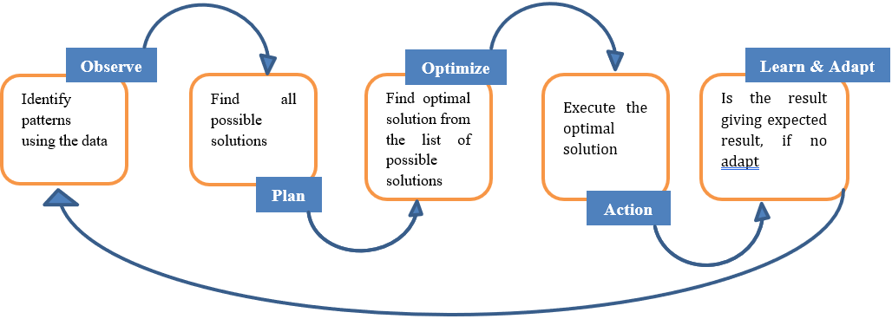
We have different sensory organs such as eyes, ears, noses, tongues, and skin to perceive our environment and organs such as hands, legs, and mouths are the effectors that enable us to take action within our environment based on the perception. AI also have these functionalities.

Need for AI
- To create expert systems that exhibit intelligent behavior with the capability to learn, demonstrate, explain and advice its users.
- Helping machines find solutions to complex problems like humans do and applying them as algorithms in a computer-friendly manner.

Sub fields of AI
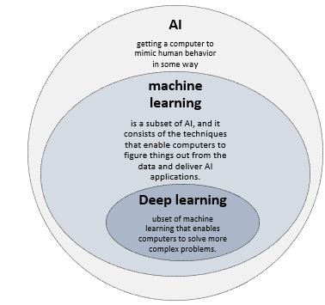
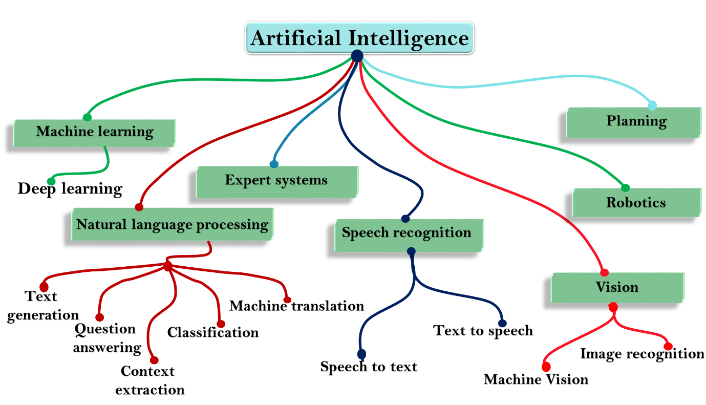

How does AI work
Intelligence or the cognitive process is composed of three main stages:
➢ Observe and input the information or data in the brain.
➢ Interpret and evaluate the input that is received from the surrounding environment.
➢ Make decisions as a reaction towards what you received as input and interpreted and evaluated.

Mapping Human thinking to artificial intelligence
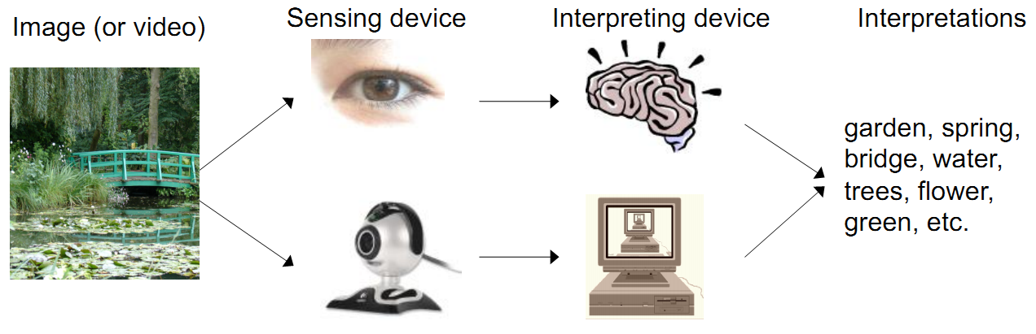
AI is the science of simulating human thinking, it is possible to map the human thinking stages to the layers or components of AI systems.
- Steg 1: humans acquire information from their surrounding environments through human senses, such as sight, hearing, smell, taste, and touch, through human organs, such as eyes, ears, and other sensing organs, for example, the hands. This stage is represented by the sensing layer, which perceives information from the surrounding environment. This information is specific to the AI application
- Steg 2: The second stage is related to interpreting and evaluating the input data. In AI, this stage is represented by the interpretation layer, that is, reasoning and thinking about the gathered input that is acquired by the sensing layer.
- Steg 3: is related to taking action or making decisions. After evaluating the input data, the interacting layer performs the necessary tasks. Robotic movement control and speech generation are examples of functions that are implemented in the interacting layer
In computers an image is represented as one large three-dimensional array of numbers. For example, consider the following image, it is the handwritten digit image of gray scale 28x28x1(width x height x depth) size resulting in 784 data points. Each number in the array is an integer that ranges from 0 (black) to 255(white). In a typical classification problem, the model has to turn this large matrix into a single label. For a color image additionally, it will have three color channels: Red, Green, Blue (RGB) for each pixel, so the same image in color would be of size 28x28x3 = 2352 data points. (Mastering machine learning in six steps, P316)
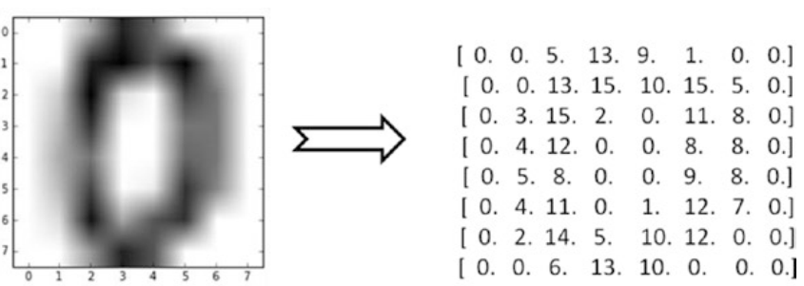

Perceptron – Single Artificial Neuron
Inspired by the biological neurons, that is the basic building block of the artificial neural
network. They are not only named after their biological counterparts but also modeled
after the behavior of the neurons in our brain.
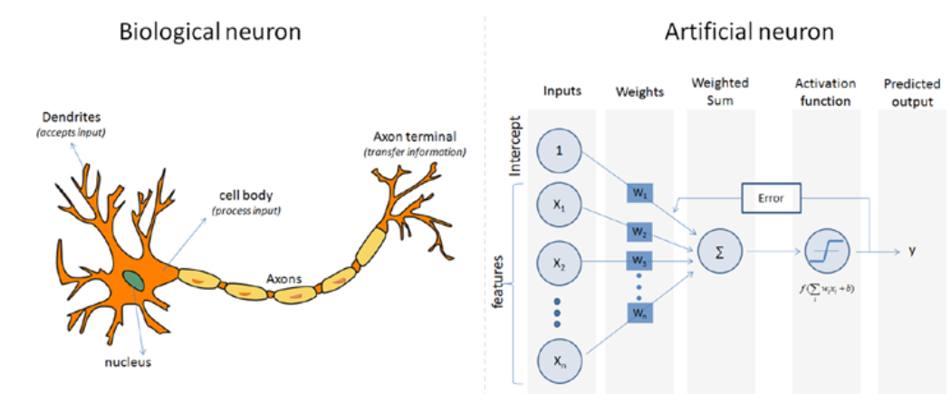
Biological neurons have
- dendrites to receive signals
- a cell body to process them and
- an axon/axon terminal to transfer signals out to other neurons.
Similarly, an artificial neuron has
- multiple input channels to accept training samples represented as a vector
- a processing stage where the weights(w) are adjusted such that the output error
(actual vs. predicted) is minimized.
- Then the result is fed into an activation function to produce output
The features of an artificial neuron are listed here:
- There is a set of inputs received from other neurons that activate the neuron in context
- There is an output transmitter that transfers signals or an activation of the other neurons
- Finally, the core processing unit is responsible for producing output activations from the input activations

Linear neurons
Linear neurons are the simplest form of neurons; they can be represented as follows:
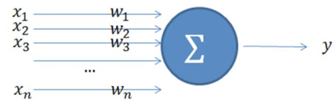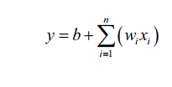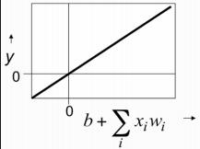
The output y is a summation of the product of the input xi and its weight wi. This is
mathematically represented as above. Where ‘b’ is bias

Rectified linear neurons / linear threshold neurons
Rectified linear neurons are similar to linear neurons, as explained in the preceding
section, with a minor difference where the output parameter value is set to zero in
cases where it is less than (<) zero (0), and in case the output value is greater than (>)
zero (0), it continues to remain as the linear weighted sum of the inputs:
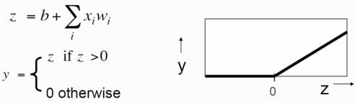

Sigmoid neurons
Sigmoid neurons are highly adopted in artificial neural networks. These neurons are known to provide the output that is smooth, real-valued, and therefore a bounded function of all the inputs. Unlike the types of the neurons that we have seen until now, these neurons use the logistic function. The logistic function is known to have an easy-to-calculate derivative that makes learning easy. This derivative value is used in computing the weights. Following is the equation for the sigmoid neuron output:

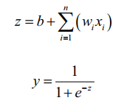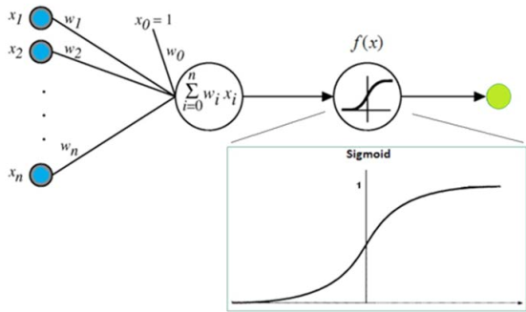

Multilayer Perceptron (Feedforward Neural Network)
To address the drawback of single perceptron, multilayer perceptron was proposed.
also commonly known as a feedforward neural network
- it is a composition of multiple perceptron connected in different ways and operating on distinctive activation functions to enable improved learning mechanisms.
- The training sample propagates forward through the network and the output error is back propagated and the error is minimized using the gradient descent method, which will calculate a loss function for all the weights in the network.
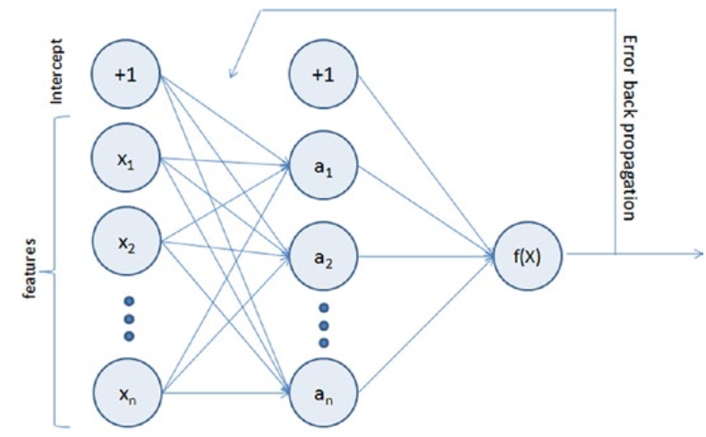
An example
A face recognition case using the multi-layered perceptron approach is shown next
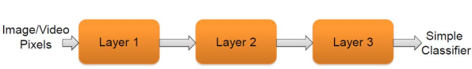
Multiple layers take this image as input and finally, a classifier definition is created and stored.
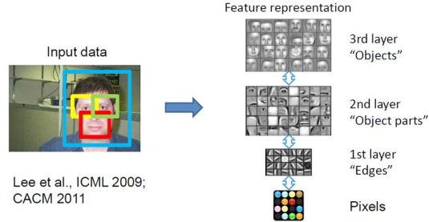

Application areas of AIs
Since AI is all about the imitation of human brain and body, it is applicable in every activity areas of human beings. Some of these areas are:

- Astronomy
- Health care
- Education
- Agriculture
- Finance
- Social media
- Cybersecurity
- Travel & Transport
- Automotive and industry
- Tourism
- E-Commerce
- Entertainment
- Gaming
- Natural Language processing (NLP)
- Weather forecasting

AI in Astronomy
Artificial Intelligence can be very useful to solve complex universe problems. AI technology can be helpful for understanding the universe such as how it works, origin, etc.

AI in Healthcare
In the last, five to ten years, AI becoming more advantageous for the healthcare industry and going to have a significant impact on this industry. Healthcare Industries are applying AI to make a better and faster diagnosis than humans. AI can help doctors with diagnoses and can inform when patients are worsening so that medical help can reach to the patient before hospitalization.

AI in Gaming
AI can be used for gaming purpose. The AI machines can play strategic games like chess, where the machine needs to think of a large number of possible places.

AI in Finance
AI and finance industries are the best matches for each other. The finance industry is implementing automation, chatbot, adaptive intelligence, algorithm trading, and machine learning into financial processes.

AI in Data Security
The security of data is crucial for every company and cyber-attacks are growing very rapidly in the digital world. AI can be used to make the data more safe and secure.

AI in social media
Social Media sites such as Facebook, Twitter, and Snapchat contain billions of user profiles, which need to be stored and managed in a very efficient way. AI can organize and manage massive amounts of data. AI can analyze lots of data to identify the latest trends, hashtag, and requirement of different users.

AI in Travel & Transport
AI is becoming highly demanding for travel industries. AI is capable of doing various travel related works such as from making travel arrangement to suggesting the hotels, flights, and best routes to the customers. Travel industries are using AI-powered chatbots which can make human-like interaction with customers for better and fast response.

AI in Automotive Industry
Some Automotive industries are using AI to provide virtual assistant to their user for better performance. Such as Tesla has introduced Tesla Bot, an intelligent virtual assistant. Various Industries are currently working for developing self-driven cars which can make your journey more safe and secure.

AI in Robotics
Artificial Intelligence has a remarkable role in Robotics. Usually, general robots are programmed such that they can perform some repetitive tasks, but with the help of AI, we can create intelligent robots which can perform tasks with their own experiences without pre-programmed. Humanoid Robots are best examples for AI in robotics, recently the intelligent Humanoid robot named as Erica and Sophia has been developed which can talk and behave like humans.

AI in Entertainment
We are currently using some AI based applications in our daily life with some entertainment services such as Netflix or Amazon. With the help of ML/AI algorithms, these services show the recommendations for programs or shows.

AI in Agriculture
Agriculture is an area which requires various resources, labor, money, and time for best result. Now a day's agriculture is becoming digital, and AI is emerging in this field. Agriculture is applying AI as agriculture robotics, solid and crop monitoring, predictive analysis. AI in agriculture can be very helpful for farmers.

AI in E-commerce
AI is providing a competitive edge to the e-commerce industry, and it is becoming more demanding in the e-commerce business. AI is helping shoppers to discover associated products with recommended size, color, or even brand.

AI in education
AI can automate grading so that the tutor can have more time to teach. AI chatbot can communicate with students as a teaching assistant. AI in the future can be work as a personal virtual tutor for students, which will be accessible easily at any time and any place.

AI in NLP (Natural language processing)
To make human being language understandable by computers (different machineries). To easily translate one language to another languages. This AI also provide a lot of services in marketing and any social media by easily making language translations among people that have different mother tongue.

AI in Weather Forecasting
AI can predict the statuses humidity, temperature, soil moisture, cloud and rain condition, wind direction, and other environmental related information.

AI in Robotics
Robotics is a branch of engineering and science that includes electronics engineering, mechanical engineering and computer science and so on. This branch deals with the design, construction, use to control robots, sensory feedback and information processing. These are some technologies which will replace humans and human activities in coming years
Robotics, design, construction, and use of machines (robots) to perform tasks done traditionally by human beings. Robots are widely used in such industries as automobile manufacture to perform simple repetitive tasks, and in industries where work must be performed in environments hazardous to humans.

Characteristics of Robotics
There are some characteristics of robots given below:
Appearance: Robots have a physical body. They are held by the structure of their body and are moved by their mechanical parts. Without appearance, robots will be just a software program.
Brain: Another name of brain in robots is On-board control unit. Using this robot receive information and sends commands as output. With this control unit robot knows what to do else it’ll be just a remote-controlled machine.
Sensors: The use of these sensors in robots is to gather info from the outside world and send it to Brain. Basically, these sensors have circuits in them that produces the voltage in them.
Actuators: The robots move and the parts with the help of these robots move is called Actuators. Some examples of actuators are motors, pumps, and compressor etc. The brain tells these actuators when and how to respond or move.
Program: Robots only works or responds to the instructions which are provided to them in the form of a program. These programs only tell the brain when to perform which operation like when to move, produce sounds etc. These programs only tell the robot how to use sensors data to make decisions.
Behavior: Robots behavior is decided by the program which has been built for it. Once the robot starts making the movement, one can easily tell which kind of program is being installed inside the robot.

Application area of Robots
Some of the application areas of the robotics are the following:
- In agriculture
- In health care
- In production industries
- In space science study
- In natural language processing
- In home task
- In military science

Chapter Two

Python Programming Language

What is python
Python as a programing language by which we can do the following tasks:

Machine learning model
Deep learning model
Software development
GUI
Web App development

Python Identifiers
As the name suggests, identifiers help us to differentiate one entity from another. Python entities such as class, functions, and variables are called identifiers.
- It can be a combination of upper- or lowercase letters (a to z or A to Z).
- It can be any digits (0 to 9) or an underscore (_).
- The general rules to be followed for writing identifiers in Python.
- It cannot start with a digit. For example, 1variable is not valid, whereas variable1 is valid.
- Python reserved keywords cannot be used as identifiers.
- Except for underscore (_), special symbols like !, @, #, $, % etc cannot be part of the identifiers.

Python keyword
lists the set of reserved words used in Python to define the syntax and structure
of the language. Keywords are case sensitive, and all the keywords are in lowercase except
True, False, and None.
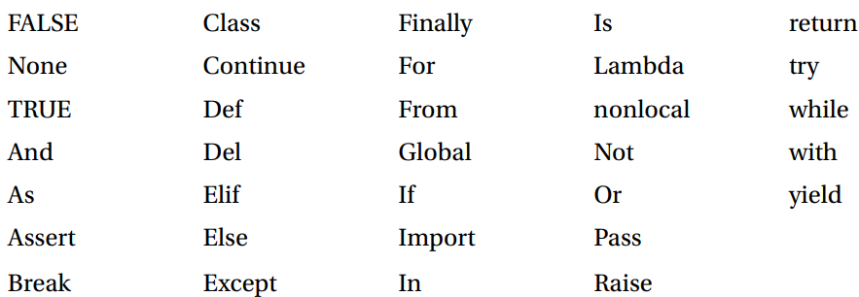

Code Blocks (Indentation & Suites)
It is very important to understand how to write code blocks in Python. Let’s look at two
key concepts around code blocks.
Indentation
One of the most unique features of Python is its use of indentation to mark blocks of code.
Each line of code must be indented by the same amount to denote a block of code in
Python. Unlike most other programming languages, indentation is not used to help make
the code look pretty. Indentation is required to indicate which block of code a code or
statement belongs to.
Suites
A collection of individual statements that makes a single code block are called suites
in Python. A header line followed by a suite are required for compound or complex
statements such as if, while, def, and class (we will understand each of these in details in
the later sections). Header lines begin with a keyword, and terminate with a colon (:) and
are followed by one or more lines that make up the suite.
Example of Correct Indentation
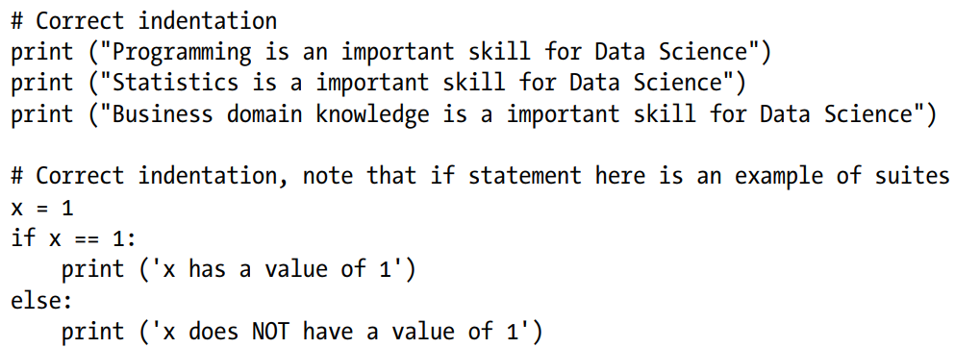

Example of incorrect indentation
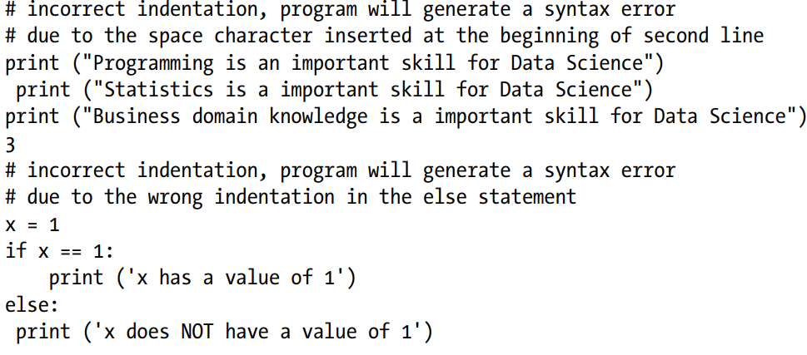

Comments in Python

Single line comment
Any characters followed by the # (hash) and up to the end of the line are considered a part of the comment and the Python interpreter ignores them. Multiline comments: Any characters between the strings """ (referred as multiline string), that is, one at the beginning and end of your comments will be ignored by the Python interpreter.
Example code for Comments
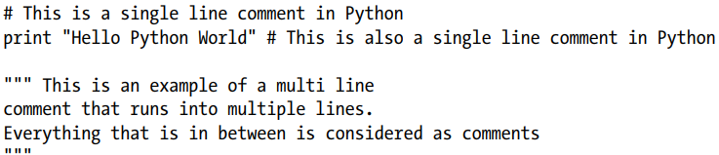

Multiline Statement
Python’s oblique line continuation inside parentheses, brackets, and braces is the favorite way of casing longer lines. Using backslash to indicate line continuation makes readability better; however, if needed you can add an extra pair of parentheses around the expression. It is important to correctly indent the continued line of your code. Note that the preferred place to break around the binary operator is after the operator, and not before it.
Example code for Multiple statement
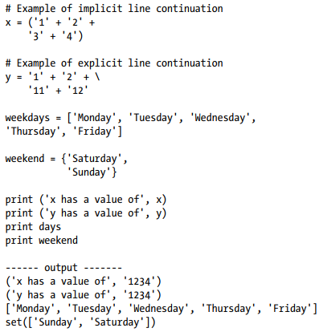
Multiple Statements on a Single Line
Python also allows multiple statements on a single line through usage of the semicolon (;), given that the statement does not start a new code block.
Code example for multi statement in a single line

Basic Operators
In Python, operators are the special symbols that can manipulate the value of operands. For example, let’s consider the expression 1 + 2 = 3. Here, 1 and 2 are called operands, which are the value on which operators operate and the symbol + is called an operator. Python language supports the following types of operators.
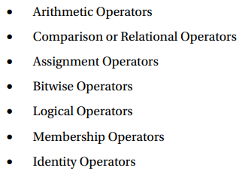
Let’s learn all operators through examples one by one.

Arithmetic Operators
Arithmetic operators are useful for performing mathematical operations on numbers such
as addition, subtraction, multiplication, division, etc.
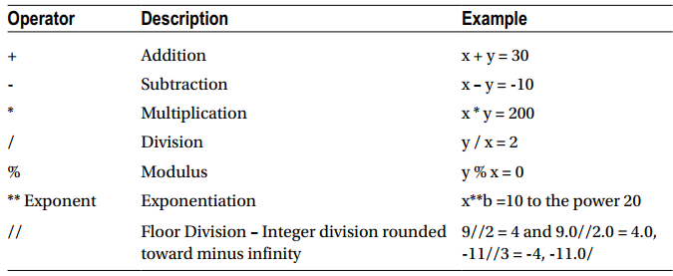
Example code for arithmetic operators
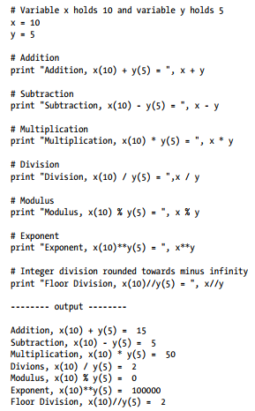

Comparison or Relational Operators
As the name suggests the comparison or relational operators are useful to compare values. It would return True or False as a result for a given condition.
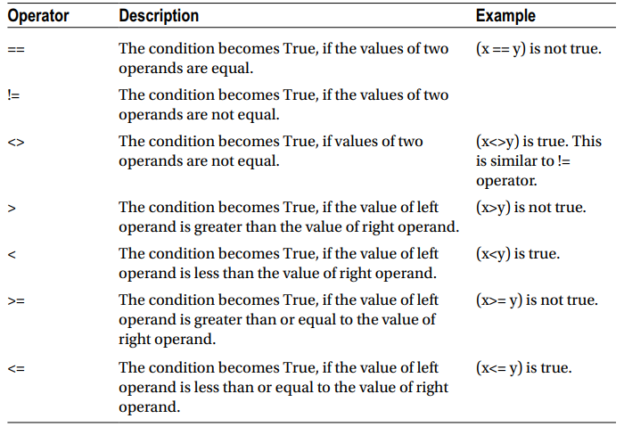

Example code for comparison/relational operators
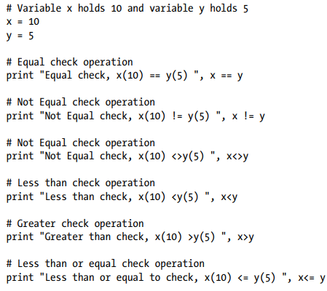
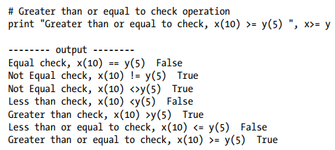

Assignment Operators
In Python, assignment operators are used for assigning values to variables. For example, consider x = 5; it is a simple assignment operator that assigns the numeric value 5, which is on the right side of the operator onto the variable x on the left side of operator. There is a range of compound operators in Python like x += 5 that add to the variable and later assign the same. It is as good as x = x + 5.
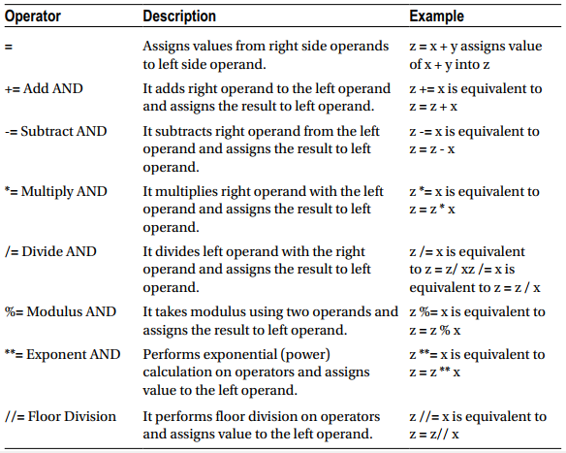

Example code for assignment operators
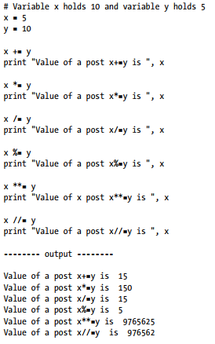

Bitwise Operators
As you might be aware, everything in a computer is represented by bits, that is, a series of 0’s (zero) and 1’s (one). Bitwise operators enable us to directly operate or manipulate bits. Let’s understand the basic bitwise operations. One of the key usages of bitwise operators is for parsing hexadecimal colors. Bitwise operators are known to be confusing for newbies to Python programming, so don’t be anxious if you don’t understand usability at first. The fact is that you aren’t really going to see bitwise operators in your everyday machine learning programming. However, it is good to be aware about these operators. For example, let’s assume that x = 10 (in binary 0000 1010) and y = 4 (in binary 0000 0100).
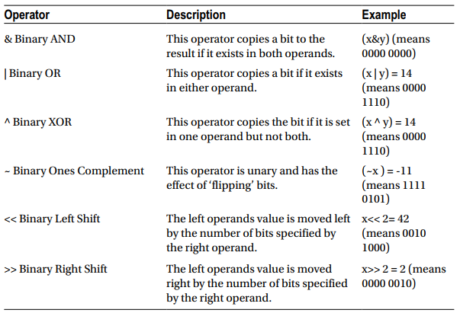

Example code for bitwise operators
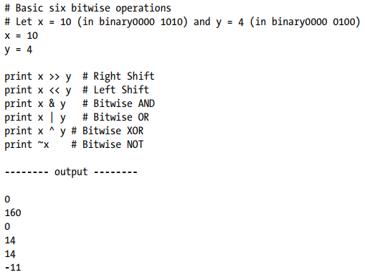

Logical Operators
The AND, OR, NOT operators are called logical operators. These are useful to check two variables against given condition and the result will be True or False appropriately
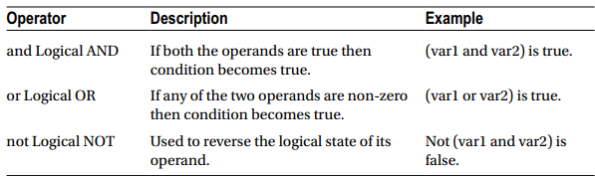

Example code for logical operators
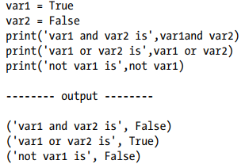

Membership Operators
Membership operators are useful to test if a value is found in a sequence, that is, string, list, tuple, set, or dictionary. There are two membership operators in Python, ‘in’ and ‘not in’. Note that we can only test for presence of key (and not the value) in case of a dictionary.
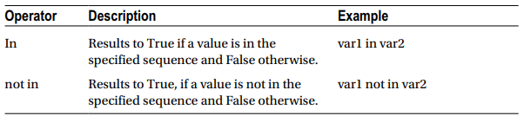

Example code for membership operators
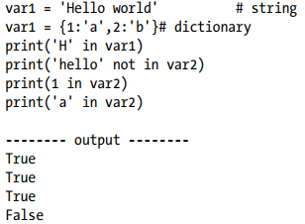
Identity Operators
Identity operators are useful to test if two variables are present on the same part of the memory. There are two identity operators in Python, ‘is’ and ‘is not’. Note that two variables having equal values do not imply they are identical.
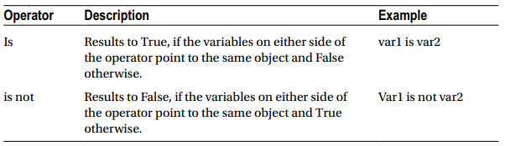

Example code for identity operators
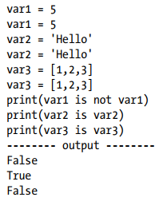

Control Structure
A control structure is the fundamental choice or decision-making process in programming. It is a chunk of code that analyzes values of variables and decides a direction to go based on a given condition. In Python there are mainly two types of control structures:
- selection and
- iteration.
Selection
Selection statements allow programmers to check a condition and based on the result
will perform different actions. There are two versions of this useful construct:

if

Example code for a simple ‘if’ statement
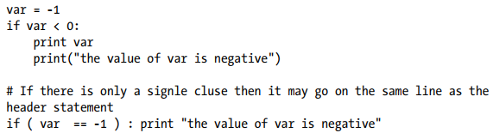

if…else.

Example code for nested if else statements
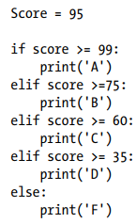

Iteration
A loop control statement enables us to execute a single or a set of programming statements multiple times until a given condition is satisfied. Python provides two essential looping statements:

for
For loop: It allows us to execute code block for a specific number of times or against a specific condition until it is satisfied

Example codes for a ‘for loop’ statement
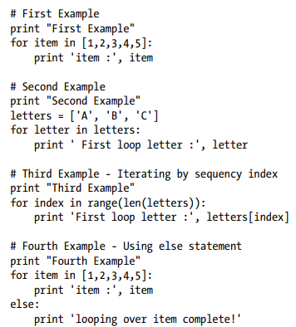
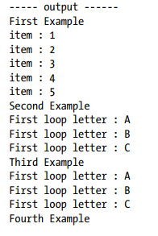
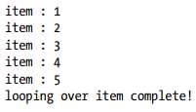

while
While loop: The while statement repeats a set of code until the condition is true.

Example code for while loop statement
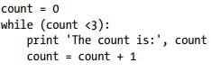
An else statement can be used with a while loop and the else will be executed when the condition becomes false
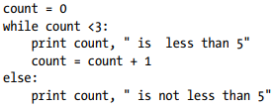

Scope of Variables
The availability of a variable or identifier within the program during and after theexecution is determined by the scope of a variable. There are two fundamental variable scopes in Python.
- Global variables
- Local variables

Example code for defining variable scopes
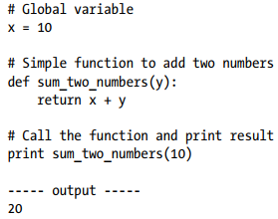

Default Argument
You can define a default value for an argument of function, which means the function will assume or use the default value in case any value is not provided in the function call for that argument.

Example code for function with default argument
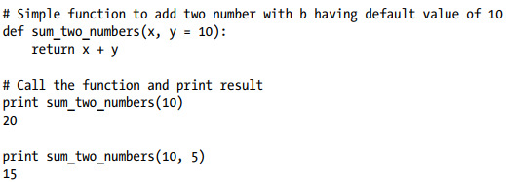

Variable Length Arguments
There are situations when you do not know the exact number of arguments while defining the function and would want the ability to process all the arguments dynamically. Python’s answer for this situation is the variable length argument that enables us to process more arguments than you specified while defining the function. The *args and **kwargs is a common idiom to allow a dynamic number of arguments

Example code for passing argumens as *args
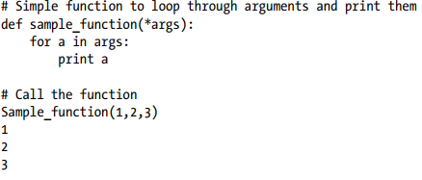
The **kwargs will give you the ability to handle named or keyword arguments keyword that you have not defined in advance.

Example code for passing argumens as **kwargs
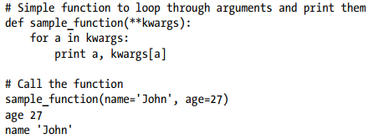

Basic Object Types
According to the Python data model reference, objects are Python’s notion for data. All data in a Python program is represented by objects or by relations between objects.
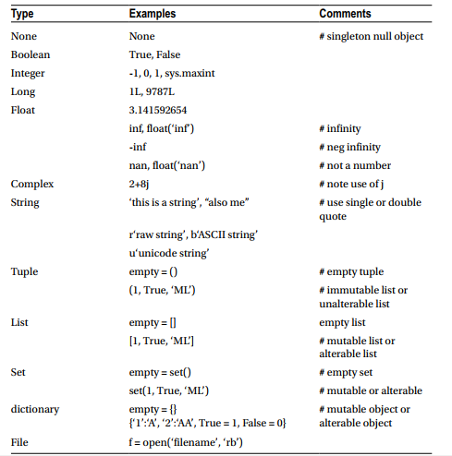

Code for basic Object Type
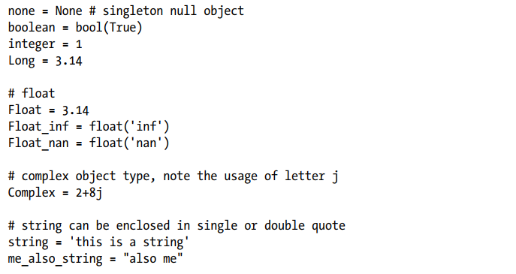
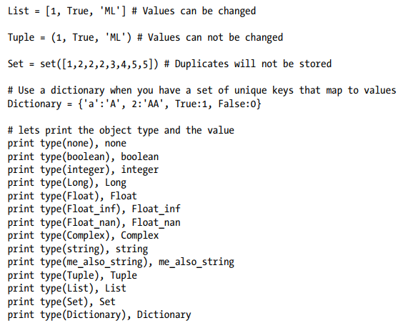

When to Use List vs. Tuples vs. Set vs. Dictionary
- List: Use when you need an ordered sequence of homogenous collections, whose values can be changed later in the program.
- Tuple: Use when you need an ordered sequence of heterogeneous collections whose values need not be changed later in the program.
- Set: It is ideal for use when you don’t have to store duplicates and you are not concerned about the order or the items. You just want to know whether a particular value already exists or not.
- Dictionary: It is ideal for use when you need to relate values with keys, in order to look them up efficiently using a key.
Lists
Python’s lists are the most flexible data type. It can be created by writing a list of comma separated values between square brackets. Note that the items in the list need not be of the same data type.
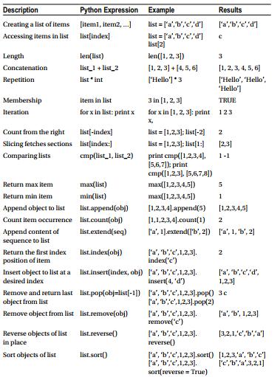

Example code for accessing lists
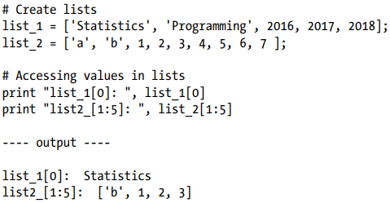

Example code for adding new values to lists
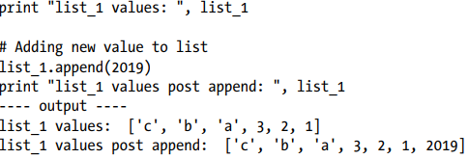

Example code for updating existing values of lists
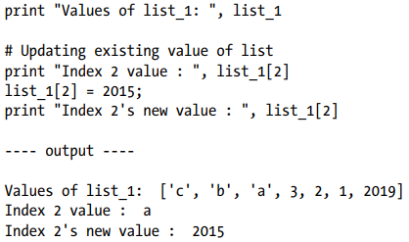

Example code for deleting a list element
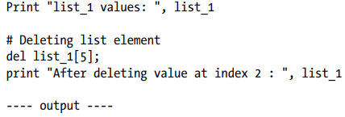

Example code for basic operations on lists
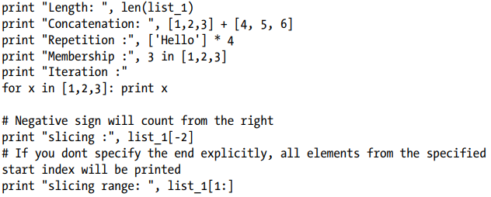
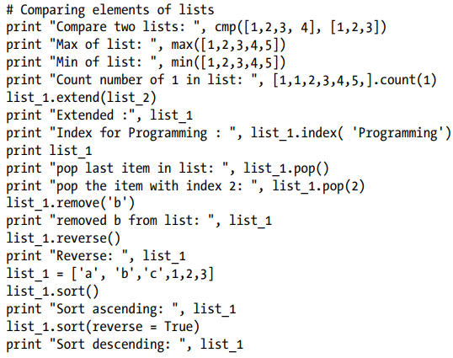
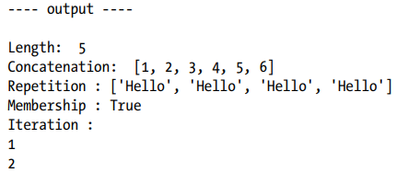
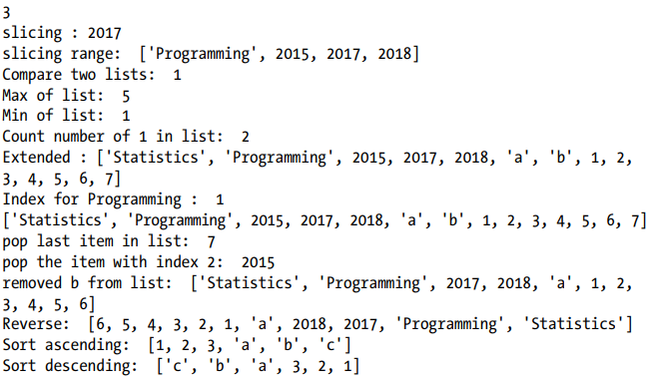
Tuple
A Python tuple is a sequences or series of immutable Python objects very much similar to the lists. However there exist some essential differences between lists and tuples, which are the following.
- Unlike list, the objects of tuples cannot be changed.
- Tuples are defined by using parentheses, but lists are defined by square brackets
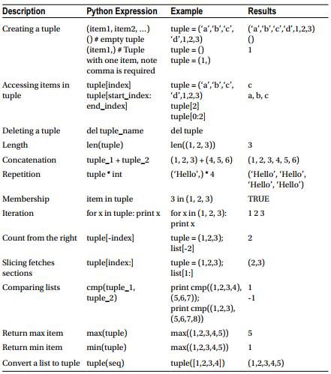

Example code for creating tuple
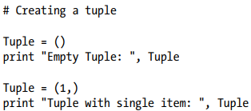
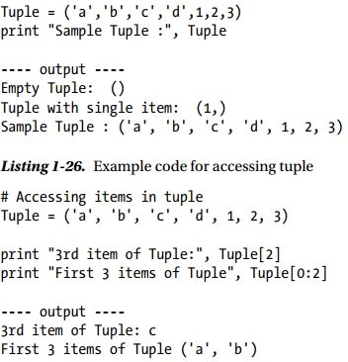
Example code for deleting tuple
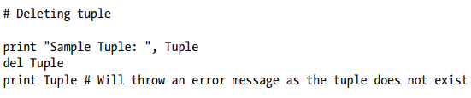

Example code for basic operations on tupl (not exhaustive)
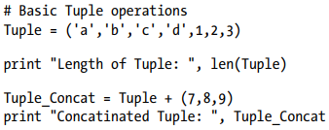
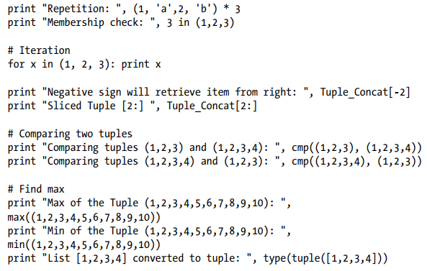
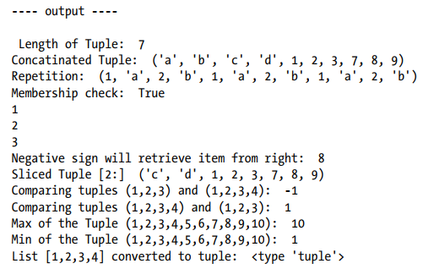

Sets
As the name implies, sets are the implementations of mathematical sets. Three key characteristics of set are the following.
- The collection of items is unordered
- No duplicate items will be stored, which means that each item is unique.
- Sets are mutable, which means the items of it can be changed.
An item can be added or removed from sets. Mathematical set operations such as union, intersection, etc., can be performed on Python sets.
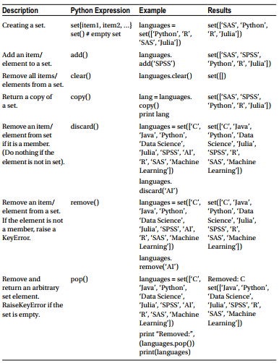
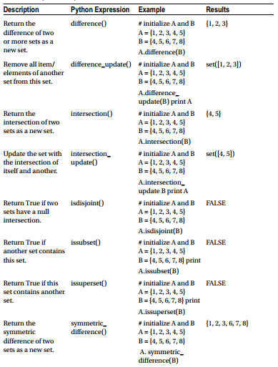
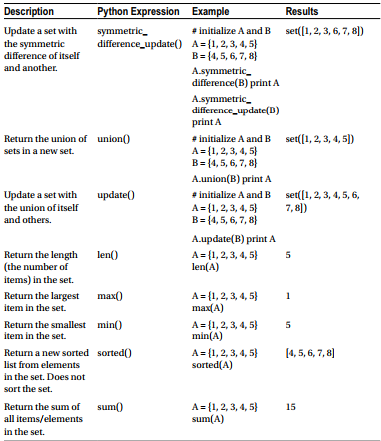

Example code for creating sets
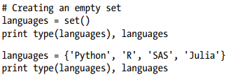
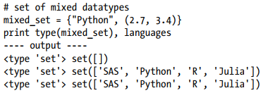

Accessing Set Elements

Example code for accessing set elements
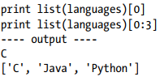

Changing a Set in Python
Although sets are mutable, indexing on them will have no meaning due to the fact that they are unordered. So, sets do not support accessing or changing an item/element using indexing or slicing. The add() method can be used to add a single element and the update() method for adding multiple elements. Note that the update() method can take the argument in the format of tuples, lists, strings, or other sets. However, in all cases the duplicates are ignored.

Example code for changing set elements
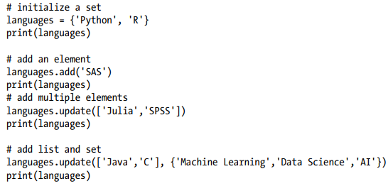
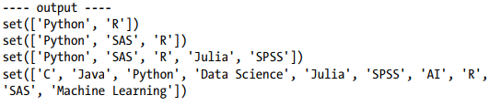
Removing Items from Set
The discard () or remove () method can be used to remove a particular item from a set. The fundamental difference between discard () and remove () is that the first do not take any action if the item does not exist in the set, whereas remove () will raise an error in such a scenario.

Example code for removing items from set
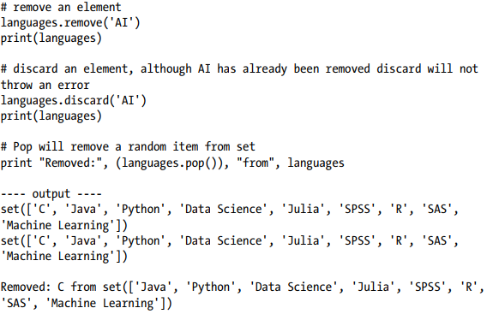

Please refer From Mastering Machine learning using python in six steps for the following concepts.
- Set operations
- Dictionary
- User Defined Function
- Module
- File Input/Output
- Exception handling

Chapter Three

Machine learning
In short, Machine Learning is a modeling technique that involves data. Machine Learning is a technique that figures out the “model” out of “data.” Here, the data literally means information such as documents, audio, images, etc. The “model” is the final product of Machine Learning.
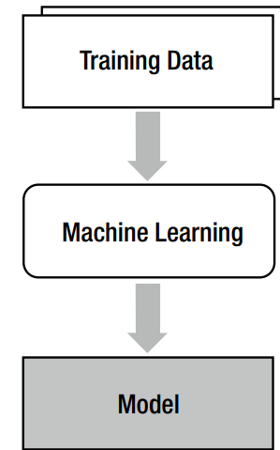

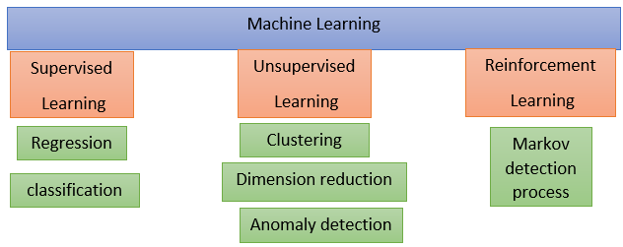
The machine learning algorithm is provided with a large enough example input dataset respective output or event/class, usually prepared in consultation with the subject matter expert of a respective domain. The goal of the algorithm is to learn patterns in the data and build a general set of rules to map input to the class or event.

Supervised learning
Supervised learning is very similar to the process in which a human learns things. Consider that humans obtain new knowledge as we solve exercise problems.
- Select an exercise problem. Apply current knowledge to solve the problem. Compare the answer with the solution.
- If the answer is wrong, modify current knowledge.
- Repeat Steps 1 and 2 for all the exercise problems.
When we apply an analogy between this example and the Machine Learning process, the exercise problems and solutions correspond to the training data, and the knowledge corresponds to the model.
In supervised learning, each training dataset should consist of input and correct output pairs. The correct output is what the model is supposed to produce for the given input.
{input, correct output }
Building supervised learning machine learning models has three stages:
- Training: The algorithm will be provided with historical input data with the mapped output. The algorithm will learn the patterns within the input data for each output and represent that as a statistical equation, which is also commonly known as a model
- Testing or validation: In this phase the performance of the trained model is evaluated, usually by applying it on a dataset (that was not used as part of the training) to predict the class or event.
- Prediction: Here we apply the trained model to a data set that was not part of either the training or testing. The prediction will be used to drive business decisions.

Broadly, there are two types commonly used as supervised learning algorithms.
Regression
The output to be predicted is a continuous number in relevance with a given input dataset. Example use cases are predictions of retail sales, prediction of number of staff required for each shift, number of car parking spaces required for a retail store, credit score, for a customer, etc.
The regression does not determine the class. Instead, it estimates a value. As an example, if you have datasets of age and income (indicated with a •) and want to find the model that estimates income by age, it becomes a regression problem.
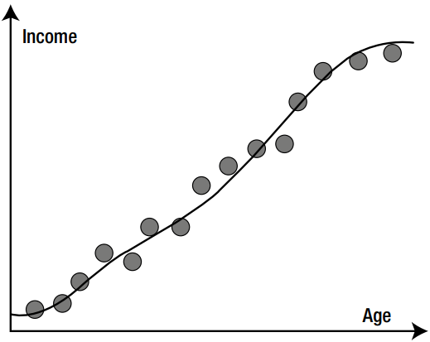
The dataset of this example will look like the table in Figure, where X and Y are age and income, respectively.
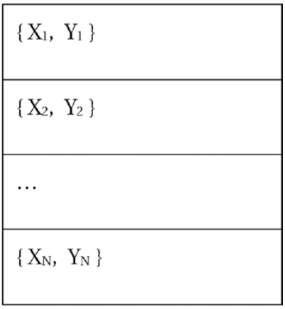
Classification
The classification problem focuses on literally finding the classes to which the data belongs. Some examples may help.
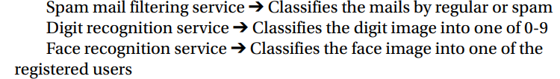
The output to be predicted is the actual or the probability of an event/class and the number of classes to be predicted can be two or more. The algorithm should learn the patterns in the relevant input of each class from historical data and be able to predict the unseen class or event in the future considering their input. An example use case is spam email filtering where the output expected is to classify an email into either a “spam” or “not spam.”
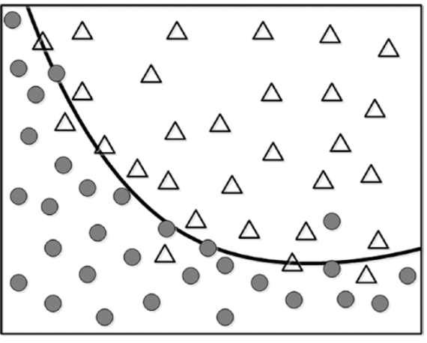
In this case, the training data of N sets of the element will look like Figure
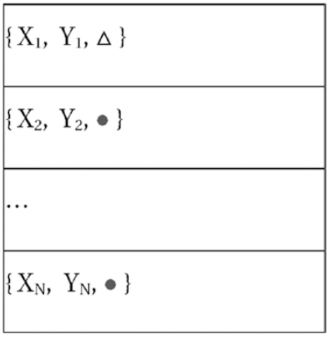
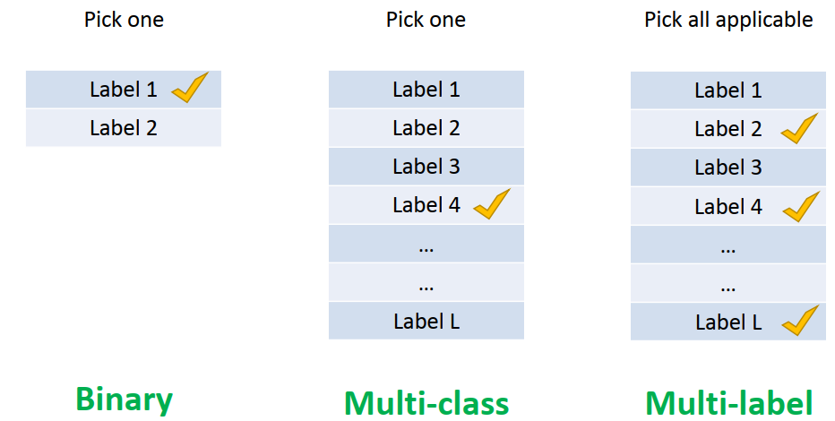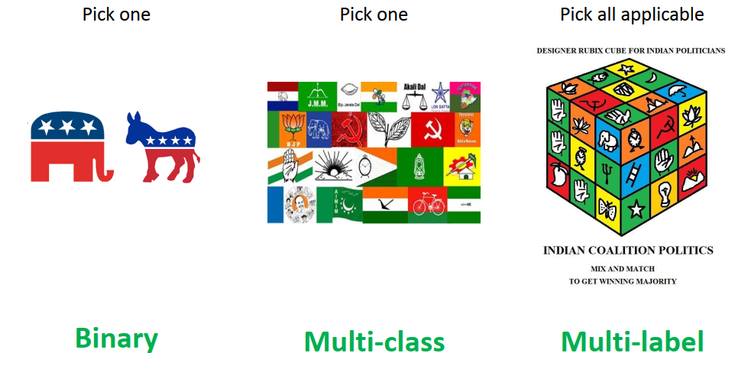

Supervised learning algorisms

Dicision tree
As the name suggests, a decision tree is a tree-like structure where internal nodes represent a test on an attribute, each branch represents outcome of a test, and each leaf node represents class label, and the decision is made after computing all attributes. A path from root to leaf represents classification rules. Thus, a decision tree consists of three types of nodes.
- Root node
- Branch node
- Leaf node (class label)

Support Vector Machine (SVM)
The key objective of SVM is to draw a hyperplane that separates the two classes optimally such that the margin is maximum between the hyperplane and the observations.
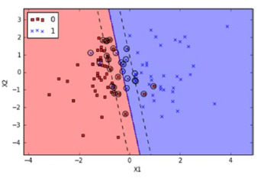

k Nearest Neighbors (kNN)
K nearest neighbor classification was developed from the need to perform discriminant analysis when reliable parametric estimates of probability densities are unknown or difficult to determine.
As the name suggests the algorithm works based on a majority vote of its k nearest neighbors class. In Figure, k = 5 nearest neighbors for the unknown data point are identified based on the chosen distance measure, and the unknown point will be classified based on the majority class among identified nearest data points class. The key drawback of kNN is the complexity in searching the nearest neighbors for each sample.
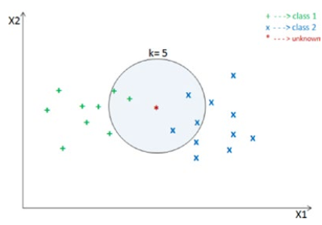

Unsupervised Learning
There are situations where the desired output class/event is unknown for historical data. The objective in such cases would be to study the patterns in the input dataset to get better understanding and identify similar patterns that can be grouped into specific classes or events. As these types of algorithms do not require any intervention from the subject matter experts beforehand, they are called unsupervised learning. Let’s look at some examples of unsupervised learning.
unsupervised learning contains only inputs without correct outputs.
{input}
Unsupervised learning is generally used for investigating the characteristics of the data and preprocessing the data. This concept is similar to a student who just sorts out the problems by construction and attribute and doesn’t learn how to solve them because there are no known correct outputs.
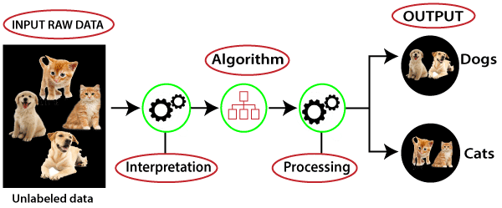
Clustering
Assume that the classes are not known beforehand for a given dataset. The goal here is to divide the input dataset into logical groups of related items. Some examples are grouping similar news articles, grouping similar customers based on their profile, etc.

Clustering algorithm
K-means
The key objective of a k-means algorithm is to organize data into clusters such that there is high intra-cluster similarity and low inter-cluster similarity. An item will only belong to one cluster, not several, that is, it generates a specific number of disjoint, non-hierarchical clusters. K-means uses the strategy of divide and concur, and it is a classic example for an expectation maximization (EM) algorithm. EM algorithms are made up of two steps: the first step is known as expectation(E) and is used to find the expected point associated with a cluster; and the second step is known as maximization(M) and is used to improve the estimation of the cluster using knowledge from the first step.
Suppose we have ‘n’ data points that we need to cluster into k (c1, c2, c3) groups.
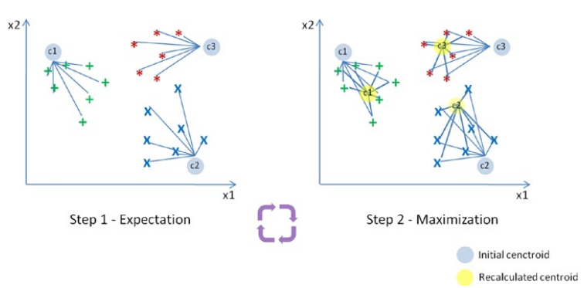
Step 1: In the first step k centroids (in above case k=3) is randomly picked (only in the first iteration) and all the points that are nearest to each centroid point are assigned to that specific cluster. Centroid is the arithmetic mean or average position of all the points.
Step 2: Here the centroid point is recalculated using the average of the coordinates of all the points in that cluster. Then step one is repeated (assign nearest point) until the clusters converge.
K-means is designed for Euclidean distance only.
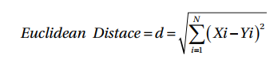
Limitations of K-means
- K-means clustering needs the number of clusters to be specified.
- K-means has problems when clusters are of differing sized, densities, and non-globular shapes.
- Presence of outlier can skew the results.

Dimension Reduction
Here the goal is to simplify a large input dataset by mapping them to a lower dimensional space. For example, carrying analysis on a large dimension dataset is very computationally intensive, so to simplify you may want to find the key variables that hold a significant percentage (say 95%) of information and only use them for analysis.

Dimension Reduction Algorithm

Principal Component Analysis (PCA)
Existence of a large number of features or dimensions makes analysis computationally intensive and hard for performing machine learning tasks for pattern identification. PCA is the most popular unsupervised linear transformation technique for dimensionality reduction. PCA finds the directions of maximum variance in high-dimensional data such that most of the information is retained and projects it onto a smaller dimensional subspace.
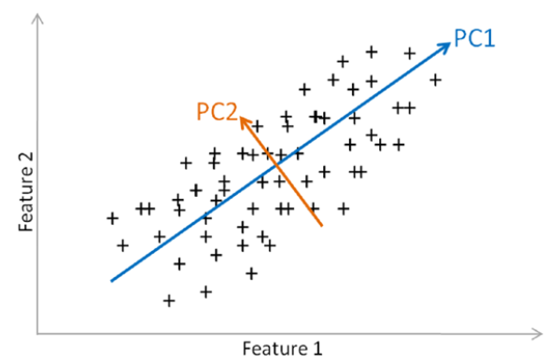
The PCA approach can be summarized as below.
- Standardize data.
- Use standardized data to generate covariance matrix or correlation matrix.
- Perform eigen decomposition, that is, compute eigen vectors that are the principal component which will give the direction and compute eigen values which will give the magnitude.
- Sort the eigen pairs and select eigen vectors with the largest eigen values that cumulatively capture information above a certain threshold (say 95%).

Anomaly Detection
Anomaly detection is also commonly known as outlier detection is the identification of items, events or observations which do not conform to an expected pattern or behavior in comparison with other items in a given dataset. It has applicability in a variety of domains, such as machine or system health monitoring, event detection, fraud/intrusion detection etc. In the recent days, anomaly detection has seen a big area of interest in the word of Internet of Things (IoT) to enable detection of abnormal behavior in a given context.

Reinforcement training
The basic objective of reinforcement learning algorithms is to map situations to actions that yield the maximum final reward. While mapping the action, the algorithm should not just consider the immediate reward but also next and all subsequent rewards. For example, a program to play a game or drive a car will have to constantly interact with a dynamic environment in which it is expected to perform a certain goal.

Data Analysis packages
There are four key packages that are most widely used for data analysis.
- NumPy
- SciPy
- Matplotlib
- Pandas

NumPy
NumPy is the core library for scientific computing in Python. It provides a high-performance multidimensional array object, and tools for working with these arrays.
Array
A NumPy array is a collection of similar data type values, and is indexed by a tuple of nonnegative numbers. The rank of the array is the number of dimensions, and the shape of an array is a tuple of numbers giving the size of the array along each dimension.
Example code for initializing NumPy array
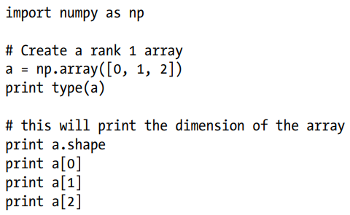
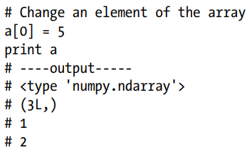
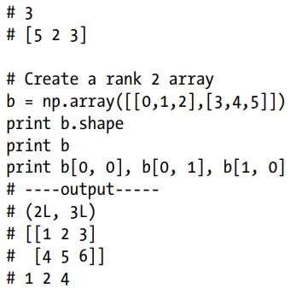

Creating NumPy Array
NumPy also provides many built-in functions to create arrays. The best way to learn this is through examples, so let’s jump into the code.
Creating NumPy array
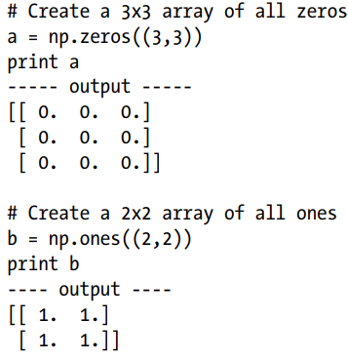
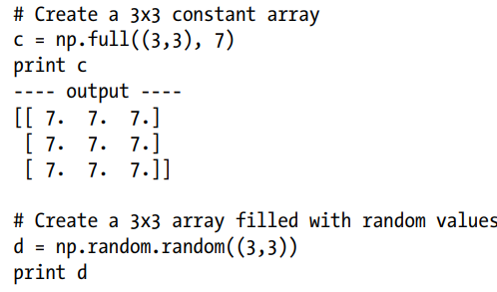
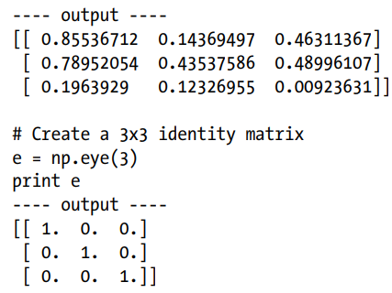
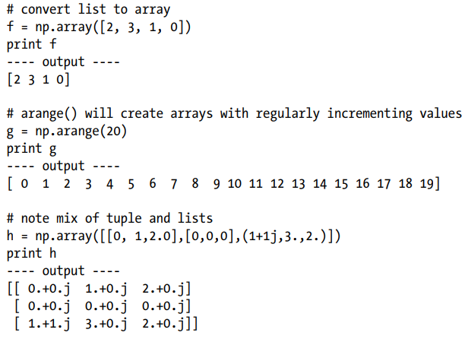
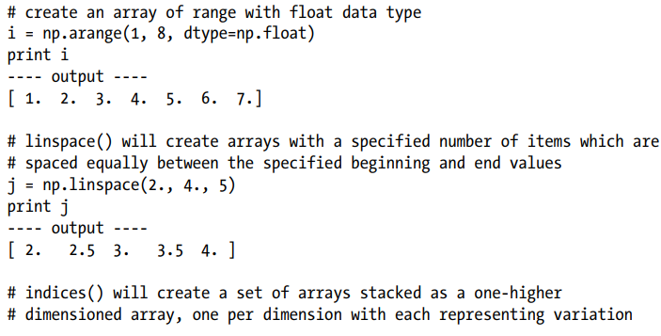
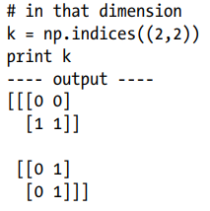

Data Types
An array is a collection of items of the same data type and NumPy supports and provides built-in functions to construct arrays with optional arguments to explicitly specify required datatypes.

NumPy datatypes
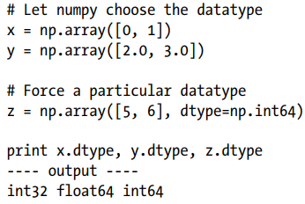
Array Indexing
NumPy offers several ways to index into arrays. Standard Python x[obj] syntax can be used to index NumPy array, where x is the array and obj is the selection. There are three kinds of indexing available:
- Field access
- Basic slicing
- Advanced indexing

Field Access
If the nd.array object is a structured array, the fields of the array can be accessed by indexing the array with strings, dictionary like. Indexing x[‘field-name’] returns a new view to the array, which is of the same shape as x, except when the field is a subarray, but of data type x.dtype[‘field-name’] and contains only the part of the data in the specified field.

Field access
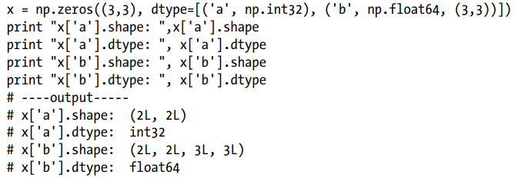

Basic Slicing
NumPy arrays can be sliced, similar to lists. You must specify a slice for each dimension of the array as the arrays may be multidimensional. The basic slice syntax is i: j: k, where i is the starting index, j is the stopping index, and k is the step and k is not equal to 0. This selects the m elements in the corresponding dimension, with index values i, i + k, …,i + (m - 1) k where m = q + (r not equal to 0) and q and r are the quotient and the remainder is obtained by dividing j - i by k: j - i = q k + r, so that i + (m - 1) k < j.
Basic slicing
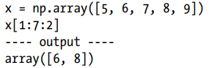
Negative k makes stepping go toward smaller indices. Negative i and j are interpreted as n + i and n + j where n is the number of elements in the corresponding dimension.
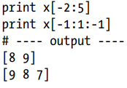
If n is the number of items in the dimension being sliced. Then if i is not given then it defaults to 0 for k > 0 and n - 1 for k < 0. If j is not given it defaults to n for k > 0 and -1 for k < 0. If k is not given it defaults to 1. Note that :: is the same as : and means select all indices along this axis. x[4:]
# ---- output ----
array ([9])
If the number of objects in the selection tuple is less than N, then: is assumed for any subsequent dimensions.
Read more from Machine learning with python in six steps
Pandas
Python has always been great for data munging; however, it was not great for analysis compared to databases using SQL or Excel or R data frames.
Pandas are an open-source Python package providing fast, flexible, and expressive data structures designed to make working with “relational” or “labeled” data both easy and intuitive.
Data Structures Pandas introduces two new data structures to Python – Series and Data Frame, both of which are built on top of NumPy.

Series
This is a one-dimensional object similar to column in a spreadsheet or SQL table. By default each item will be assigned an index label from 0 to N.
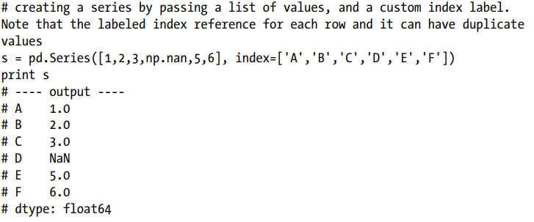
Read more from……………………………….

Data Frame
It is a two-dimensional object similar to a spreadsheet or an SQL table. This is the most commonly used pandas object.
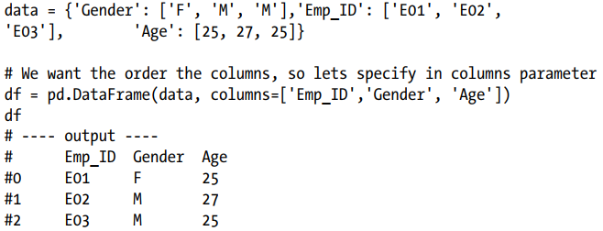
Reading and Writing Data
We’ll see three commonly used file formats: csv, text file, and Excel in Listing
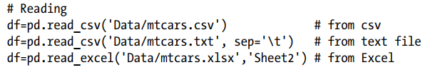
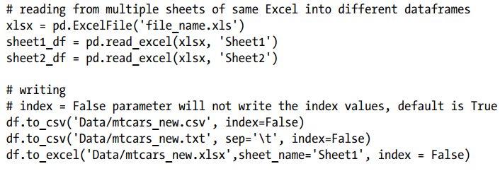

Basic Statistics Summary
Pandas has some built-in functions to help us to get better understanding of data using basic statistical summary methods.
describe ()- will returns the quick stats such as count, mean, std (standard deviation), min, first quartile, median, third quartile, max on each column of the data frame
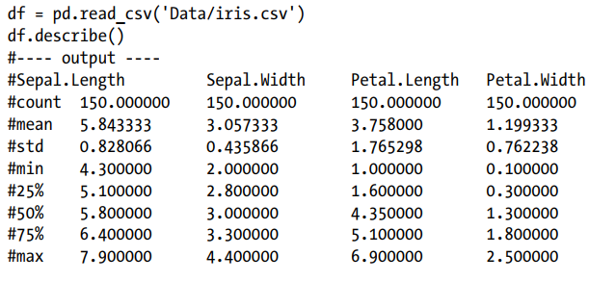
Read more from…………………………………
Matplotlib
Matplotlib is a numerical mathematics extension NumPy and a great package to view or present data in a pictorial or graphical format. It enables analysts and decision makers to see analytics presented visually, so they can grasp difficult concepts or identify new patterns.

Using Global Functions
The most common and easy approach is by using global functions to build and display a global figure using matplotlib as a global state machine. Let’s look at some of the most commonly used charts.
- plt.bar – creates a bar chart
- plt.scatter – makes a scatter plot
- plt.boxplot – makes a box and whisker plot
- plt.hist – makes a histogram
- plt.plot – creates a line plot
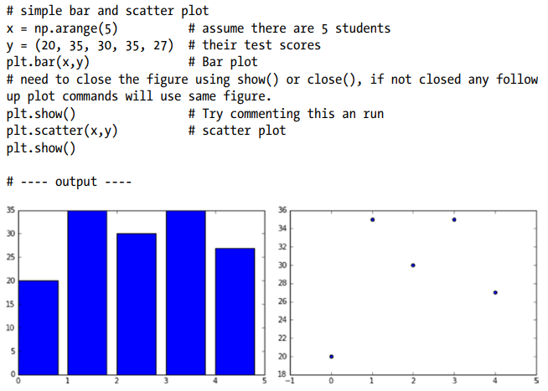

Multiple line plot on same axis
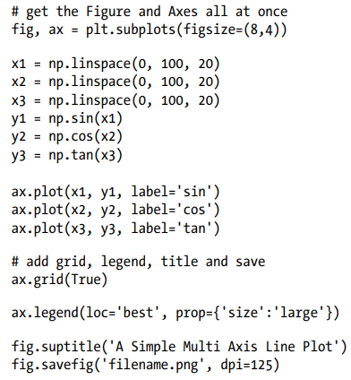
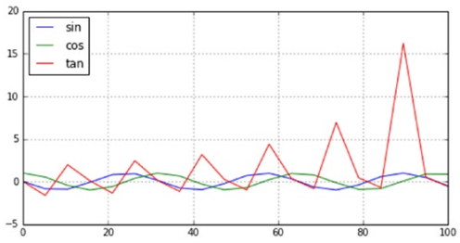

Bar Plots – using ax.bar() and ax.barh()
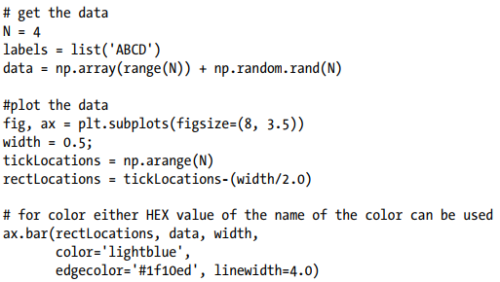
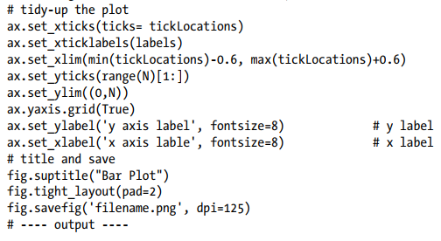
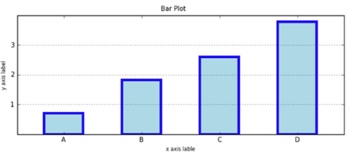

Side-by-Side Bar Chart
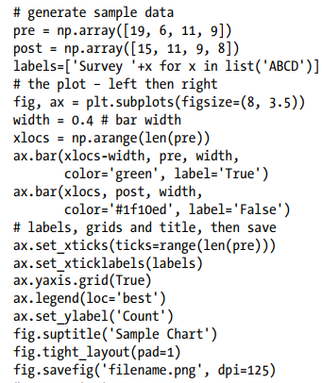
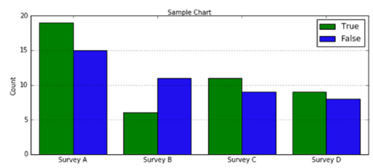

Chapter Four

Introduction to Deep Learning

What we can do with deep learning
The three primary research areas of Deep Learning are usually said to be
- Image recognition
- Speech recognition, and
- Natural language processing.
Deep Learning is a result of many small technical improvements of machine learning. This section briefly introduces why the deep neural network yielded poor performance and how Deep Learning overcame this problem.
The reason that the neural network with deeper layers yielded poorer performance was that the network was not properly trained. The backpropagation algorithm experiences the following three primary difficulties in the training process of the deep neural network (machine learning):
- Vanishing gradient
- Overfitting
- Computational load

Vanishing Gradient
The gradient in this context can be thought as a similar concept to the delta of the back-propagation algorithm. The vanishing gradient in the training process with the back-propagation algorithm occurs when the output error is more likely to fail to reach the farther nodes. The back-propagation algorithm trains the neural network as it propagates the output error backward to the hidden layers. However, as the error hardly reaches the first hidden layer, the weight cannot be adjusted. Therefore, the hidden layers that are close to the input layer are not properly trained. There is no point of adding hidden layers if they cannot be trained.
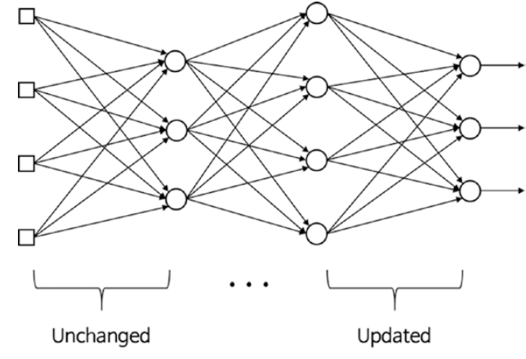
The representative solution to the vanishing gradient is the use of the Rectified Linear Unit (ReLU) function as the activation function. It is known to better transmit the error than the sigmoid function. The ReLU function is defined as follows:
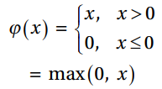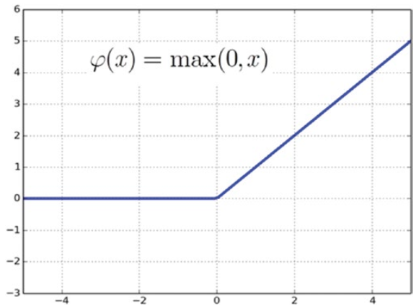
Overfitting
The reason that the deep neural network is especially vulnerable to overfitting is that the model becomes more complicated as it includes more hidden layers, and hence more weight.
The most representative solution is the dropout, which trains only some of the randomly selected nodes rather than the entire network. It is very effective, while its implementation is not very complex. Using dropout Some nodes are randomly selected at a certain percentage and their outputs are set to be zero to deactivate the nodes.
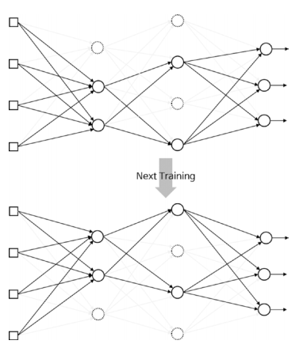
The dropout effectively prevents overfitting as it continuously alters the nodes and weights in the training process. The adequate percentages of the dropout are approximately 50% and 25% for hidden and input layers, respectively.

Computational Load
The last challenge is the time required to complete the training. The number of weights increases geometrically with the number of hidden layers, thus requiring more training data. This ultimately requires more calculations to be made. The more computations the neural network performs, the longer the training takes. This problem is a serious concern in the practical development of the neural network. If a deep neural network requires a month to train, it can only be modified 20 times a year.
This trouble has been relieved to a considerable extent by the introduction of high-performance hardware, such as GPU, and algorithms, such as batch normalization.

Basic Python Library for Deep learning

Sckit-Learn
Skikit-learn was built on top of two Python libraries – NumPy and SciPy and has become the most popular Python machine learning library for developing machine learning algorithms.
Scikit-learn has a wide range of supervised and unsupervised learning algorithms that works on a consistent interface in Python. The library can also be used for data-mining and data analysis. The main machine learning functions that the Scikit-learn library can handle are classification, regression, clustering, dimensionality reduction, model selection, and preprocessing.

TenserFlow
TensorFlow is a free and open-source Python library that specializes in differentiable programming. The library offers a collection of tools and resources that help make building Deep Learning and Machine Learning models. TensorFlow’s architecture and framework are flexible and allow it to run on several computational platforms such as CPU and GPU. However, it performs its best when working on a tensor processing unit (TPU).
TensorFlow can be used to implement reinforcement-learning in ML and DL models and allows you to directly visualize your machine learning models with its built-in tools. TensorFlow isn’t limited to working on desktop devices. It lets you create and train smart models on servers and smartphones.

Keras
Keras is an open-source Python library designed for developing and evaluating neural networks within deep learning and machine learning models. It can run on top of Theano and TensorFlow, making it possible to start training neural networks with a little code. The Keras library is modular, flexible, and extensible, making it beginner- and user-friendly. It also offers a fully functioning model for creating neural networks as it integrates with objectives, layers, optimizers, and activation functions.
Keras framework is flexible and portable, allowing it to operate in multiple environments and work on both CPUs and GPUs. It allows for fast and efficient prototyping, research work, and data modeling and visualization. Keras also has one of the widest ranges when it comes to data types because it can work on text images and images to train models.

Pytorch
PyTorch is an open-source machine learning Python library that’s based on the C programming language framework, Torch. PyTorch qualifies as a data science library and can integrate with other similar Python libraries such as NumPy. It’s able to seamlessly create computational graphs that can be changed anytime while the Python program is running. It’s mainly used in ML and DL applications such as computer vision and natural language processing.
PyTorch is known for its high speeds of execution even when it’s handling heavy and extensive graphs. It’s also highly flexible, which allows it to operate on simplified processors in addition to CPUs and GPUs. PyTorch comes with a collection of powerful APIs that lets you expand on the PyTorch library, as well as a natural language toolkit for smoother processing. It’s compatible with Python’s IDE tools, which makes for an easy debugging process.

Pandas
Pandas is a data science and analysis Python library that allows developers to build intuitive and seamless high-level data structures. Built on top of NumPy, Pandas is responsible for preparing data sets and points for machine training. Pandas uses two types of data structures, one-dimensional (series) and two-dimensional (DataFrame), which, together, allow Pandas to be used in a variety of sectors, from science and statistics to finance and engineering.
The Pandas library is flexible and can be used in tandem with other scientific and numerical libraries. Its data structures are easy to use because they’re highly descriptive, quick, and compliant. With Pandas, you can manipulate data functionality by grouping, integrating, and re-indexing it using minimal commands.

OpenCV
OpenCV is a library consisting of various programming functions, which makes it useful for real-time computer vision programs. It’s able to process a variety of visual inputs from image and video data and identify objects, faces, and handwriting.
OpenCV was designed with computational efficiency in mind. The library takes full advantage of its multicore processing functions to allow for a strong focus on real-time data processing in applications. It also has a supportive and active online community that keeps it going.

Convolutional Neural Network (CNN)
Convolution network architecture comprises a fixed set of layers designated for specialized functions. The most critical layers are as follows
- Convolutional layer (CONV)
- Pooling layer (POOL)
- Full-connected (FC) layer
Convolutional layer (CONV)
The convolutional layer forms the core of convolution nets. This layer is responsible for holding the neurons in a three-dimensional format and is therefore responsible for a three-dimensional output. The left side figure is an example of an input volume with the dimensions 32 x 32 x 3. As shown, each neuron is connected to a particular input region. Along the depth, there can be many neurons; we can see five neurons in the example.
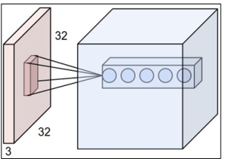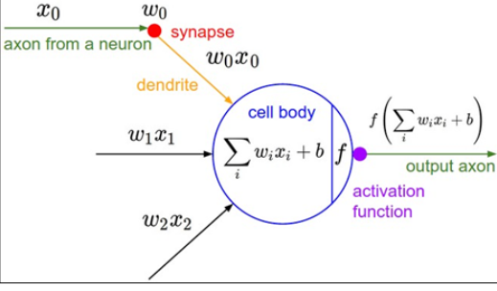
The right diagram here shows how the net convolution function works in the neuron function representation:

Convolution
The term convolution refers to the mathematical combination of two functions to produce a third function. It merges two sets of information. In the case of a CNN, the convolution is performed on the input data with the use of a filter or kernel (these terms are used interchangeably) to then produce a feature map.
Suppose we have 5X5 pixel image and 3X3 filter (kernel) matrix. The following figure elaborates how convolution is proceeded. HS represents horizontal stride and VS is vertical stride.
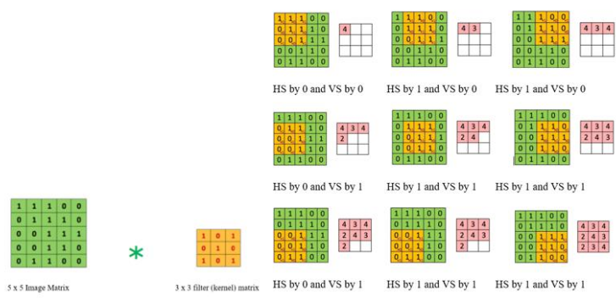

Pooling layer (POOL)
There can be multiple convolution layers and, between these convolution layers, there can be a pooling layer. The pooling layer is responsible for reducing the chances of over-fitting by reducing the spatial size of the input volume. The reduction of the spatial size implies reducing the number of parameters or the amount of computations in the network. The MAX functions contribute to reducing the spatial size. The pooling layers use the MAX functions and apply it on every slice in the three-dimensional representation, sliced depth-wise. Usually, the pooling layers apply filters of size 2 X 2 applied along both width and height. This can discard around 75% of the activations.

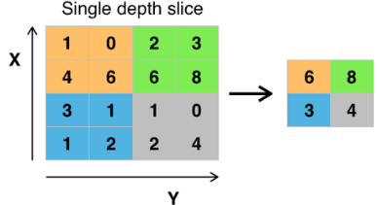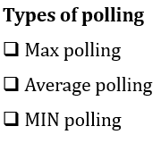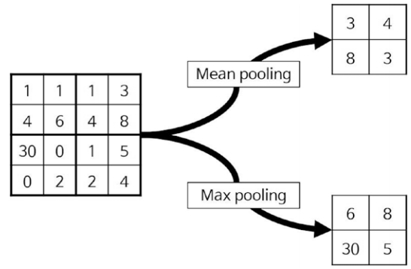

Fully connected layer
The fully connected layer will compute the class score, and the resulted dimension will be a single vector 1x1x10 (if there is 10 class scores). Each neural in this layer is connected to all numbers in the previous volume.
This layer is a regular neural network layer that takes input from the previous layer and computes the class scores and outputs the 1-D array of size equal to the number of classes.
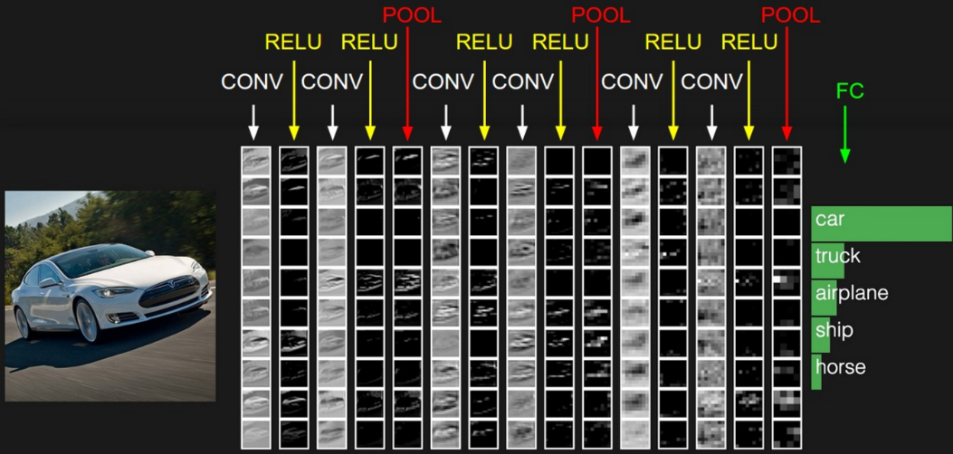
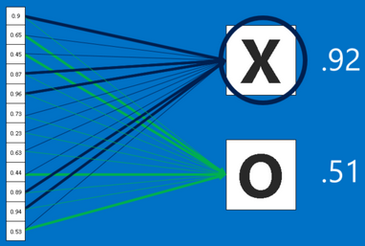
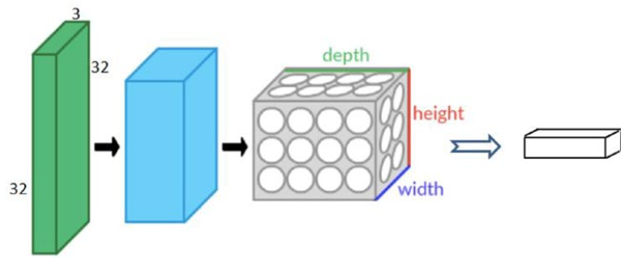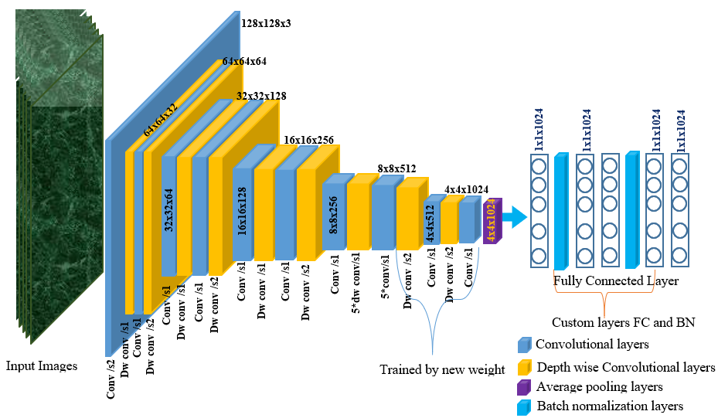
CNN basically has two main parts such as feature extraction (learning) layer and Classification layer as follows
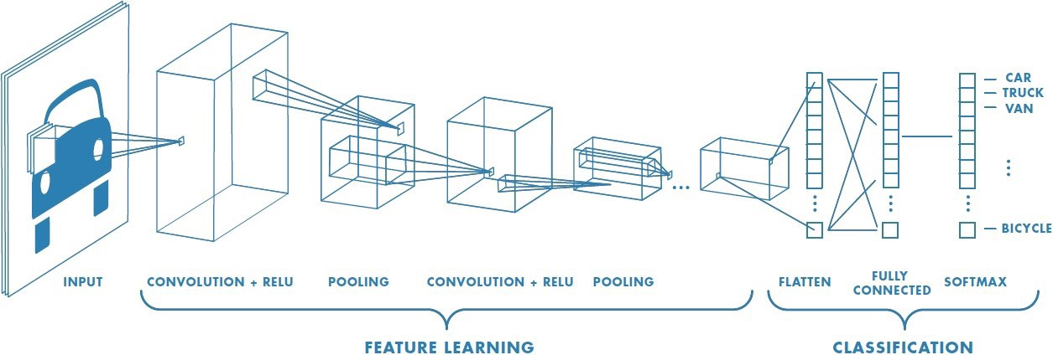

Recurrent Neural Network (RNN)
The MLP (feedforward network) is not known to do well on sequential events models such as the probabilistic language model of predicting the next word based on the previous work at every given point. RNN architecture addresses this issue. It is similar to MLP except that they have a feedback loop, which means they feed previous time steps into the current step. This type of architecture generates sequences to simulate situation and create synthetic data, making them the ideal modeling choice to work on sequence data such as speech text mining, image captioning, time series prediction, robot control, language modeling, etc.
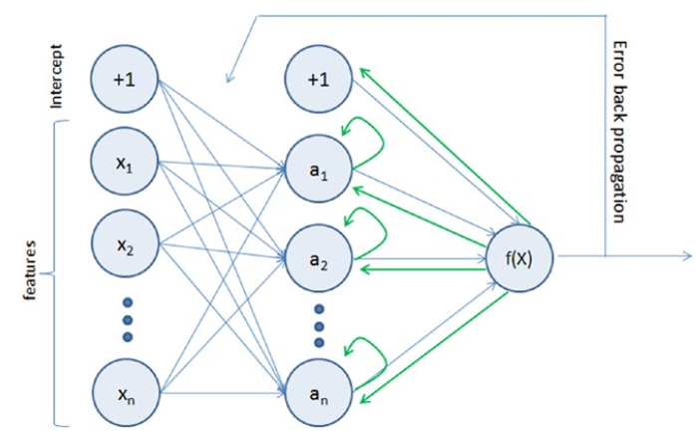

Long Short-Term Memory (LSTM)
LSTM is an implementation of improved RNN architecture to address the issues of general RNN, and it enables long-range dependencies. It is designed to have better memory through linear memory cells surrounded by a set of gate units used to control the flow of information, when information should enter the memory, when to forget, and when to output. It uses no activation function within its recurrent components, thus the gradient term does not vanish with back propagation.
Transfer Learning
Based on our past experience, we humans can learn a new skill easily. We are more efficient
in learning, particularly if the task in hand is similar to what we have done in the past, for
example, learning a new programming language for a computer professional or driving a
new type of vehicle for a seasoned driver is relatively easy based on our past experience.
Transfer learning is an area in machine learning that aims to utilize the knowledge
gained while solving one problem to solve a different but related problem.
Transfer learning is a popular method in computer vision because it allows us to build accurate models in a timesaving way (Rawat & Wang 2017). With transfer learning, instead of starting the learning process from scratch, you start from patterns that have been learned when solving a different problem. This way you leverage previous learnings and avoid starting from scratch.
In computer vision, transfer learning is usually expressed through the use of pre-trained models. A pre-trained model is a model that was trained on a large benchmark dataset to solve a problem similar to the one that we want to solve. Accordingly, due to the computational cost of training such models, it is common practice to import and use models from published literature (e.g. VGG, Inception, MobileNet).

Repurposing a pre-trained model
When you’re repurposing a pre-trained model for your own needs, you start by removing the original classifier, then you add a new classifier that fits your purposes, and finally you have to fine-tune your model according to one of three strategies:
- Train the entire model. In this case, you use the architecture of the pre-trained model and train it according to your dataset. You’re learning the model from scratch, so you’ll need a large dataset (and a lot of computational power).
- Train some layers and leave the others frozen. Lower layers refer to general features (problem independent), while higher layers refer to specific features (problem dependent). Here, we play with that dichotomy by choosing how much we want to adjust the weights of the network (a frozen layer does not change during training). Usually, if you’ve a small dataset and a large number of parameters, you’ll leave more layers frozen to avoid overfitting. By contrast, if the dataset is large and the number of parameters is small, you can improve your model by training more layers to the new task since overfitting is not an issue.
- Freeze the convolutional base. This case corresponds to an extreme situation of the train/freeze trade-off. The main idea is to keep the convolutional base in its original form and then use its outputs to feed the classifier. You’re using the pre-trained model as a fixed feature extraction mechanism, which can be useful if you’re short on computational power, your dataset is small, and/or pretrained model solves a problem very similar to the one you want to solve.

Transfer learning process
From a practical perspective, the entire transfer learning process can be summarized as follows:
- Select a pre-trained model. From the wide range of pre-trained models that are available, you pick one that looks suitable for your problem. For example, if you’re using Keras, you immediately have access to a set of models, such as VGG (Simonyan & Zisserman 2014), InceptionV3 (Szegedy et al. 2015), and ResNet5 (He et al. 2015).
- Classify your problem according to the Size-Similarity Matrix. In the following figure you have ‘The Matrix’ that controls your choices. This matrix classifies your computer vision problem considering the size of your dataset and its similarity to the dataset in which your pre-trained model was trained.
- Fine-tune your model. Here you can use the Size-Similarity Matrix to guide your choice and then refer to the three options we mentioned before about repurposing a pre-trained model.
- Classify your problem according to the Size-Similarity Matrix. In the following figure you have ‘The Matrix’ that controls your choices. This matrix classifies your computer vision problem considering the size of your dataset and its similarity to the dataset in which your pre-trained model was trained.
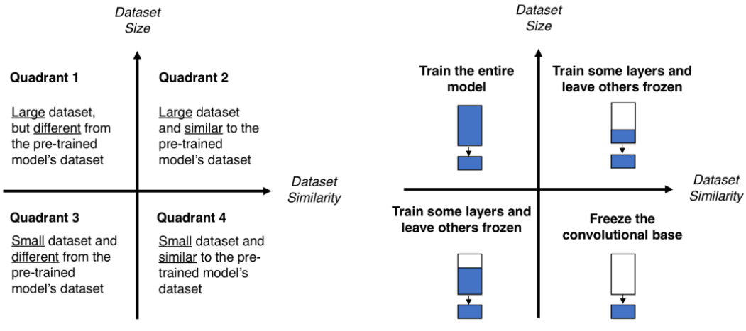

Chapter Five

Module Building and Evaluation

Concepts incorporated in model building
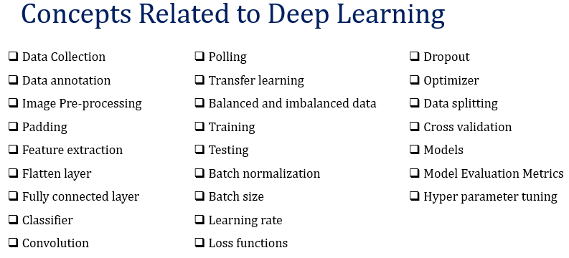

Data collection Mechanism
AI based Application is nothing without qualified data
