
Database system for 4th Year ECE (Computer Engineering) students
Prepared by M.A
Debre Tabor University, Ethiopia
2010 E.C
Chapter 1
Introduction to database system
A database is a collection of data, typically describing the activities of one or more related organizations. For example, a university database might contain information about the following:
- Entities such as students, faculty, courses, and classrooms.
- Relationships between entities, such as students’ enrollment in courses, faculty teaching courses, and the use of rooms for courses.
Application of database
Some application areas of database are:

- Banking
- Airlines
- Universities
- Credit card transactions
- Telecommunication
- Finance
- Sales
- Manufacturing
- Human resources

Data management
There is two approaches to manage data this are:
- File based
- Database system
Component and functionalities of database system
The two basic components of database system are:
- Data model
- DBMS (Database management system)
DBMS
It is software package designed to assist in maintaining and utilizing large collections of data.
Database system = DBMS + data

Structure of DBMS
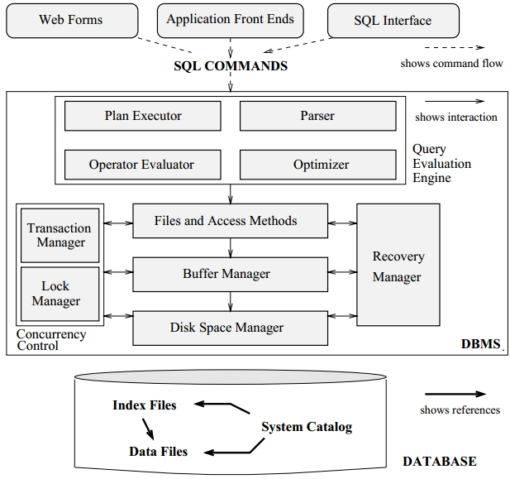
The two basic components of DBMS are:
- DDL(data definition language)
- DML(data manipulation language)\

DDL
It is used to define the external and conceptual schemas (Database instance and database schema respectively)
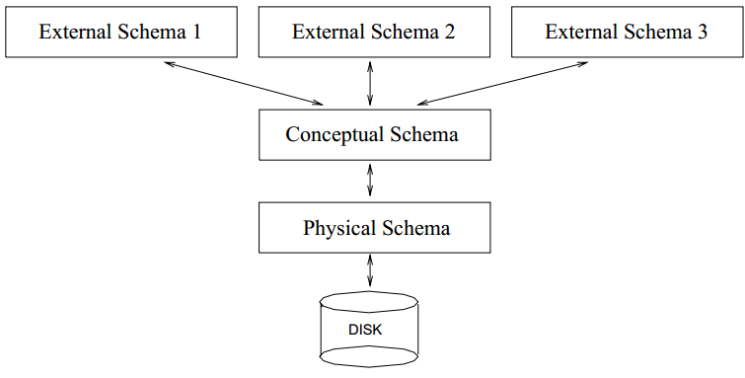
Conceptual Schema:- The conceptual schema (sometimes called the logical schema) describes the stored data in terms of the data model of the DBMS. In a relational DBMS, the conceptual schema describes all relations that are stored in the database
Physical Schema The physical schema specifies additional storage details. Essentially, the physical schema summarizes how the relations described in the conceptual schema are actually stored on secondary storage devices such as disks and tapes.
External schemas, which usually are also in terms of the data model of the DBMS, allow data access to be customized (and authorized) at the level of individual users or groups of users.

DML
It is a language that enables users to access or manipulate data as organized by the appropriate data model.
Data manipulation is
- The retrieval of information stored in the database
- The insertion of new information into the database
- The deletion of information from the database
- The modification of information stored in the database
Advantages of DBMS
Using a DBMS to manage data has many advantages:

- Data independence
- Efficient data access
- Data integrity and security
- Data administration
- Concurrent access and crash recovery
- Reduced application development time

Data Models
Underlying the structure of a database is the data model: a collection of conceptual tools for describing data, data relationships, data semantics, and consistency constraints. Data model help us to translate a real world into a structure that a computer can store.

Types of data models
- Conceptual data model
- Physical data model
- Implementation data model
Database design steps
- Requirements Analysis: The very first step in designing a database application is to understand what data is to be stored in the database, what applications must be built on top of it, and what operations are most frequent and subject to performance requirements. In other words, we must find out what the users want from the database.
- Conceptual Database Design: This step is often carried out using the ER model, or a similar high-level data model.
- Logical Database Design: the task in the logical design step is to convert an ER schema into a relational database schema.
- Schema Refinement: The fourth step in database design is to analyze the collection of relations in our relational database schema to identify potential problems, and to refine it.
- Physical Database Design: This step may simply involve building indexes on some tables and clustering some tables, or it may involve a substantial redesign of parts of the database schema obtained from the earlier design steps.
- Security Design: In this step, we identify different user groups and different roles played by various users (e.g., the development team for a product, the customer support representatives, the product manager). For each role and user group, we must identify the parts of the database that they must be able to access and the parts of the database that they should not be allowed to access, and take steps to ensure that they can access only the necessary parts.

Database system for 4th Year ECE (Computer Engineering) students
Prepared by M.A
Debre Tabor University, Ethiopia
2010 E.C
Chapter 2
E.R Data model
One of the most parts of conceptual design is entity relation diagram
Entity
An entity is a “thing” or “object” in the real world that is distinguishable from all other objects and represented in the database.
An entity set is a set of entities of the same type that share the same properties, or attributes.
- The set of all persons who are customers at a given bank, for example, can be defined as the entity set customer.
- Similarly, the entity set loan might represent the set of all loans awarded by a particular bank.
- An entity is represented by a set of attributes.
- In other word entity means tables
- E.g. there may be a table customer and loan table
Weak entity: an entity with no key attribute
Attributes
It is a property that describes the entity (table). E.g. student table may contain name. ID, department, CGPA and employee table may contain employee id, name, address, salary.
Types of entity
- Simple entity: it can’t divide into subparts.
- Composite entity: can be divided into subparts (that is, other attributes). E.g. customer name and address
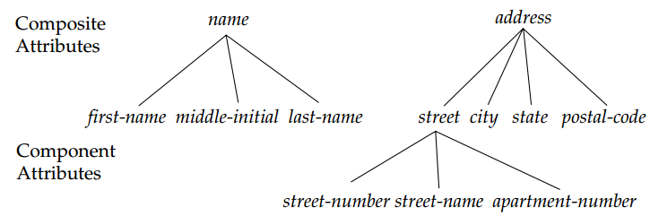
- Single valued entity: have single value its attribute
- Multi valued entity: have multiple value of its attribute. E.g. Name Address of customer
- Derived attribute: The value for this type of attribute can be derived from the values of other related attributes or entities. For instance, let us say that the customer entity set has an attribute loans-held, which represents how many loans a customer has from the bank. We can derive the value for this attribute by counting the number of loan entities associated with that customer. Thus, age is a derived attribute. In this case, date-of-birth may be referred to as a base attribute, or a stored attribute. The value of a derived attribute is not stored, but is computed when required.
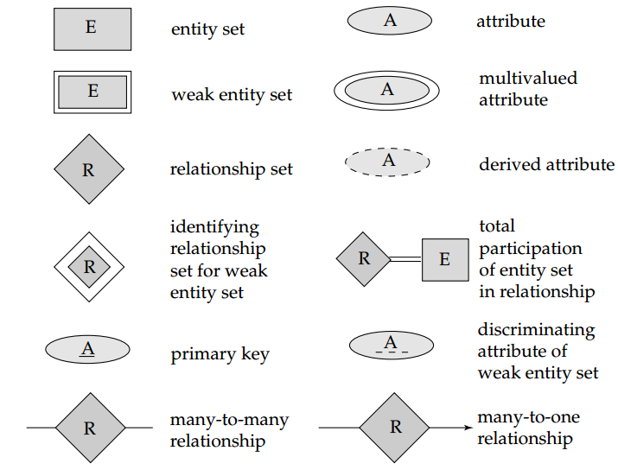
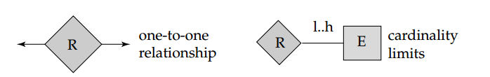
An E-R diagram can express the overall logical structure of a database graphically. Such a diagram consists of the following major components:
- Rectangles, which represent entity sets
- Ellipses, which represent attributes
- Diamonds, which represent relationship sets
- Lines, which link attributes to entity sets and entity sets to relationship sets
- Double ellipses, which represent multivalued attributes
- Dashed ellipses, which denote derived attributes
- Double lines, which indicate total participation of an entity in a relationship set
- Double rectangles, which represent weak entity sets
Constraints on relationship type
The two main types of relationship constraint are
- Cardinalities constraints, or cardinality ratios, express the number of entities to which another entity can be associated via a relationship set.
For a binary relationship set R between entity sets A and B, the mapping cardinality must be one of the following:
- One to one. An entity in A is associated with at most one entity in B, and an entity in B is associated with at most one entity in A.
- One to many. An entity in A is associated with any number (zero or more) of entities in B. An entity in B, however, can be associated with at most one entity in A
- Many to one. An entity in A is associated with at most one entity in B. An entity in B, however, can be associated with any number (zero or more) of entities in A.
- Many to many. An entity in A is associated with any number (zero or more) of entities in B, and an entity in B is associated with any number (zero or more) of entities in A.
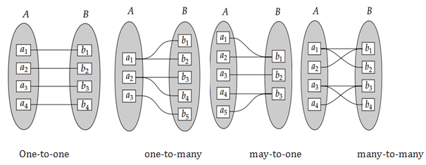
- Participation constraint
- Total participation: if every entity in E participates in at least one relationship in R.
- Partial participation: some entities in E participate in relationships in R,
Consider the entity-relationship diagram in in the following figure which consists of two entity sets, customer and loan, related through a binary relationship set borrower.
The attributes associated with customer are
- customer-id
- customer-name
- customer-street
- customer-city
The attributes associated with loan are
- loan-number and
- Amount.
In Figure attributes of an entity set that are members of the primary key are underlined. The relationship set borrower may be many-to-many, one-to-many, many-to-one, or one-to-one. To distinguish among these types, we draw either a directed line (→) or an undirected line (—) between the relationship set and the entity set in question.
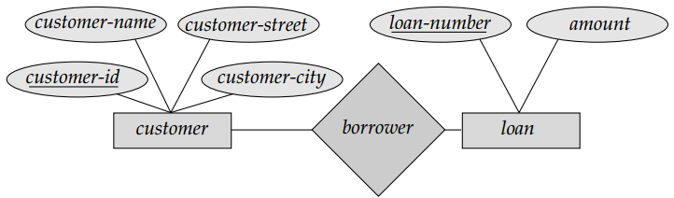
An undirected line from the relationship set borrower to the entity set loan specifies that borrower is either a many-to-many or one-to-many relationship set from customer to loan.
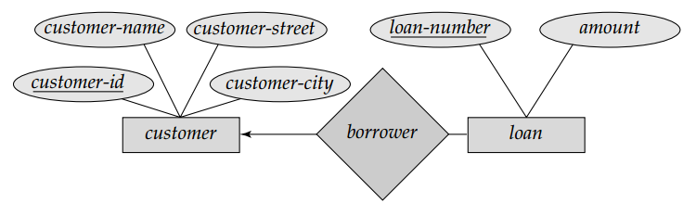
One-to-many
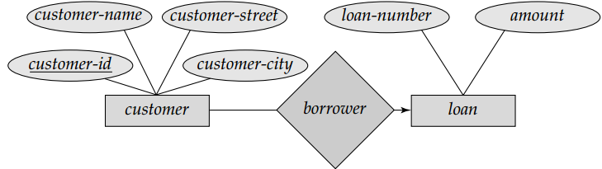
Many-to-one
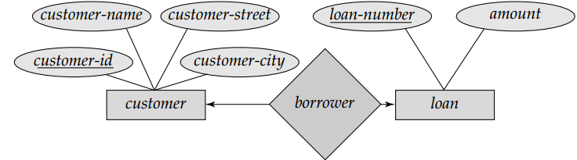
One-to-one
Steps in designing of E.R diagram
- Analyze the statement of design
- Identify entities
- Identify attributes for each entities
- Pick up the relational word
- Design E.R diagram
UML (Universal modeling language)
This includes:
- Use case diagram
- Class diagram
- Activity diagram and
- Sequence diagram
Case study
- Suppose you want to develop a database for technology faculty, and then design the following concepts?
- E-R diagram
- UML diagram

Database system for 4th Year ECE (Computer Engineering) students
Prepared by M.A
Debre Tabor University, Ethiopia
2010 E.C
Chapter 3
Relational data model
Introduction
Relational data model basically consists of two things. Thus are:
DDL: which define the structure of entities and their relationships.
DML: which specify manipulation of database contents were also established
Data model = DDL + DML.
There is no single method for organizing data in a database
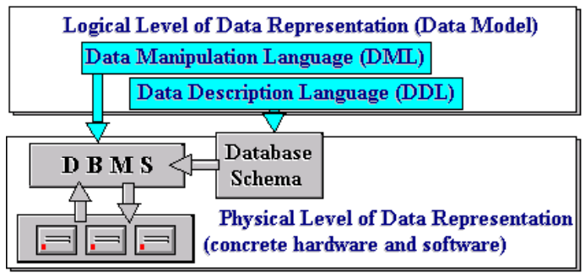

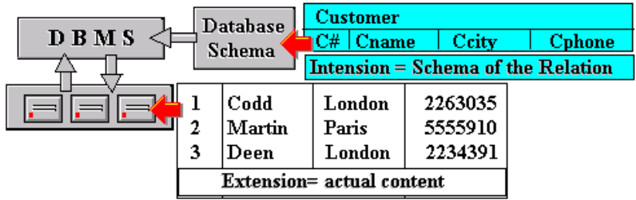
More formally, a Data Model is a combination of at least three components:
- A collection of data structure types
- A collection of operators or rules of inference, which can be applied to any valid instance of data types
- A collection of general integrity rules, which implicitly or explicitly define the set of consistent database states or change of state or both
Relations
The term relation in data model refers to a two-dimensional table of data. In other words, according to the model, information is arranged in columns and rows.
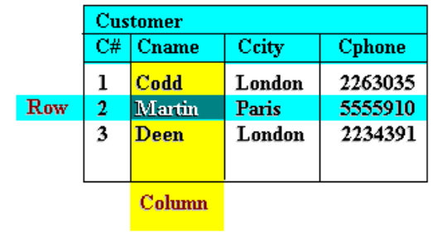
Relation consists of a relation schema and a relation instance. The relation instance is a table, and the relation schema describes the column heads for the table.
- The schema specifies the relation’s name, the name of each field (or column, or attribute), and the domain of each field.
- An instance of a relation is a set of tuples, also called records, in which each tuple has the same number of fields as the relation schema.
A relation has a unique name and represents a particular entity. Each row of a relation, referred to as a tuple, is a collection of facts (values) about a particular individual of that entity. In other words, a tuple represents an instance of the entity represented by the relation.
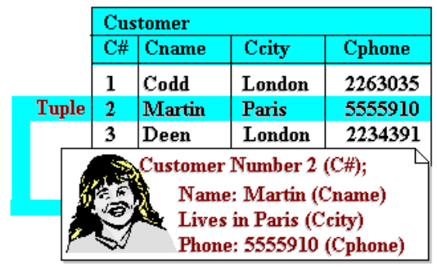
The columns of a relation hold values of attributes that we wish to associate with each entity instance, and each is labeled with a distinct attribute name at the top of the column. This name, of course, provides a unique reference to the entire column or to a particular value of a tuple in the relation. But more than that, it denotes a domain of values that is defined over all relations in the database. The term domain is used to refer to a set of values of the same kind or type.
Moreover, in the relational model, the term domain refers to the current set of values found under an attribute name. Thus, if the relation in the above Figure is the only relation in the database, the domain of ‘Cname’ is the set {Codd, Martin, Deen}, while that of ‘Ccity’ is {London, Paris}. But if there were other relations and an attribute name occurs in more than one of them, then its domain is the union of values in all columns with that name. This is illustrated in the following Figure where two relations each have a column labelled ‘C#’. It also clarifies the statement above that a domain is defined over all relations, ie. an attribute name always denotes the same domain in whatever relation in occurs.
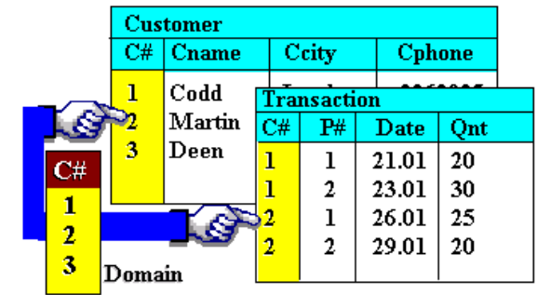
When two relations share a domain, identical domain values act as a link between tuples that contain them (because such values mean the same thing). As an example, consider a database comprising three relations as shown in following Figure. It highlights a Transaction tuple and a Customer tuple linked through the C# domain value ‘2’, and the same Transaction tuple and a Product tuple linked through the P# domain value ‘1’. The Transaction tuple is a record of a purchase by customer number ‘2’ of product number ‘1’. Through such links, we are able to retrieve the name of the customer and the product, ie. we are able to state that the customer ‘Martin’ bought a ‘Camera’. They help to avoid redundancy in recording data.
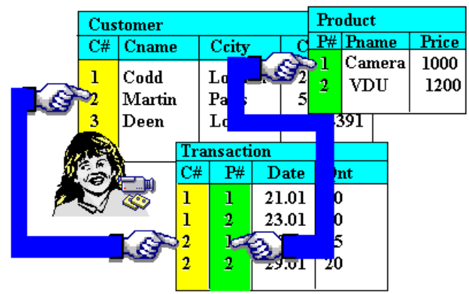
Properties of relational model
The characteristic properties of a relation are as follows:
- All entries in a given column are of the same kind or type
- The ordering of columns is immaterial. This is illustrated in the following Figure where the two tables shown are identical in every respect except for the ordering of their columns.
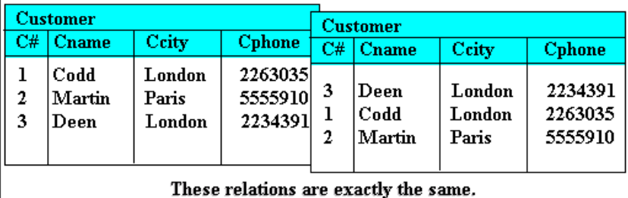
- No two tuples are exactly the same. A relation is a set of tuples. Thus a table that contains duplicate tuples is not a relation and cannot be stored in a relational database.
- There is only one value for each attribute of a tuple. Thus a table such as in the following Figure is not allowed in the relational model.
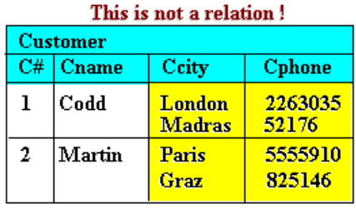
- The ordering of tuples is immaterial. This follows directly from defining a relation as a set of tuples, rather than a sequence or list.
Keys of relation (integrity key)
A key is a part of a tuple (one or more attributes) that uniquely distinguishes it from other tuples in a given relation. There are around five relation keys thus are:
- Primary key: Uniquely identifies each row/record in a database table.
- Foreign key: Uniquely identifies a row/record in any another database table
- Unique key: Ensures that all the values in a column are different.
- Super key: A super key is a set of one or more attributes that, taken collectively, allow us to identify uniquely an entity in the entity set. The set {sid, name} is an example of a superkey, which is a set of fields that contains a key.
- Candidate key: A set of fields that uniquely identifies a tuple according to a key constraint is called
a candidate key for the relation.
Functional dependency and Normalization
Functional dependency
Consider R(A,B,C) Let the following functional dependencies hold:
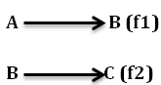
We can show that f1 and f2 together logically imply that the following functional dependency also holds:
Database normalization is the process of efficiently organizing data in a database. There
are two reasons of this normalization process:
- Eliminating redundant data. For example, storing the same data in more than one
table.
- Ensuring data dependencies make sense.
Or normalization is the process of decomposing bade table relation by breaking its attribute in to smaller relation

Database Normalization Examples - Assume a video library maintains a database of movies rented out. Without any normalization, all information is stored in one table as shown below.

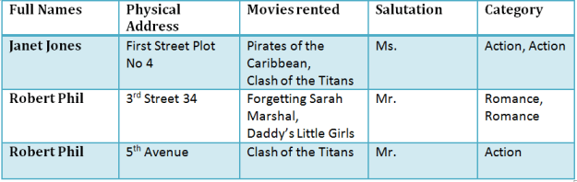

Here you see Movies Rented column has multiple values
The aim of normal forms is to organize the database structure, so that it complies with the rules of
- first normal form, then
- second normal form and finally
- The third normal form.

1NF (Second Normal Form) Rules
First Normal Form is defined in the definition of relations tables itself.
- Each table cell should contain a single value.
- Each record needs to be unique.
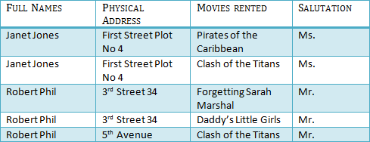

2NF (Second Normal Form) Rules
- Rule 1- Be in 1NF
- Rule 2- Single Column Primary Key
It is clear that we can't move forward to make our simple database in 2nd Normalization form unless we partition the table above.
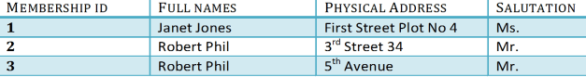
Tablre1
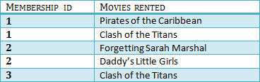
Tablre2
We have divided our 1NF table into two tables viz. Table 1 and Table2. Table 1 contains member information. Table 2 contains information on movies rented.
We have introduced a new column called Membership_id which is the primary key for table 1. Records can be uniquely identified in Table 1 using membership id
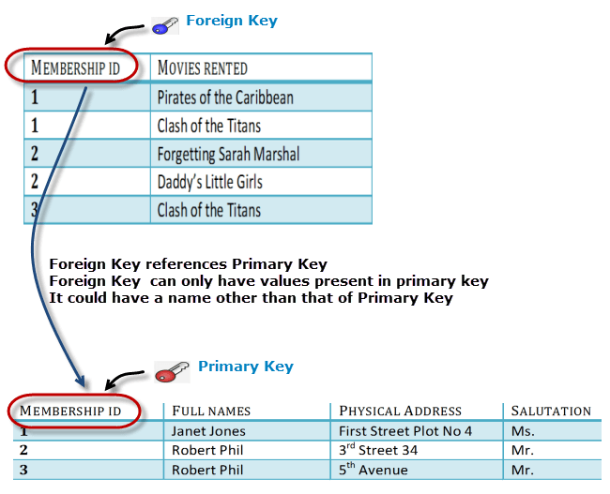

3NF (Third Normal Form) Rules
- Rule 1- Be in 2NF
- Rule 2- Has no transitive functional dependencies

What are transitive functional dependencies?
A transitive functional dependency is when changing a non-key column, might cause any of the other non-key columns to change
Consider the table 1. Changing the non-key column Full Name may change Salutation.
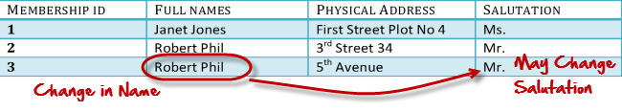
Third normal form
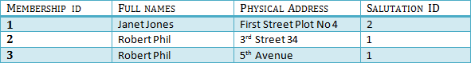
Table 1
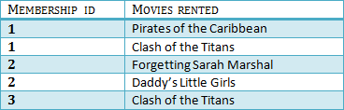
Table 2
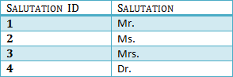
Table 3
We have again divided our tables and created a new table which stores Salutations. There are no transitive functional dependencies, and hence our table is in 3NF. In Table 3 Salutation ID is primary key, and in Table 1 Salutation ID is foreign to primary key in Table 3
Case study
- Suppose you want to develop a database for technology faculty, and then design the following concepts?
- Relational model (table relation)
- Set the relation in 2nd and 3rd Normal form
- Suppose you want to develop a database for student attendance in laboratory, and then design the following concepts?
- Relational model (table relation)
- Set the relation in 2nd and 3rd Normal form

Database system for 4th Year ECE (Computer Engineering) students
Prepared by M.A
Debre Tabor University, Ethiopia
2010 E.C

Chapter four
Fundamentals of relational algebra
Queries are composed using a collection of operators.
- Every operator:
- Accepts one or two relation instances
- Returns a relation instance.
- Compose relational algebra expression
- Each query describes a step-by-step procedure for computing the desired answer.
Basic operations
Five basic operators
- Selection
- Projection
- Union
- Cross-product
- Difference

Selection operator
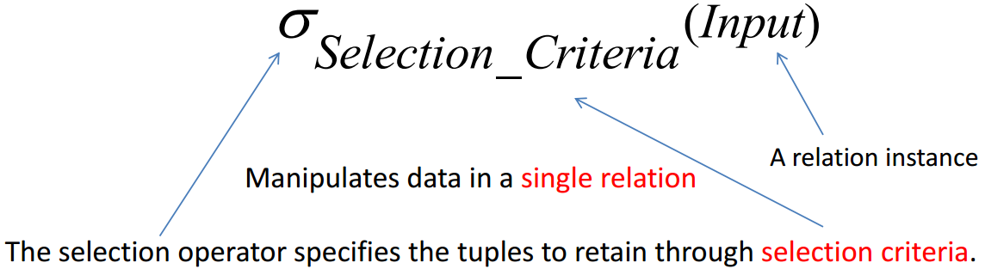

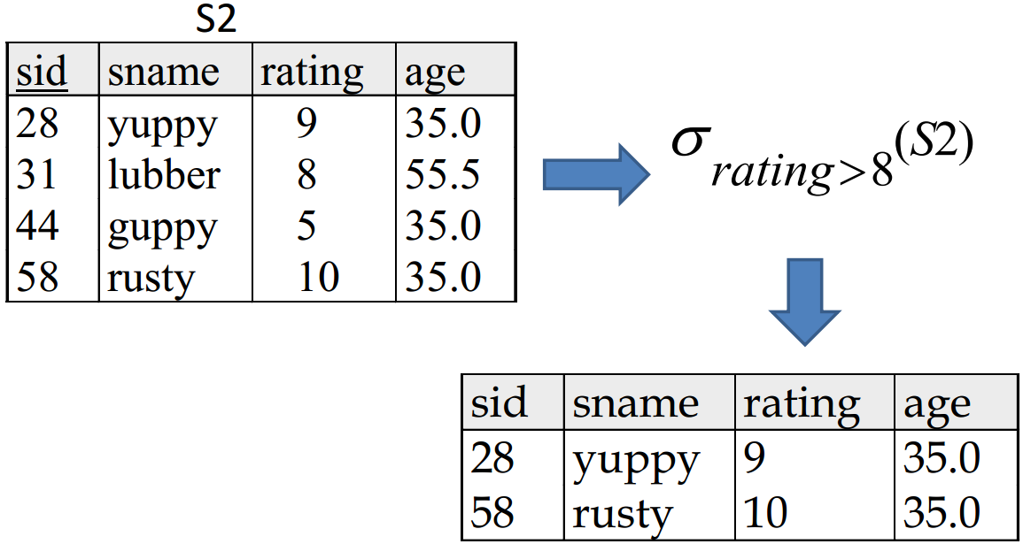

Projection operation
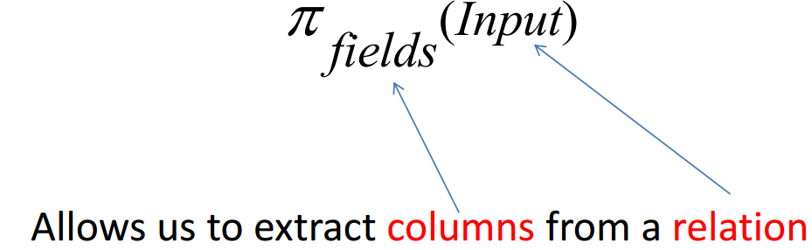
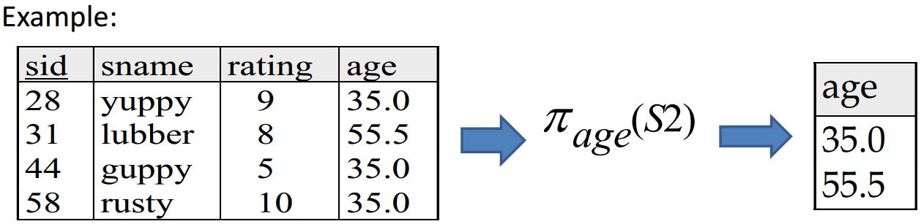
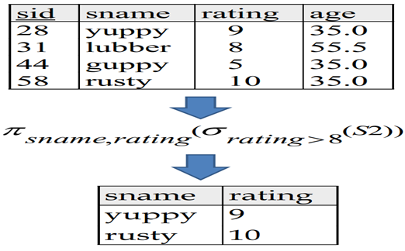

Set operation
- Takes as input two relation instances
- Four standard operations
- Union
- Intersection
- Set-difference
- Cross-product
Union, intersection, and difference require the two input set to be union compatible
- They have the same number of fields
- corresponding fields, taken in order from left to right, have the same domains
Union
R U S returns relation instance containing all tuples that occur in either relation instance R or S, or both.
- R and S must be union compatible.
- Schema of the result is defined to be that of R.
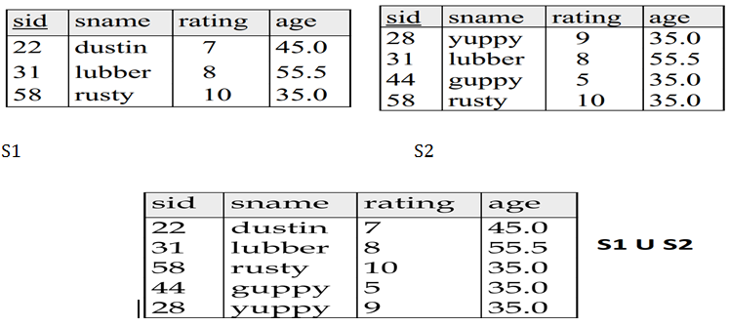
Interception operator
R ⋂ S: returns a relation instance containing all tuples that occur in both R and S.
- R and S must be union compatible.
- Schema of the result is that of schema of R
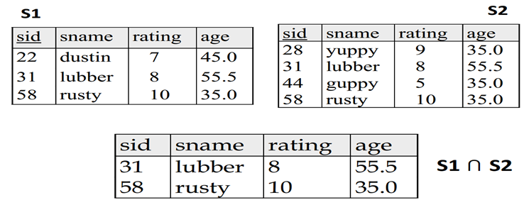
Set difference operator
R – S: returns a relation instance containing all tuples that occur in R but
not in S.
- R and S must be union-compatible.
- Scheme of the result is the schema of R.
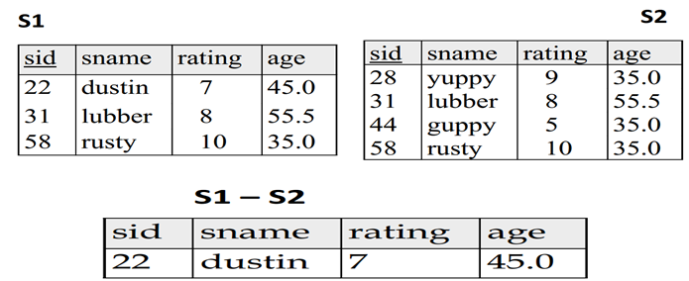
Cross-product
R x S: Returns a relation instance whose scheme contains:
- All the fields of R (in the same order as they appear in R)
- All the fields of S (in the same order as they appear in S)
- The result contains one tuple <r,s> for each pair with r ⋳ R and s ⋳ S
- Basically, it is the Cartesian product.
- Fields of the same name are unnamed.
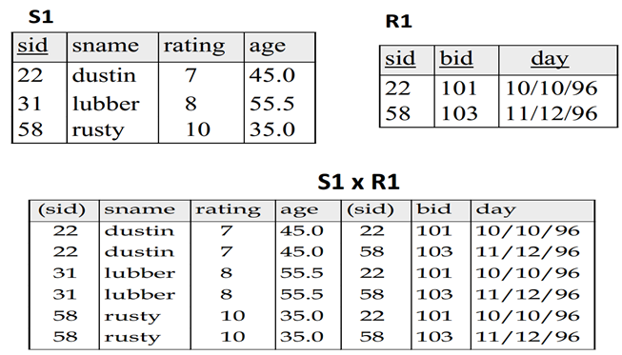
Activities
- If you want to select student name from student table that have CGPA of greater than 3.87, describe this query using relational algebra
- Write the relational algebra for the query that select user id and user name from student table
- Suppose you have two database table that have somewhat similar tuples then write the relational algebra to select the data that is present only in first table which enable the table differ from the second table

Database system for 4th Year ECE (Computer Engineering) students
Prepared by M.A
Debre Tabor University, Ethiopia
2010 E.C
Chapter 5
SQL (Structural Query Language)
Introduction
- SQL is Structured Query Language, which is a computer language for storing, manipulating and retrieving data stored in a relational database.
- SQL is the standard language for Relational Database System.
- All the Relational Database Management Systems (RDMS) like MySQL, MS Access, Oracle, Sybase, Informix, Postgres and SQL Server use SQL as their standard database language
Why SQL?
SQL is widely popular because it offers the following advantages:
- Allows users to access data in the relational database management systems.
- Allows users to describe the data.
- Allows users to define the data in a database and manipulate that data.
- Allows embedding within other languages using SQL modules, libraries & pre-compilers.
- Allows users to create and drop databases and tables.
- Allows users to create view, stored procedure, functions in a database.
- Allows users to set permissions on tables, procedures and views.

SQL Process and Architecture
When we are executing an SQL command for any RDBMS, the system determines the best way to carry out our request and SQL engine figures out how to interpret the task.
Some of the components that include in this process are:
- Query Dispatcher
- Optimization Engines
- Classic Query Engine
- SQL Query Engine, etc
Following is a simple diagram showing the SQL Architecture:
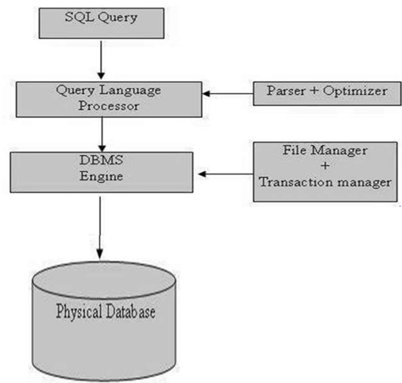
Basic SQL Commands
The standard SQL commands to interact with relational databases are CREATE, SELECT, INSERT, UPDATE, DELETE and DROP.
Types of SQL commands
These commands can be classified into the following groups based on their nature:
DDL - Data Definition Language
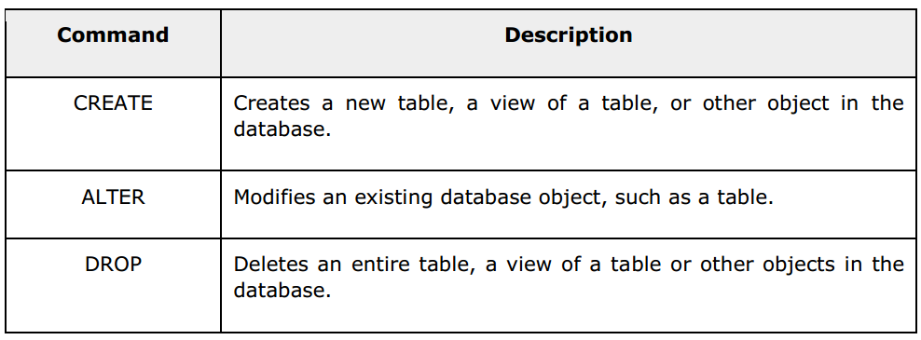
DML - Data Manipulation Language
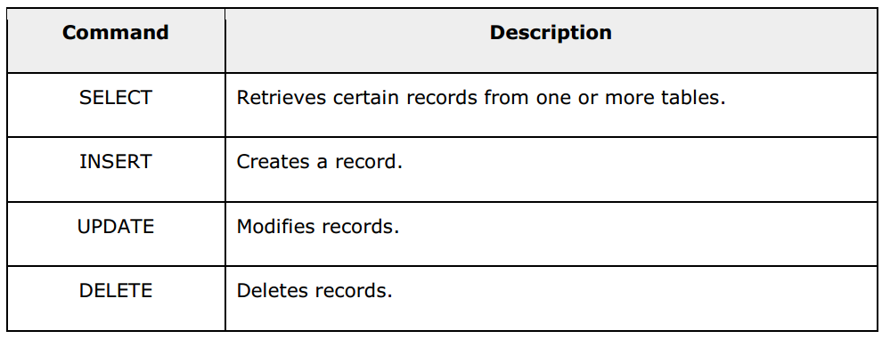
DCL - Data Control Language
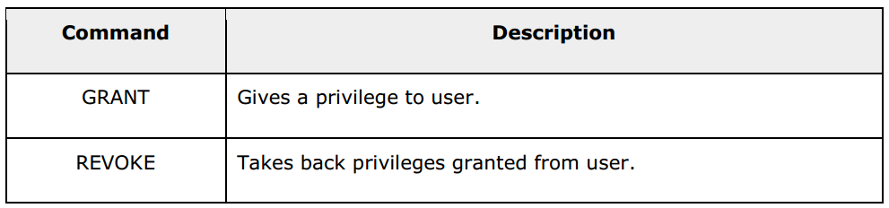

Creating a database
CREATE DATABASE databasename;
Example:
CREATE DATABASE testDB;
In our SQL server there may be multiple database to use one specified database we will use the use key word to manipulate a table inside that database
USE databsename;
Drop a database
DROP DATABASE databasename;
Example : DROP DATABASE testDB;
Creating a table
CREATE TABLE table_name (
column1 datatype,
column2 datatype,
column3 datatype,
....
);
Example :
CREATE TABLE Persons (
PersonID int,
LastName varchar(255),
FirstName varchar(255),
Address varchar(255),
City varchar(255) );
Drop tables
DROP TABLE table_name;
Example : DROP TABLE person;

SQL truncate table
The TRUNCATE TABLE statement is used to delete the data inside a table, but not the table itself.
TRUNCATE TABLE table_name;
Example :
TRUNCATE TABLE person;

SQL alter table Statement
The ALTER TABLE statement is used to add, delete, or modify columns in an existing table.

Alter table - add column
To add a column in a table, use the following syntax:
ALTER TABLE table_name
ADD column_name datatype;

Example
Look at the "Persons" table:
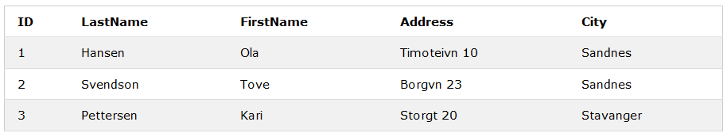
After executing the following query the table will be changed as follows:
ALTER TABLE Persons
ADD DateOfBirth date;
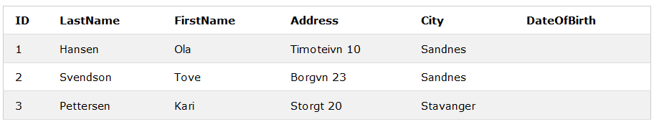

Alter table - drop column
To delete a column in a table, use the following syntax (notice that some database systems don't allow deleting a column):
ALTER TABLE table_name
DROP COLUMN column_name;

Example Next, we want to delete the column named "DateOfBirth" in the "Persons" table. We use the following SQL statement:
ALTER TABLE Persons
DROP COLUMN DateOfBirth;
The "Persons" table will now look like this:
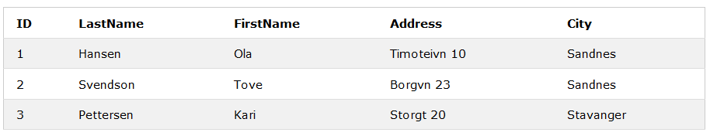

Alter table - alter/modify column
ALTER TABLE table_name
ALTER COLUMN column_name datatype;
Example:
ALTER TABLE persons
ALTER COLUMN PersonId varchar(12);
SQL Constraints
- SQL constraints are used to specify rules for data in a table.
- Constraints can be specified when the table is created with the CREATE TABLE statement, or after the table is created with the ALTER TABLE statement.
Basic syntax
CREATE TABLE table_name (
column1 datatype constraint,
column2 datatype constraint,
column3 datatype constraint,
....
);
- Constraints can be column level or table level. Column level constraints apply to a column, and table level constraints apply to the whole table. The following constraints are commonly used in SQL:
- NOT NULL - Ensures that a column cannot have a NULL value
- UNIQUE - Ensures that all values in a column are different
- PRIMARY KEY - A combination of a NOT NULL and UNIQUE. Uniquely identifies each row in a table
- FOREIGN KEY - Uniquely identifies a row/record in another table
- CHECK - Ensures that all values in a column satisfies a specific condition
- DEFAULT - Sets a default value for a column when no value is specified
- INDEX - Used to create and retrieve data from the database very quickly

SQL not null constraint
- By default, a column can hold NULL values.
- The NOT NULL constraint enforces a column to NOT accept NULL values.
- This enforces a field to always contain a value, which means that you cannot insert a new record, or update a record without adding a value to this field.
The following SQL ensures that the "ID", "LastName", and "FirstName" columns will NOT accept NULL values:
Example:
CREATE TABLE Persons (
ID int NOT NULL,
LastName varchar(255) NOT NULL,
FirstName varchar(255) NOT NULL,
Age int);

SQL unique constraint
- The UNIQUE constraint ensures that all values in a column are different.
- Both the UNIQUE and PRIMARY KEY constraints provide a guarantee for uniqueness for a column or set of columns.
- A PRIMARY KEY constraint automatically has a UNIQUE constraint.
However, you can have many UNIQUE constraints per table, but only one PRIMARY KEY constraint per table.
CREATE TABLE Persons (
ID int NOT NULL,
LastName varchar(255) NOT NULL,
FirstName varchar(255),
Age int,
UNIQUE (ID));

SQL unique constraint on alter table
To create a UNIQUE constraint on the "ID" column when the table is already created, use the following SQL:
ALTER TABLE Persons
ADD UNIQUE (ID);

Drop a unique constraint
To drop a UNIQUE constraint, use the following SQL:
ALTER TABLE Persons
DROP INDEX UC_Person;

SQL primary key constraint
- The PRIMARY KEY constraint uniquely identifies each record in a database table.
- Primary keys must contain UNIQUE values, and cannot contain NULL values.
A table can have only one primary key, which may consist of single or multiple fields.
Example:
CREATE TABLE Persons (ID int NOT NULL, LastName varchar(255) NOT NULL,
FirstName varchar(255), Age int, PRIMARY KEY (ID));

SQL primary key on alter table
To create a PRIMARY KEY constraint on the "ID" column when the table is already created, use the following SQL:
ALTER TABLE Persons
ADD PRIMARY KEY (ID);

Drop a primary key constraint
To drop a PRIMARY KEY constraint, use the following SQL:
ALTER TABLE Persons
DROP PRIMARY KEY;

SQL foreign key constraint
- A FOREIGN KEY is a key used to link two tables together.
- A FOREIGN KEY is a field (or collection of fields) in one table that refers to the PRIMARY KEY in another table.
- The table containing the foreign key is called the child table, and the table containing the candidate key is called the referenced or parent table.
Look at the following two tables: "Persons" table:
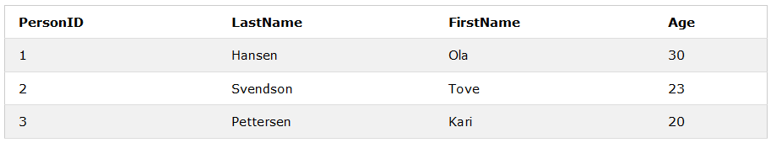
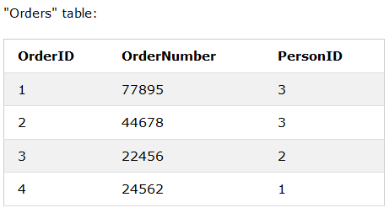
- Notice that the "PersonID" column in the "Orders" table points to the "PersonID" column in the "Persons" table.
- The "PersonID" column in the "Persons" table is the PRIMARY KEY in the "Persons" table.
- The "PersonID" column in the "Orders" table is a FOREIGN KEY in the "Orders" table
Example:
CREATE TABLE Orders (OrderID int NOT NULL, OrderNumber int NOT NULL, PersonID int,
PRIMARY KEY (OrderID),
FOREIGN KEY (PersonID) REFERENCES Persons(PersonID));

SQL foreign key on alter table
To create a FOREIGN KEY constraint on the "PersonID" column when the "Orders" table is already created, use the following SQL:
ALTER TABLE Orders
ADD FOREIGN KEY (PersonID) REFERENCES Persons(PersonID);

Drop a foreign key constraint
To drop a FOREIGN KEY constraint, use the following SQL:
ALTER TABLE Orders
DROP FOREIGN KEY FK_PersonOrder;

SQL check constraint
- The CHECK constraint is used to limit the value range that can be placed in a column.
- If you define a CHECK constraint on a single column it allows only certain values for this column.
- If you define a CHECK constraint on a table it can limit the values in certain columns based on values in other columns in the row.
Example:
CREATE TABLE Persons (ID int NOT NULL, LastName varchar(255) NOT NULL,
FirstName varchar(255), Age int,
CHECK (Age>=18));

SQL default constraint
- The DEFAULT constraint is used to provide a default value for a column.
- The default value will be added to all new records IF no other value is specified.
CREATE TABLE Persons (ID int NOT NULL, LastName varchar(255) NOT NULL,
FirstName varchar(255), Age int,
City varchar(255) DEFAULT 'Sandnes');

SQL default on alter table
To create a DEFAULT constraint on the "City" column when the table is already created, use the following SQL:
ALTER TABLE Persons
ALTER City SET DEFAULT 'Sandnes'

Drop a default constraint
To drop a DEFAULT constraint, use the following SQL:
ALTER TABLE Persons
ALTER City DROP DEFAULT;

SQL CREATE INDEX Statement
The CREATE INDEX statement is used to create indexes in tables.
Indexes are used to retrieve data from the database very fast. The users cannot see the indexes, they are just used to speed up searches/queries.

CREATE INDEX Syntax
Creates an index on a table. Duplicate values are allowed:
CREATE INDEX index_name
ON table_name (column1, column2, ...);
Example:
CREATE INDEX idx_lastname
ON Persons (LastName);
If you want to create an index on a combination of columns, you can list the column names within the parentheses, separated by commas:
CREATE INDEX idx_pname
ON Persons (LastName, FirstName);

CREATE UNIQUE INDEX Syntax
Creates a unique index on a table. Duplicate values are not allowed:
CREATE UNIQUE INDEX index_name
ON table_name (column1, column2, ...);

The SQL INSERT INTO Statement
The INSERT INTO statement is used to insert new records in a table.

INSERT INTO Syntax
It is possible to write the INSERT INTO statement in two ways.
The first way specifies both the column names and the values to be inserted:
INSERT INTO table_name (column1, column2, column3, ...)
VALUES (value1, value2, value3, ...);
The second way specifies only the values to be inserted:
INSERT INTO table_name
VALUES (value1, value2, value3, ...)
Example:
Below is a selection from the "Customers" table in the sample database
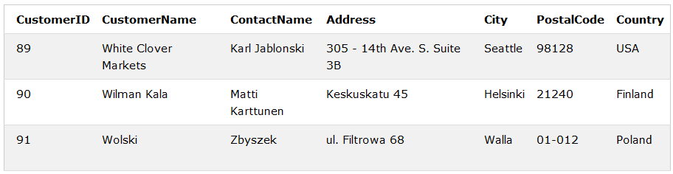
NSERT INTO Customers (CustomerName, ContactName, Address, City, PostalCode, Country)
VALUES ('Cardinal', 'Tom B. Erichsen', 'Skagen 21', 'Stavanger', '4006', 'Norway');
After applying insert query the selection from the "Customers" table will now look like this
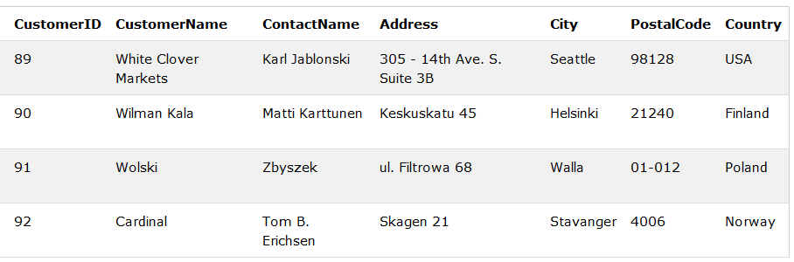

The SQL WHERE Clause
- The WHERE clause is used to filter records.
- The WHERE clause is used to extract only those records that fulfill a specified condition.

WHERE Syntax

SELECT column1, column2, ...

FROM table_name

WHERE condition;

The SQL UPDATE Statement
The UPDATE statement is used to modify the existing records in a table.

UPDATE Syntax

UPDATE table_name

SET column1 = value1, column2 = value2, ...

WHERE condition;
Example:
Below is a selection from the "Customers" table in the Northwind sample database:
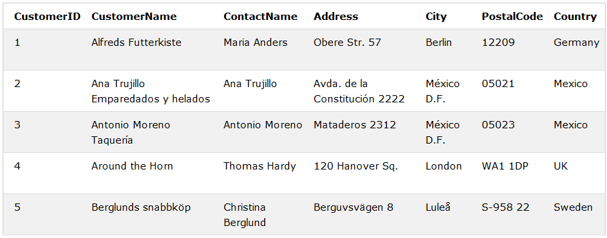
UPDATE Customers
SET ContactName = 'Alfred Schmidt', City= 'Frankfurt'
WHERE CustomerID = 1;
After applying the update query, The selection from the "Customers" table will now look like this:
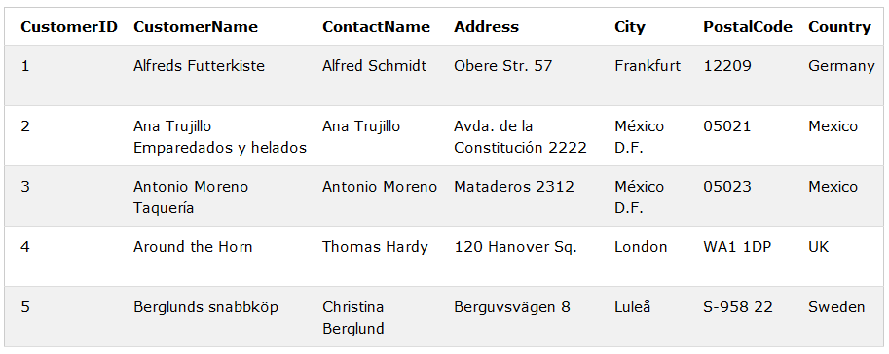

The SQL SELECT Statement
The SELECT statement is used to select data from a database.
The data returned is stored in a result table, called the result-set.

SELECT Syntax
SELECT column1, column2, ...
FROM table_name;
Here, column1, column2, ... are the field names of the table you want to select data from. If you want to select all the fields available in the table, use the following syntax:
SELECT * FROM table_name;
Example:
SELECT CustomerName, City FROM Customers;
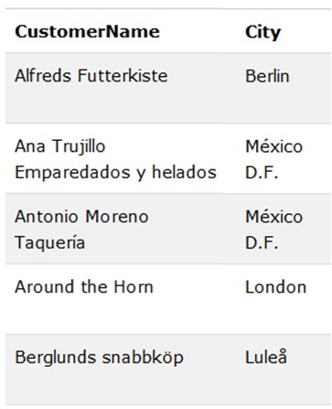

The SQL SELECT DISTINCT Statement
- The SELECT DISTINCT statement is used to return only distinct (different) values.
- Inside a table, a column often contains many duplicate values; and sometimes you only want to list the different (distinct) values.
- The SELECT DISTINCT statement is used to return only distinct (different) values.

SELECT DISTINCT Syntax
SELECT DISTINCT column1, column2, ...
FROM table_name;
To count the number of distinct value to know how much is present inside agiven table we can use the following syntax
SELECT Count(*) AS DistinctCountries
FROM (SELECT DISTINCT Country FROM Customers);

The SQL DELETE Statement
The DELETE statement is used to delete existing records in a table.

DELETE Syntax

DELETE FROM table_name

WHERE condition

Example:

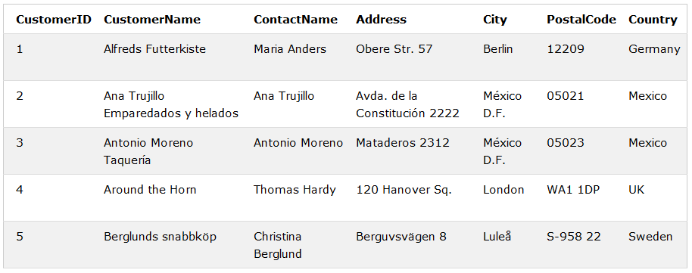

DELETE FROM Customers

WHERE CustomerName='Alfreds Futterkiste';

After applying the delete query, The "Customers" table will now look like this:

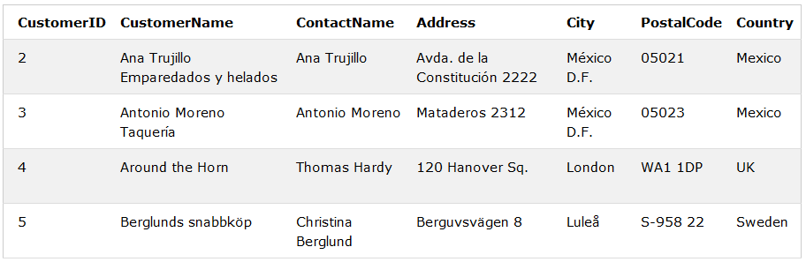

SQL aggregate functions

The SQL count(), avg() and sum() functions
- The COUNT() function returns the number of rows that matches a specified criteria.
- The AVG() function returns the average value of a numeric column.
- The SUM() function returns the total sum of a numeric column.

COUNT() Syntax
SELECT COUNT(column_name)
FROM table_name
WHERE condition;
Example:
SELECT COUNT(ProductID)
FROM Products;

AVG() Syntax
SELECT AVG(column_name)
FROM table_name
WHERE condition;

Example:
Below is a selection from the "Products" table in the Northwind sample database:
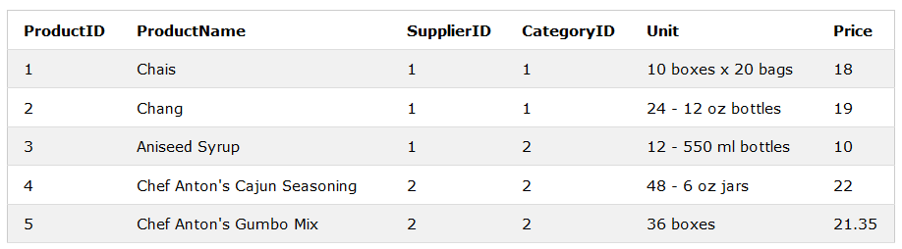
SELECT AVG(Price)
FROM Products;

SUM() Syntax
SELECT SUM(column_name)
FROM table_name
WHERE condition;
Example:
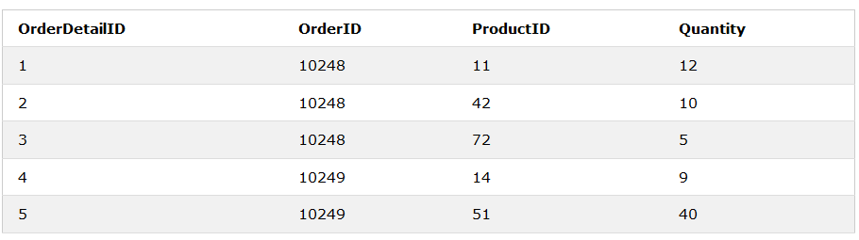
SELECT SUM(Quantity)
FROM OrderDetails

The SQL min() and max() functions
- The MIN() function returns the smallest value of the selected column.
- The MAX() function returns the largest value of the selected column.

MIN() Syntax

SELECT MIN(column_name)

FROM table_name

WHERE condition;

Example:

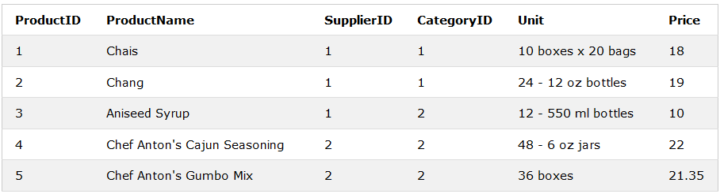

SELECT MIN(Price) AS SmallestPrice

FROM Products;

MAX() Syntax
SELECT MAX(column_name)
FROM table_name
WHERE condition;

Example:

SELECT MAX(Price) AS LargestPrice
FROM Products;

The SQL ORDER BY Keyword
- The ORDER BY keyword is used to sort the result-set in ascending or descending order.
- The ORDER BY keyword sorts the records in ascending order by default. To sort the records in descending order, use the DESC keyword.

ORDER BY Syntax
SELECT column1, column2, ...
FROM table_name
ORDER BY column1, column2, ... ASC|DESC;

Example: a selection from the "Customers" table
SELECT * FROM Customers
ORDER BY Country DESC;

The SQL GROUP BY Statement
The GROUP BY statement is often used with aggregate functions (COUNT, MAX, MIN, SUM, AVG) to group the result-set by one or more columns.

GROUP BY Syntax
SELECT column_name(s)
FROM table_name
WHERE condition
GROUP BY column_name(s)
ORDER BY column_name(s);
Example:
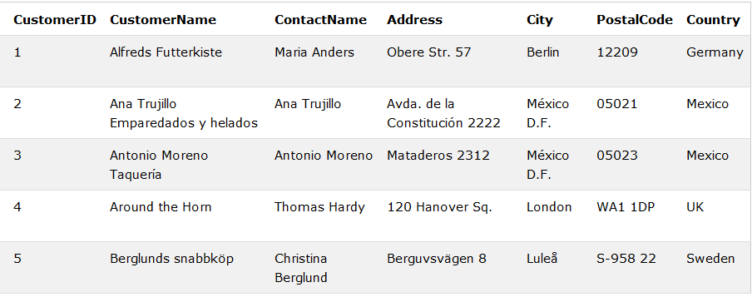
SELECT COUNT(CustomerID), Country
FROM Customers
GROUP BY Country;

The SQL HAVING Clause
The HAVING clause was added to SQL because the WHERE keyword could not be used with aggregate functions.

HAVING Syntax
SELECT column_name(s)
FROM table_name
WHERE condition
GROUP BY column_name(s)
HAVING condition
ORDER BY column_name(s);

Example

The following SQL statement lists the number of customers in each country, sorted high to low (Only include countries with more than 5 customers):
SELECT COUNT(CustomerID), Country
FROM Customers
GROUP BY Country
HAVING COUNT(CustomerID) > 5
ORDER BY COUNT(CustomerID) DESC;
Relational query

The SQL UNION Operator
The UNION operator is used to combine the result-set of two or more SELECT statements.
- Each SELECT statement within UNION must have the same number of columns
- The columns must also have similar data types
- The columns in each SELECT statement must also be in the same order

UNION Syntax
SELECT column_name(s) FROM table1
UNION
SELECT column_name(s) FROM table2;

UNION ALL Syntax
The UNION operator selects only distinct values by default. To allow duplicate values, use UNION ALL:
SELECT column_name(s) FROM table1
UNION ALL
SELECT column_name(s) FROM table2;
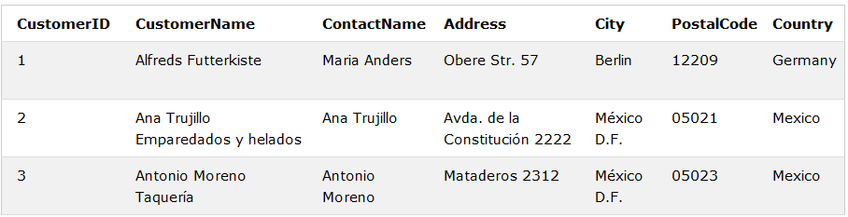Customer table
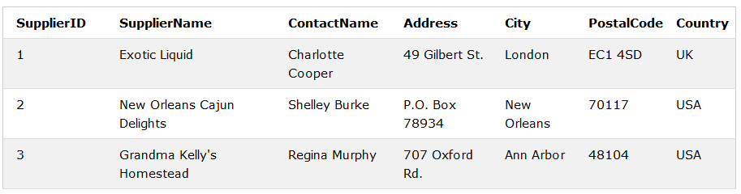Suppliers table
The following SQL statement selects all the different cities (only distinct values) from "Customers" and "Suppliers":
SELECT City FROM Customers
UNION
SELECT City FROM Suppliers
ORDER BY City;
The following SQL statement selects all cities (duplicate values also) from "Customers" and "Suppliers":
SELECT City FROM Customers
UNION ALL
SELECT City FROM Suppliers
ORDER BY City;

SQL UNION With WHERE
The following SQL statement selects all the different German cities (only distinct values) from "Customers" and "Suppliers":

SELECT City, Country FROM Customers
WHERE Country='Germany'
UNION
SELECT City, Country FROM Suppliers
WHERE Country='Germany'
ORDER BY City;

The SQL EXISTS Operator
- The EXISTS operator is used to test for the existence of any record in a subquery.
- The EXISTS operator returns true if the subquery returns one or more records.

EXISTS Syntax
SELECT column_name(s)
FROM table_name
WHERE EXISTS
(SELECT column_name FROM table_name WHERE condition);

Example:
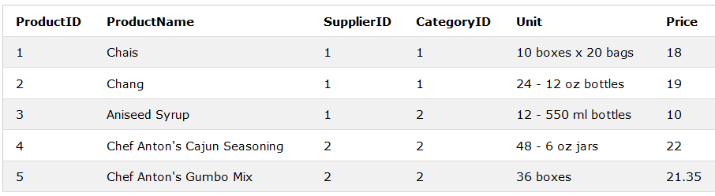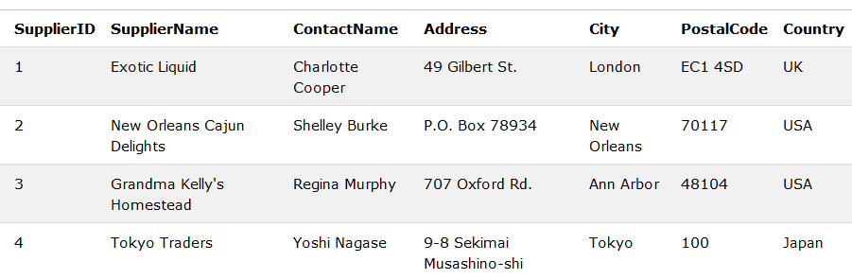
Product table supplier table
SELECT SupplierName
FROM Suppliers
WHERE EXISTS (SELECT ProductName FROM Products WHERE SupplierId = Suppliers.supplierId AND Price < 20);
Returns suppliers name from supplier table whose product is less than 20 at product table

SQL JOIN
A JOIN clause is used to combine rows from two or more tables, based on a related column between them.

Different Types of SQL JOINs
Here are the different types of the JOINs in SQL:
- (INNER) JOIN: Returns records that have matching values in both tables
- LEFT (OUTER) JOIN: Return all records from the left table, and the matched records from the right table
- RIGHT (OUTER) JOIN: Return all records from the right table, and the matched records from the left table
- FULL (OUTER) JOIN: Return all records when there is a match in either left or right table
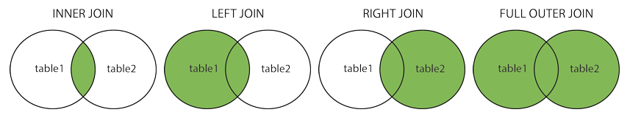

SQL INNER JOIN Keyword
The INNER JOIN keyword selects records that have matching values in both tables.

INNER JOIN Syntax
SELECT column_name(s)
FROM table1
INNER JOIN table2 ON table1.column_name = table2.column_name;
Example:
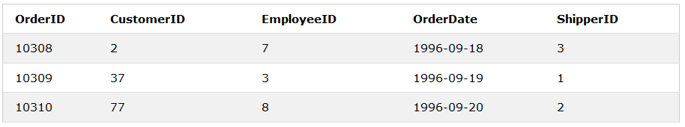 Orders table
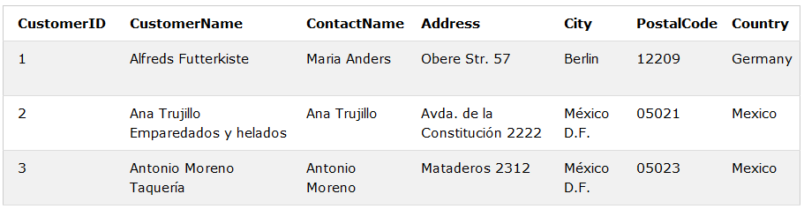Customers
SELECT Orders.OrderID, Customers.CustomerName
FROM Orders
INNER JOIN Customers ON Orders.CustomerID = Customers.CustomerID;
It returns (displays) order ID and order Date from order table and customers name from customer table where CustomerId at order table equal to CustomerId at Customer table

SQL LEFT JOIN Keyword
The LEFT JOIN keyword returns all records from the left table (table1), and the matched records from the right table (table2). The result is NULL from the right side, if there is no match.

LEFT JOIN Syntax
SELECT column_name(s)
FROM table1
LEFT JOIN table2 ON table1.column_name = table2.column_name;
Example: take order and customers table from the above
SELECT Customers.CustomerName, Orders.OrderID
FROM Customers
LEFT JOIN Orders ON Customers.CustomerID = Orders.CustomerID
ORDER BY Customers.CustomerName;
It display all customerNname from customer table and also display orderID from order table if only customerID at customer table equal to customerId at order table

SQL RIGHT JOIN Keyword
The RIGHT JOIN keyword returns all records from the right table (table2), and the matched records from the left table (table1). The result is NULL from the left side, when there is no match.

RIGHT JOIN Syntax
SELECT column_name(s)
FROM table1
RIGHT JOIN table2 ON table1.column_name = table2.column_name;
Example:
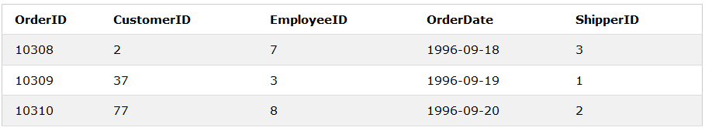Order table
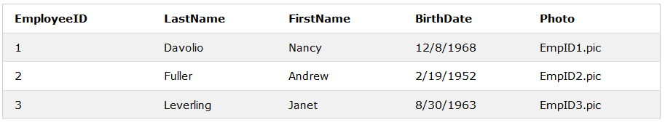Employee table
SELECT Orders.OrderID, Employees.LastName, Employees.FirstName
FROM Orders
RIGHT JOIN Employees ON Orders.EmployeeID = Employees.EmployeeID
ORDER BY Orders.OrderID;
It display all LastNname from employee table and also display orderID from order table if only EmployeeID at Employee table equal to EmployeeId at order table

The SQL INSERT INTO SELECT Statement
The INSERT INTO SELECT statement copies data from one table and inserts it into another table.
- INSERT INTO SELECT requires that data types in source and target tables match
- The existing records in the target table are unaffected

INSERT INTO SELECT Syntax
Copy all columns from one table to another table:
INSERT INTO table2
SELECT * FROM table1
WHERE condition;
Copy only some columns from one table into another table:
INSERT INTO table2 (column1, column2, column3, ...)
SELECT column1, column2, column3, ...
FROM table1
WHERE condition;

Example
The following SQL statement copies "Suppliers" into "Customers" (the columns that are not filled with data, will contain NULL):
INSERT INTO Customers (CustomerName, City, Country)
SELECT SupplierName, City, Country FROM Suppliers;
The following SQL statement copies only the German suppliers into "Customers":
INSERT INTO Customers (CustomerName, City, Country)
SELECT SupplierName, City, Country FROM Suppliers
WHERE Country='Germany';

Database simple Application
Form1.cs(design)
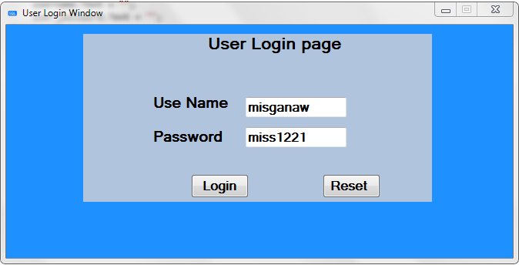
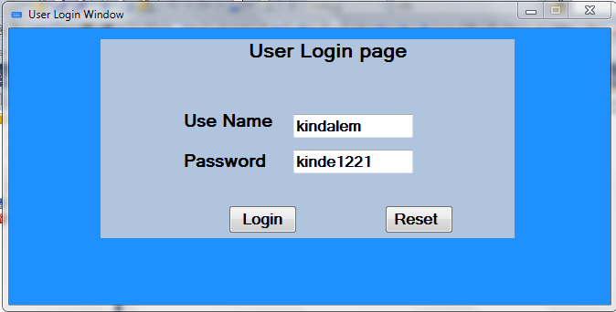
Form1.cs
using System;
using System.Collections.Generic;
using System.ComponentModel;
using System.Data;
using System.Drawing;
using System.Linq;
using System.Text;
using System.Windows.Forms;
using System.Data.SqlClient;
namespace WindowsFormsApplication3
{
public partial class Form1 : Form

{

public Form1()
{
InitializeComponent();

}

private void login_Click(object sender, EventArgs e)
{
SqlConnection con = new SqlConnection(" Data Source=FABOURIT-PC\\SQLEXPRESS;Initial Catalog=user_login;Integrated Security=True");
SqlDataAdapter sda = new SqlDataAdapter("SELECT count(*) FROM user_login where username='" + username.Text + "' and user_password='" + user_password.Text + "'", con);
DataTable dt = new DataTable();
sda.Fill(dt);
//username.Text=dt.Rows[0][0].ToString();
//password.Text=dt.Rows[0][1].ToString();
if (dt.Rows[0][0].ToString() == "1")
{
//this.Hide();
//Registration ss = new Registration();
//ss.Show();
SqlDataAdapter sda1 = new SqlDataAdapter("SELECT user_type FROM user_login where username='" + username.Text + "' and user_password='" + user_password.Text + "'", con);
DataTable dt1 = new DataTable();
sda1.Fill(dt1);
if (dt1.Rows[0][0].ToString() == "admin")
{
this.Hide();
Registration ss = new Registration();
ss.Show();
}
if (dt1.Rows[0][0].ToString() == "user")
{
this.Hide();
Customer_Data ss = new Customer_Data();
ss.Show();
}
}
else
{
MessageBox.Show("the user name and password are not correct");
}
}

private void Form1_Load(object sender, EventArgs e)
{

}

private void button2_Click(object sender, EventArgs e)
{
username.Text = "";
user_password.Text = "";
}
}
}

Registration.cis (design)
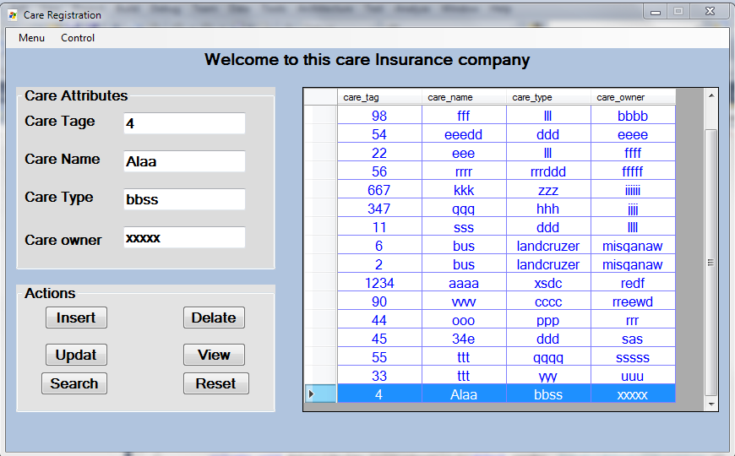

Registration.cs
using System;
using System.Collections.Generic;
using System.ComponentModel;
using System.Data;
using System.Drawing;
using System.Linq;
using System.Text;
using System.Windows.Forms;
using System.Data.SqlClient;
namespace WindowsFormsApplication3
{
public partial class Registration : Form
{
SqlConnection con = new SqlConnection(" Data Source=FABOURIT-PC\\SQLEXPRESS;Initial Catalog=user_login;Integrated Security=True");
public Registration()
{
InitializeComponent();
}
int selectedRow;
private void Registration_Load(object sender, EventArgs e)
{

}

private void insert_Click(object sender, EventArgs e)
{
con.Open();
SqlCommand cmd = con.CreateCommand();
cmd.CommandType = CommandType.Text;
cmd.CommandText = "insert into care values('" + care_tag.Text + "','" + care_name.Text + "','" + care_type.Text + "','" + care_owner.Text + "')";
cmd.ExecuteNonQuery();
con.Close();
care_tag.Text = "";
care_name.Text = "";
care_type.Text = "";
care_owner.Text = "";
display_data();
MessageBox.Show("Your recorde Inserted Successfully");
}
public void display_data()
{
con.Open();
SqlCommand cmd = con.CreateCommand();
cmd.CommandType = CommandType.Text;
cmd.CommandText = "select * from care ORDER BY care_owner ASC";
cmd.ExecuteNonQuery();
DataTable dt = new DataTable();
SqlDataAdapter sda = new SqlDataAdapter(cmd);
sda.Fill(dt);
datagrideview.DataSource = dt;
con.Close();

}

private void delete_Click(object sender, EventArgs e)
{
con.Open();
SqlCommand cmd = con.CreateCommand();
cmd.CommandType = CommandType.Text;
cmd.CommandText = "delete from care where care_tag='" + care_tag.Text + "'";
cmd.ExecuteNonQuery();
con.Close();
display_data();
MessageBox.Show("Your recorde Deleted Successfully");
}

private void update_Click(object sender, EventArgs e)
{
con.Open();
SqlCommand cmd = con.CreateCommand();
cmd.CommandType = CommandType.Text;
cmd.CommandText = "update care set care_name='" + care_name.Text + "', care_type='" + care_type.Text + "', care_owner='" + care_owner.Text + "' where care_tag='" + care_tag.Text + "'";
cmd.ExecuteNonQuery();
con.Close();
display_data();
MessageBox.Show("Your recorde Updated Successfully");
}

private void reset_Click(object sender, EventArgs e)
{
care_tag.Text = "";
care_name.Text = "";
care_type.Text = "";
care_owner.Text = "";
}

private void search_Click(object sender, EventArgs e)
{
con.Open();
SqlCommand cmd = con.CreateCommand();
cmd.CommandType = CommandType.Text;
cmd.CommandText = "select * from care where care_tag='" + care_tag.Text + "'ORDER BY care_owner ASC";
cmd.ExecuteNonQuery();
DataTable dt = new DataTable();
SqlDataAdapter sda = new SqlDataAdapter(cmd);
sda.Fill(dt);
datagrideview.DataSource = dt;
con.Close();
}

private void view_Click(object sender, EventArgs e)
{
display_data();
}

private void datagride_cell_click(object sender, DataGridViewCellEventArgs e)
{
selectedRow = e.RowIndex;
DataGridViewRow row= datagrideview.Rows[selectedRow];
care_tag.Text = row.Cells[0].Value.ToString();
care_name.Text = row.Cells[1].Value.ToString();
care_type.Text = row.Cells[2].Value.ToString();
care_owner.Text = row.Cells[3].Value.ToString();
}

private void datagrideview_CellContentClick(object sender, DataGridViewCellEventArgs e)
{

}

private void logoutToolStripMenuItem_Click(object sender, EventArgs e)
{
this.Hide();
Form1 ss = new Form1();
ss.Show();
}

private void customerToolStripMenuItem_Click(object sender, EventArgs e)
{
this.Hide();
Customer_Data ss = new Customer_Data();
ss.Show();
}

}
}

Costomer_Data.ce (design)
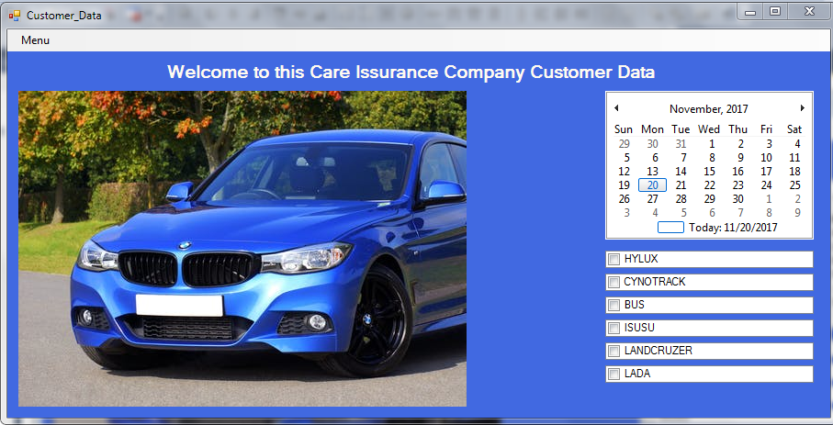
Customer_Data.cs
using System;
using System.Collections.Generic;
using System.ComponentModel;
using System.Data;
using System.Drawing;
using System.Linq;
using System.Text;
using System.Windows.Forms;

namespace WindowsFormsApplication3
{
public partial class Customer_Data : Form
{
public Customer_Data()
{
InitializeComponent();
}

private void logoutToolStripMenuItem_Click(object sender, EventArgs e)
{
this.Hide();
Form1 ss = new Form1();
ss.Show();
}

private void pictureBox1_Click(object sender, EventArgs e)
{

}

private void monthCalendar1_DateChanged(object sender, DateRangeEventArgs e)
{

}

private void checkedListBox1_SelectedIndexChanged(object sender, EventArgs e)
{

}

private void checkedListBox6_SelectedIndexChanged(object sender, EventArgs e)
{

}

private void checkedListBox5_SelectedIndexChanged(object sender, EventArgs e)
{

}

}
}

Embedded and Dynamic SQL
Embedded SQL
Enables a programmer to access a database from a general purpose programming language for at least two reasons:
- Not all queries can be expressed in SQL, since SQL does not provide the full expressive power of a general-purpose language. That is, there exist queries that can be expressed in a language such as C, c#, Java, or Cobol that cannot be expressed in SQL. To write such queries, we can embed SQL within a more powerful language
- Non declarative actions such as, printing a report, interacting with a user, or sending the results of a query to a graphical user interface cannot be done from within SQL. Applications usually have several components, and querying or updating data is only one component; other components are written in general-purpose programming languages. For an integrated application, the programs written in the programming language must be able to access the database.
A language in which SQL queries are embedded is referred to as a host language, and the SQL structures permitted in the host language constitute embedded SQL.
Static or Embedded SQL are SQL statements in an application that do not change at runtime and, therefore, can be hard-coded into the application. Dynamic SQL is SQL statements that are constructed at runtime; for example, the application may allow users to enter their own queries.

e.g. of embedded SQL
EXEC SQL
declare c cursor for
select *
from account
where branch-name = ‘Perryridge‘
END-EXEC

Dynamic SQL
The dynamic SQL component of SQL allows programs to construct and submit SQL queries at run time.
- In contrast, embedded SQL statements must be completely present at compile time; they are compiled by the embedded SQL preprocessor.
- Using dynamic SQL, programs can create SQL queries as strings at run time (perhaps based on input from the user) and can either have them executed immediately or have them prepared for subsequent use.
- Preparing a dynamic SQL statement compiles it, and subsequent uses of the prepared statement use the compiled version.
- SQL defines standards for embedding dynamic SQL calls in a host language, such
as C, as in the following example.
char * sqlprog = ”update account set balance = balance ∗1.05
where account-number = ?”
EXEC SQL prepare dynprog from :sqlprog;
char account[10] = ”A-101”;
EXEC SQL execute dynprog using :account;
Dynamic SQL is a programming technique that enables you to build SQL statements dynamically at runtime. You can create more general purpose, flexible applications by using dynamic SQL because the full text of a SQL statement may be unknown at compilation.

No | Embedded SQL | Dynamic SQL
1 | In static SQL how database will be accessed is predetermined in the compile | In dynamic SQL how database will be accessed is determined at run time
2 | It is more swift and efficient. | It is less swift and efficient.
3 | SQL statements are compiled at compile time. | SQL statements are compiled at run time.
4 | Parsing, validation, optimization, and generation of application plan are done at compile time. | Parsing, validation, optimization, and generation of application plan are done at run time.
5 | It is generally used for situations where data is distributed uniformly. | It is generally used for situations where data is distributed none uniformly.
6 | EXECUTE IMMEDIATE, EXECUTE and PREPARE statements are not used | EXECUTE IMMEDIATE, EXECUTE and PREPARE statements are used
7 | It is less flexible. | It is more flexible.

ODBC and JDBC
ODBC:
ODBC is used to provide connection between front-end application (other than java) and back-end (database like ms-access)
Architectures
The ODBC architecture consists of four components, as described in the following list.
- Application programming interface (API) Calls ODBC functions to connect to a data source, send and receive data, and disconnect.
- Driver manager Provides information to an application (such as a list of available data sources), loads drivers dynamically as they are needed, and provides argument and state transition checking.
- Driver Processes ODBC function calls and manages all exchanges between an application and a specific relational database. If necessary, the driver may translate the standard SQL syntax into the native SQL of the target data source.
- Data source Comprises the data and its associated database engine.
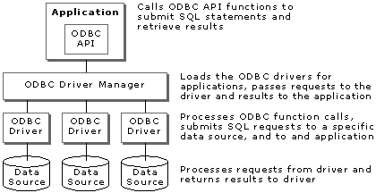

JDBC
JDBC is used to provide connection between JAVA application and database (oracle,sybase,DB2,ms-access)
The JDBC library includes APIs for each of the tasks mentioned below that are commonly associated with database usage.
- Making a connection to a database.
- Creating SQL or MySQL statements.
- Executing SQL or MySQL queries in the database.
- Viewing & Modifying the resulting records.
Architecture
JDBC API: This provides the application-to-JDBC Manager connection.
JDBC Driver API: This supports the JDBC Manager-to-Driver Connection.
The JDBC API: uses a driver manager and database-specific drivers to provide transparent connectivity to heterogeneous databases.
The JDBC driver manager: ensures that the correct driver is used to access each data source. The driver manager is capable of supporting multiple concurrent drivers connected to multiple heterogeneous databases.
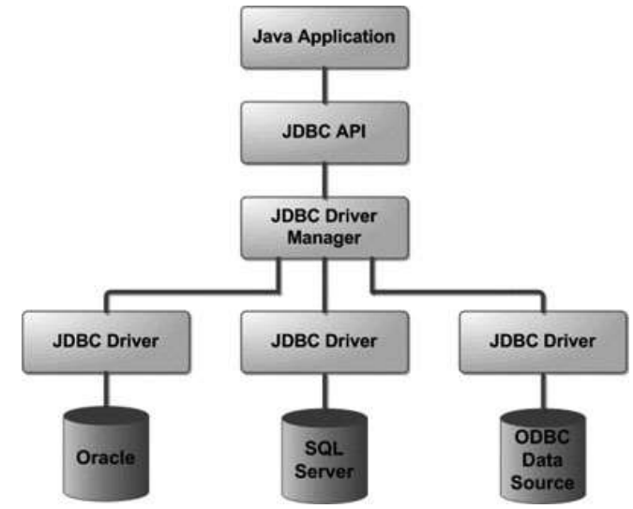
1. JDBC ─ Introduction
Chapter 6
Database security and integrity
Database security is about controlling access to information
- Some information should be available freely
- Other information should only be available to certain people or groups
Many aspects to consider for security
- Legal issues
- Physical security
- OS/Network security
- Security policies and protocols
- Encryption and passwords
- DBMS security
DBMS Security
DBMS can provide some security
- Each user has an account, username and password
- These are used to identify a user and control their access to information
DBMS verifies password and checks a user’s permissions when they try to
- Retrieve data
- Modify data
- Modify the database structure
Permissions and Privilege
SQL uses privileges to control access to tables and other database objects
- SELECT privilege
- INSERT privilege
- UPDATE privilege
- DELETE privilege
- The owner (creator) of a database has all privileges on all objects in the database, and can grant these to others
- The owner (creator) of an object has all privileges on that object and can pass them on to others
Privileges in SQL
GRANT <privileges>
ON <object>
TO <users>
[WITH GRANT OPTION]
- <privileges> is a list of SELECT <columns>, INSERT <columns>, DELETE, and UPDATE <columns>, or simply ALL
- <users> is a list of user names or PUBLIC
- <object> is the name of a table or view (later)
- WITH GRANT OPTION means that the users can pass their privileges on to others
Privileges Examples
GRANT ALL ON Employee
TO Manager
WITH GRANT OPTION
The user ‘Manager’ can do anything to the Employee table, and can allow other users to do the same (by using GRANT statements)
GRANT SELECT,
UPDATE (Salary) ON
Employee TO Finance
The user ‘Finance’ can view the entire Employee table, and can change Salary values, but cannot change other values or pass on their privilege.

Removing Privileges
- If you want to remove a privilege you have granted you use
REVOKE <privileges>
ON <object>
FROM <users>
- If a user has the same privilege from other users then they keep it
- All privileges dependent on the revoked one are also revoked
Example
- ‘Admin’ grants ALL privileges to ‘Manager’, and SELECT to ‘Finance’ with grant option
- ‘Manager’ grants ALL to Personnel
- ‘Finance’ grants SELECT to Personnel
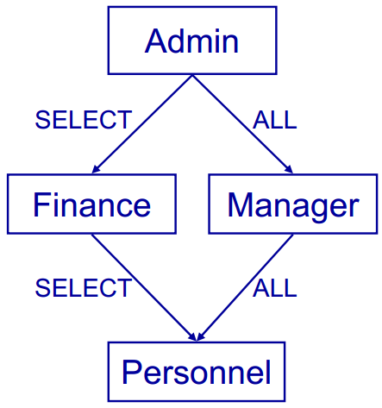

- Manager’ revokes ALL from ‘Personnel’. ‘Personnel’ still has SELECT privileges from ‘Finance’
- ‘Admin’ revokes SELECT from ‘Finance’. Personnel loses SELECT also
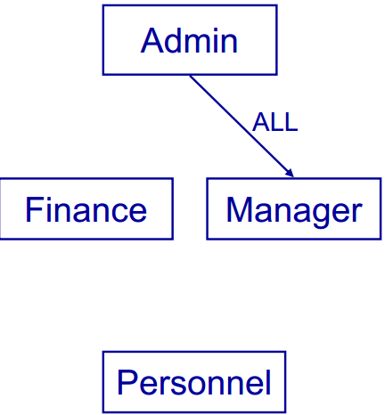
Views
Privileges work at the level of tables
- You can restrict access by column
- You cannot restrict access by row
Views, along with privileges, allow for customized access
- Views provide ‘derived’ tables
- A view is the result of a SELECT statement which is treated like a table
- You can SELECT from (and sometimes UPDATE etc) views just like tables
CREATE VIEW <name>
AS <select stmt>
- <name> is the name of the new view
- <select stmt> is a query that returns the rows and columns of the view
Example
- We want each user to be able to view the names and phone numbers (only) of those employees in their own department
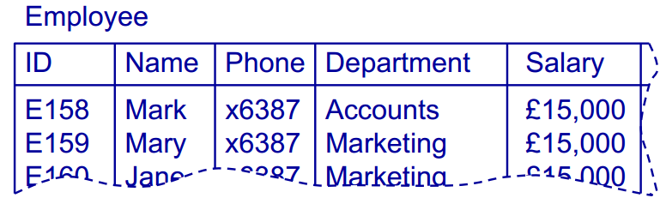

CREATE VIEW OwnDept AS
SELECT Name, Phone FROM Employee
WHERE Department = (SELECT Department FROM Employee WHERE name = USER)
GRANT SELECT ON OwnDept TO PUBLIC
Using Views and Privileges
Views and privileges are used together to control access
- A view is made which contains the information needed
- Privileges are granted to that view, rather than the underlying tables
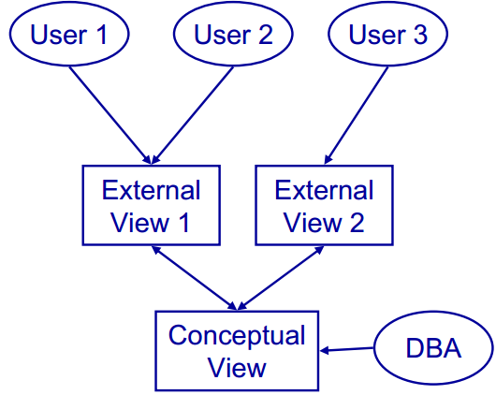
View Updating
Views are like virtual tables
- Their value depends on the ‘base’ tables that they are defined from
- You can select from views just like a table
- What about update, insert, and delete?
Updating views
- Updates to the base tables change the views and vice-versa
- It is often not clear how to change the base tables to make the desired change to the view
For a view to be updatable, the defining query of the view should satisfy certain conditions:
- Every element in SELECT is a column name
- Should not use DISTINCT
- View should be defined on a single table (no join, union, etc. used in FROM)
- WHERE should not have nested SELECTs
- Should not use GROUP BY or HAVING
To restrict someone's access to a table
- Create a view of that table that shows only the information they need to see
- Grant them privileges on the view
- Revoke any privileges they have on the original table
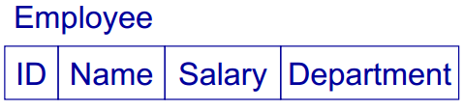
- We want to let the user 'John' read the department and name, and be able to update the department (only)
Create a view
CREATE VIEW for John
AS SELECT Name, Department FROM Employee

Set the privileges
GRANT SELECT,
UPDATE (Department) ON forJohn
TO John
REVOKE ALL ON Employee FROM John
Database Integrity
Security vs Integrity
- Database security makes sure that the user is authorised to access information
- Database integrity makes sure that (authorised) users use that information correctly
Integrity constraints
- Domain constraints apply to data types Attribute constraints apply to columns
- Relation constraints apply to rows in a single table
- Database constraints apply between tables
Domains and Attributes
- Domains constraints are data types
CREATE DOMAIN Colour VARCHAR(15) CONSTRAINT checkCol
CHECK (VALUE IN (‘RED’,‘Blue’…))
- Attributes are constrained by their domains
CREATE TABLE Rainbow ( Rorder Int, Rcolour Colour)
Assertions
- Provide a way to give relation and database constraints
- Give a Boolean condition that must always be true
- No action is permitted that would make the condition false
CREATE ASSERTION <name>
CHECK (<condition> )
- The condition can refer to one or several tables
- Often use EXISTS or NOT EXISTS
Relation Constraints
To create a relation constraint
- We simply make an assertion that checks the constraint
- Example: in an Employee table, no employee’s bonus should be more than 15% of their salary
CREATE ASSERTION
checkSalaryBonus
CHECK ( NOT EXISTS ( SELECT * FROM EMPLOYEE
WHERE (Bonus > 0.15*Salary) ))

Database Constraints
- Database constraints are similar but refer to several tables
- Example: Given tables student and enrolment, make sure no CS student takes more than 12 modules
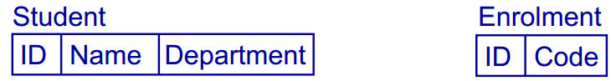
CREATE ASSERTION CSEnrolment CHECK
(NOT EXISTS (SELECT * FROM Student AS S
WHERE S.Department = ‘CS’ AND ((SELECT COUNT (*) FROM Enrolment AS E
WHERE S.ID = E.ID) > 12)))

