Embedded system Hardware training
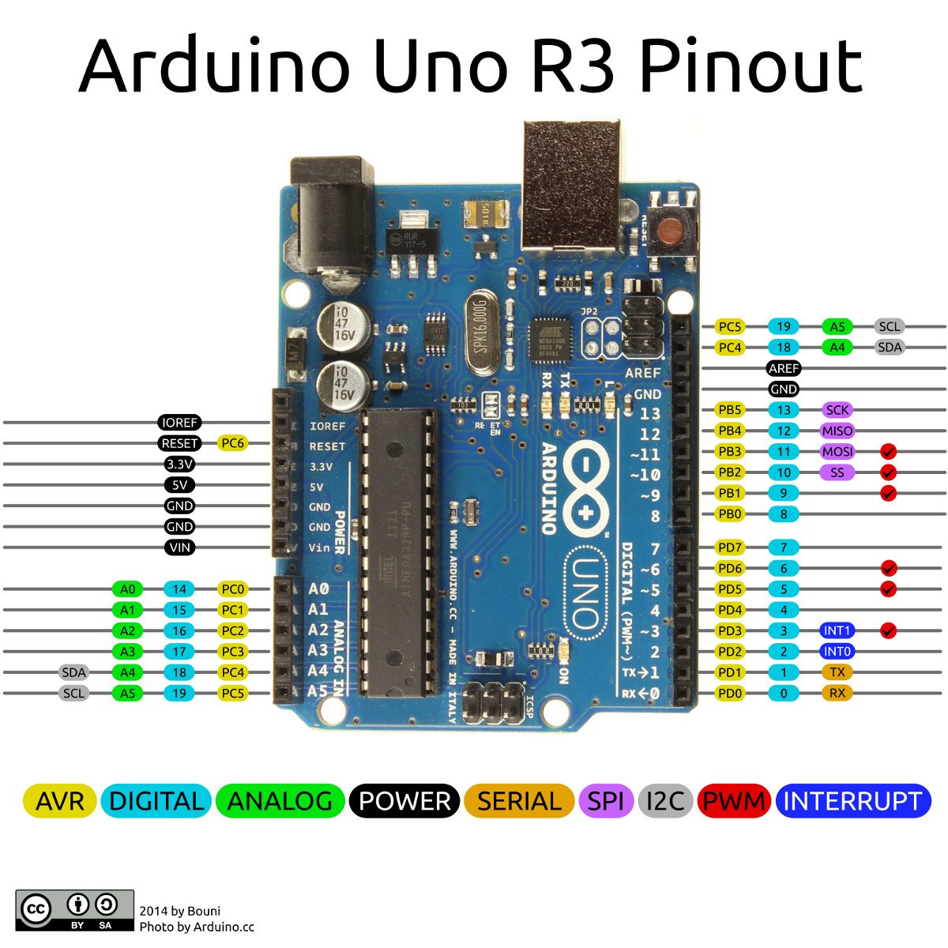

Objectives
- To install Arduino and Proteus IDE
- To integrate different sensors and Arduino microcontroller with proteus softwar
- To design different embedded system projects using proteus
- To write Arduino microcontroller instructions in Arduino IDE
- To integrate proteus design with Arduino code (instructions)
Arduino and proteus installation guide: https://www.youtube.com/watch?v=TGWWjQ-QSD4&list=PL96nIhJ9rAuocWTsmrrb_v7H2WPI28Q_g&index=17
You can get full Arduino and proteus tutorials in YouTube: https://www.youtube.com/@ethioptech/playlists in Aduino with proteus playlist
Steps in writing Arduino instructions
- Click on the file - new project or you can presssCTRL + N after opening Arduino IDE
- Save the project in any location you want. You can use CTRL + S to save
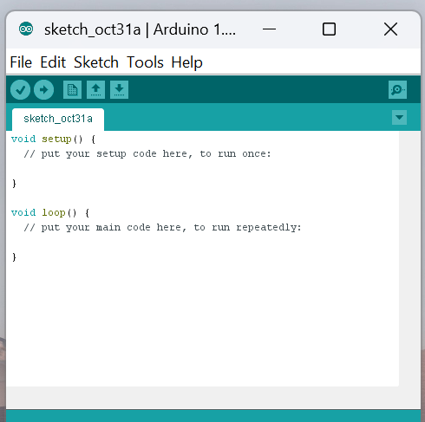
- To check the validity of your code, click on the right icon. To upload the code on the real Arduino, click on the right arrow.
- Please make sure that the following setting is available.
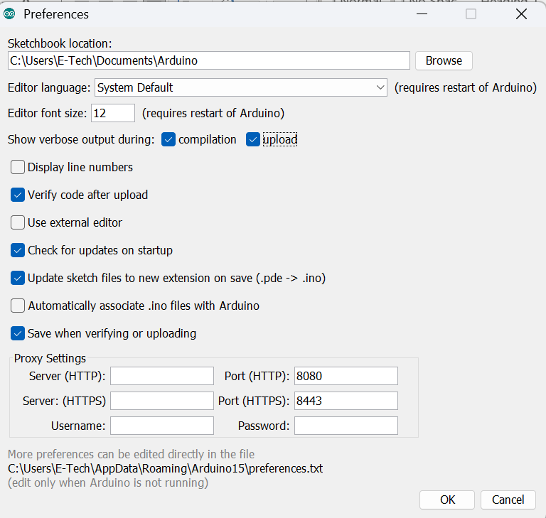
The sow verbose output during compilation and upload should be checked. To do so, click on file from the top left corner of active Arduino IDE - click on Preferences. Then you will get the above windows.
The verbose output used to get the .hex file to be uploaded on the Arduino microcontroller from Proteus design.
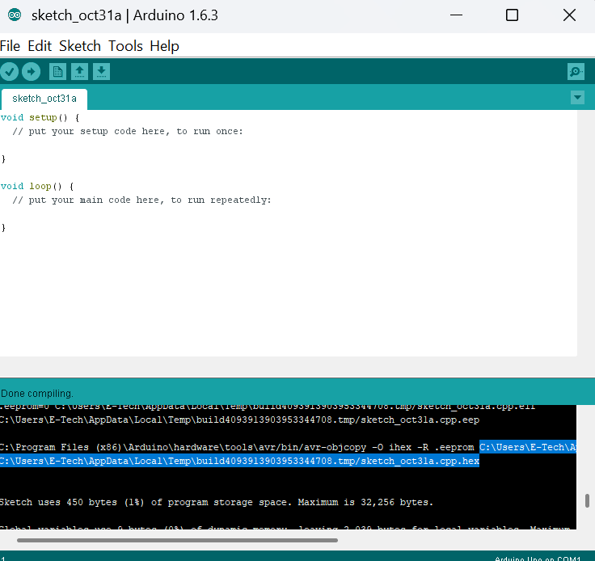
After writing you Arduino code, when click on the right icon, you will get the verbose out but like the above. Hence, to load the instruction to your microcontroller, you have to copy the file path with .hex file as indicated above.
- LED Blinking
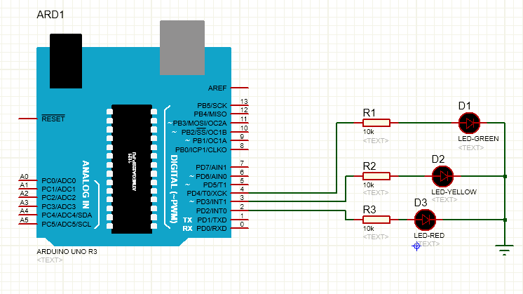
Arduino Instruction

#define GreenLed 4
#define YellowLed 3
#define RedLed 2
void setup() {
// put your setup code here, to run once:
pinMode(GreenLed, OUTPUT);
pinMode(YellowLed, OUTPUT);
pinMode(RedLed, OUTPUT);

}

void loop() {
// put your main code here, to run repeatedly:
digitalWrite(GreenLed, HIGH);
digitalWrite(YellowLed, LOW);
digitalWrite(RedLed, LOW);
delay(500);
digitalWrite(GreenLed, LOW);
digitalWrite(YellowLed, LOW);
digitalWrite(RedLed, HIGH);
delay(500);
digitalWrite(GreenLed, LOW);
digitalWrite(YellowLed, HIGH);
digitalWrite(RedLed, LOW);
delay(300)
- LED fade
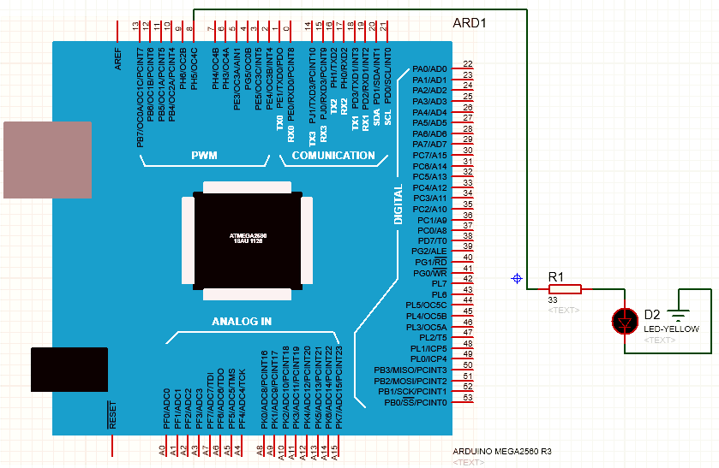
Arduino Instruction

int led = 8; // the PWM pin the LED is attached to
int brightness = 0; // how bright the LED is
int fadeAmount = 5; // how many points to fade the LED by
void setup() {
// put your setup code here, to run once:
pinMode(led, OUTPUT);
}

void loop() {
// put your main code here, to run repeatedly:
// set the brightness of pin 9:
analogWrite(led, brightness);
// change the brightness for next time through the loop:
brightness = brightness + fadeAmount;
// reverse the direction of the fading at the ends of the fade:
if (brightness == 0 || brightness == 255)
{
fadeAmount = -fadeAmount ;
}
// wait for 30 milliseconds to see the dimming effect
delay(300);
}

- Arduino Timer With LCD
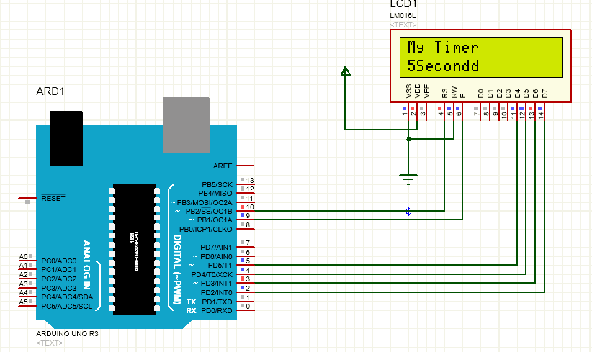
Arduino Instruction

#include <LiquidCrystal.h>
LiquidCrystal LCD(10,9,5,4,3,2);
int mycounter=0;
void setup() {
// put your setup code here, to run once:
LCD.begin(16,2);
LCD.setCursor(0,0);
LCD.print("My Timer");
}
void loop() {
// put your main code here, to run repeatedly:
for(mycounter=1; mycounter<=10; mycounter=mycounter+1){
LCD.setCursor(0,1);
LCD.print(mycounter);
LCD.print("Second");
delay(100);
}
for(mycounter=10; mycounter>=1; mycounter=mycounter-1){
LCD.setCursor(0,1);
LCD.print(mycounter);
LCD.print("Second");
delay(100);
}
}

- Arduino with DC Motor
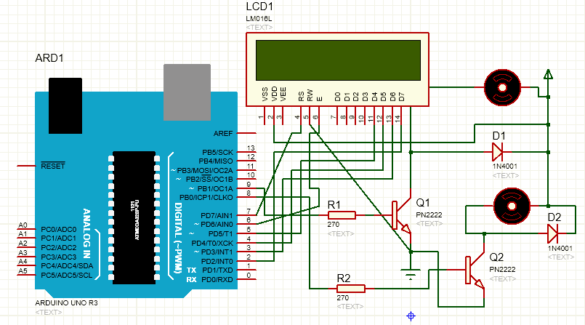
Arduino instruction

#include <LiquidCrystal.h>
LiquidCrystal LCD(7,6,5,4,3,2);
#define motorpin 9
#define motorp 8
void setup() {
// put your setup code here, to run once:
pinMode(motorpin,OUTPUT);
pinMode(motorp,OUTPUT);
LCD.begin(16,2);
LCD.setCursor(0,0);
LCD.print("Motor Detection");
}
void loop() {
// put your main code here, to run repeatedly:
digitalWrite(motorpin,LOW);
delay(100);
digitalWrite(motorpin,HIGH);
digitalWrite(motorp,LOW);
LCD.setCursor(0,1);
LCD.print("MOTOR1 Start");
delay(800);
digitalWrite(motorpin,LOW);
LCD.setCursor(0,1);
LCD.print("M1_Stop");
delay(100);
digitalWrite(motorp,HIGH);
LCD.setCursor(0,1);
LCD.print("MOTOR2 Start");
delay(800);
}

- DC Motor Direction Control
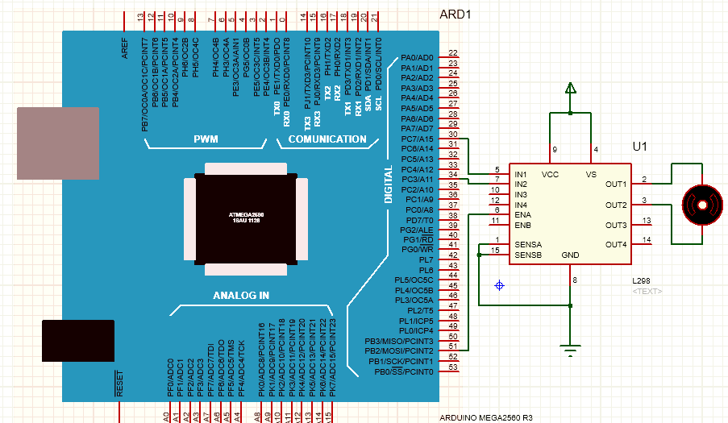
Arduino instruction

#define in1 30
#define in2 34
#define ena 51
void setup() {
// put your setup code here, to run once:
pinMode(in1,OUTPUT);
pinMode(in2,OUTPUT);
pinMode(ena,OUTPUT);
}
void loop() {
// put your main code here, to run repeatedly:
//For Clock wise motion , in_1 = High , in_2 = Low
digitalWrite(in1,HIGH) ;
digitalWrite(in2,LOW) ;
analogWrite(ena,255) ;
//Clockwise for 3 secs
delay(3000) ;
//For brake
digitalWrite(in1,HIGH) ;
digitalWrite(in2,HIGH) ;
delay(1000) ;
//For Anti Clock-wise motion - IN_1 = LOW , IN_2 = HIGH
digitalWrite(in1,LOW) ;
digitalWrite(in2,HIGH) ;
delay(3000) ;
//For brake
digitalWrite(in1,HIGH) ;
digitalWrite(in2,HIGH) ;
delay(1000) ;
}

- Servo Motor Direction Control
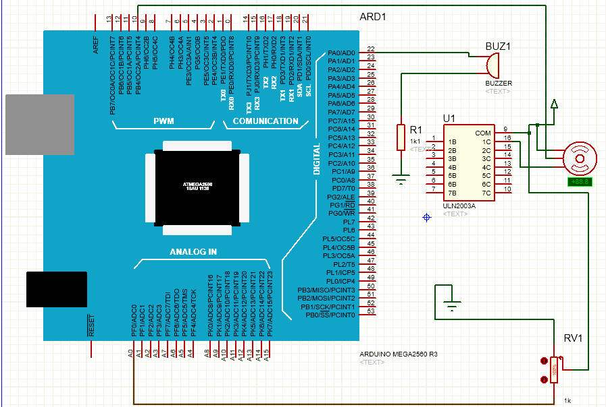
Arduino instruction

#include <Servo.h>
#define b 22
Servo myservo; // create servo object to control a servo
int potpin = 0; // analog pin used to connect the potentiometer
int val=0; // variable to read the value from the analog pin
int servodelay=25;
void setup() {
// put your setup code here, to run once:
myservo.attach(10);
pinMode(b,OUTPUT);
}

void loop() {
// put your main code here, to run repeatedly:
for(val=15; val<=170; val=val+1){
myservo.write(val); // sets the servo position according to the scaled value
delay(servodelay);
}
for(val=180; val>=15; val=val-1){
myservo.write(val); // sets the servo position according to the scaled value
delay(servodelay);
}
digitalWrite(b,HIGH);
delay(15);
}

- Motion detection with PIR
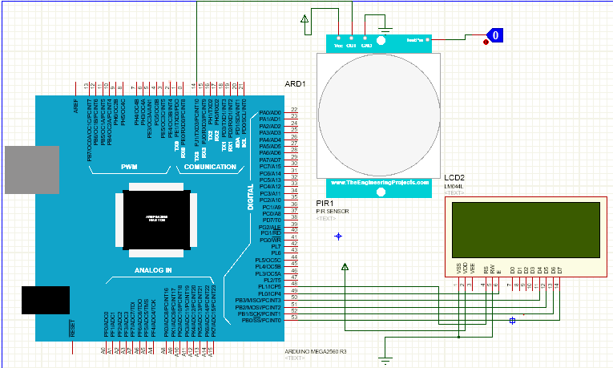
Arduino instruction

#include <LiquidCrystal.h>
LiquidCrystal LCD(48,49,50,51,52,53);
void setup() {
// put your setup code here, to run once:
LCD.begin(20,4);
}
void loop() {
// put your main code here, to run repeatedly:
int pirpin=digitalRead(14);
LCD.setCursor(0,0);
LCD.print("Study PIR");
if(pirpin==LOW){
LCD.setCursor(0,1);
LCD.print("HELLO");
delay(2);
LCD.clear();
}
else if(pirpin==HIGH){
LCD.setCursor(0,1);
LCD.print(" WLCOME");
delay(2);
LCD.clear();
}
}

- Distance measurement using Ultrasonic sensor
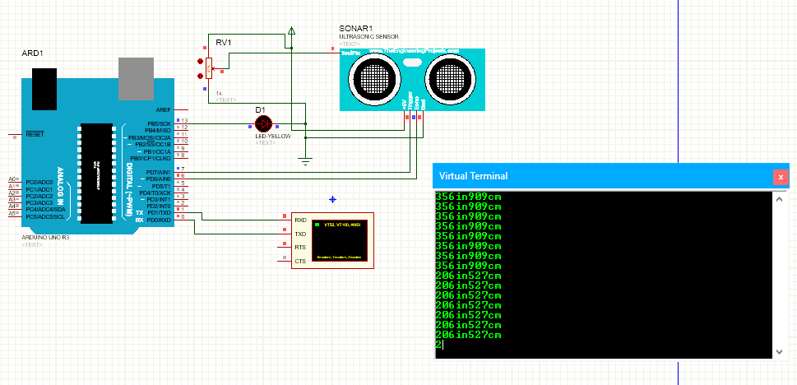
Arduino instruction

#define ledpin 13
const int pingPin = 7; // Trigger Pin of Ultrasonic Sensor
const int echoPin = 6; // Echo Pin of Ultrasonic Sensor
void setup()
{
Serial.begin(9600); // Starting Serial Terminal
pinMode(echoPin, INPUT);
pinMode(pingPin, OUTPUT);
pinMode(ledpin, OUTPUT);
}
void loop()
{
long duration, inches, cm;
digitalWrite(pingPin, LOW);
delayMicroseconds(2);
digitalWrite(pingPin, HIGH);
delayMicroseconds(10);
digitalWrite(pingPin, LOW);
duration = pulseIn(echoPin, HIGH);
inches = microsecondsToInches(duration);
cm = microsecondsToCentimeters(duration);
Serial.print(inches);
Serial.print("in");
Serial.print(cm);
Serial.print("cm");
Serial.println();

delay(100);
}
long microsecondsToInches(long microseconds)
{
return microseconds / 74 / 2;
}
long microsecondsToCentimeters(long microseconds)
{
return microseconds / 29 / 2;
}

- Alarm system using Ultrasonic Sensor and Buzzer
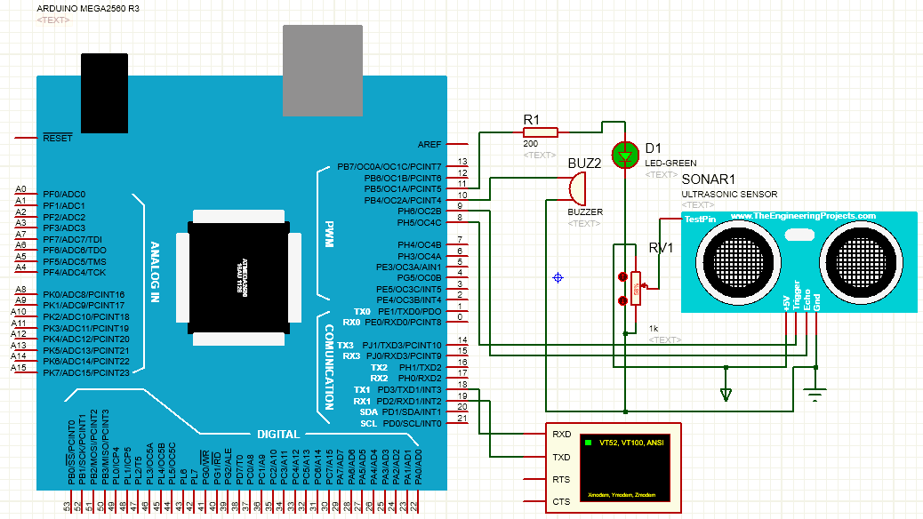

Arduino Instruction

#define trigpin 8
#define echopin 9
#define buzzer 10
#define ledpin 11
long duration;
int distance;
int alarm;
void setup() {
// put your setup code here, to run once:
Serial.begin(9600);
pinMode(8,OUTPUT);
pinMode(9,INPUT);
pinMode(10,OUTPUT);
pinMode(11,OUTPUT);
}

void loop() {
// put your main code here, to run repeatedly:
digitalWrite(trigpin,LOW);
delayMicroseconds(2);
digitalWrite(trigpin,HIGH);
delayMicroseconds(20);
digitalWrite(trigpin,LOW);
duration=pulseIn(echopin,HIGH);
distance=duration*0.034/2;
alarm=distance;
if(alarm<=5){
digitalWrite(buzzer,HIGH);
digitalWrite(ledpin,HIGH);
}
else{
digitalWrite(buzzer,LOW);
digitalWrite(ledpin,LOW);
}
Serial.print("Distance of object: ");
Serial.println(distance);
}

- Control Servo Motor with Joystick
#include <Servo.h>
Servo joyservo;
int joyX= 0;
int joyY=1;
int joystick_value;
void setup() {
// put your setup code here, to run once:
joyservo.attach(14);
}
void loop() {
// put your main code here, to run repeatedly:
joystick_value=analogRead(joyX);
joystick_value=map(joystick_value, 0, 1023, 0, 180);
joyservo.write(joystick_value);
}

