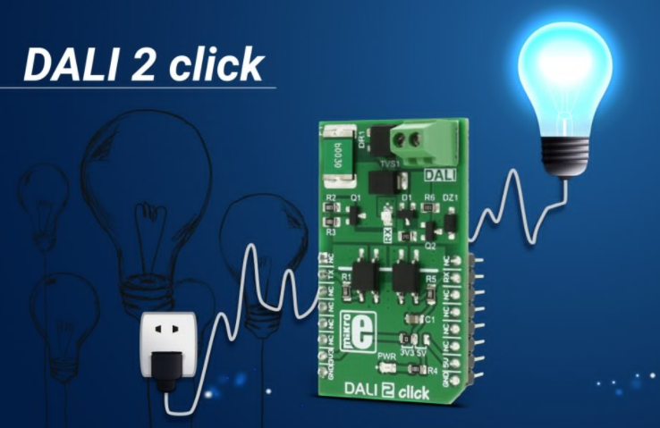

EMBEDDED SYSTEM MODUL PREPARED 2010
Introduction
System
- A system is an arrangement in which all its unit assemble work together according to a set of rules.
- It can also be defined as a way of working, organizing or doing one or many tasks according to a fixed plan
- For example, a watch is a time displaying system. Its components follow a set of rules to show time. If one of its parts fails, the watch will stop working. So we can say, in a system, all its subcomponents depend on each other.
Embedded system
- in it. An embedded system can be an independent system or it can be a part of a large system. An embedded system is a microcontroller or microprocessor based system which is designed to perform a specific task.
- we can define an embedded system as a Microcontroller based, software driven, reliable,
real-time control system.
- Embedded systems (ES) = information processing systems embedded into a larger product
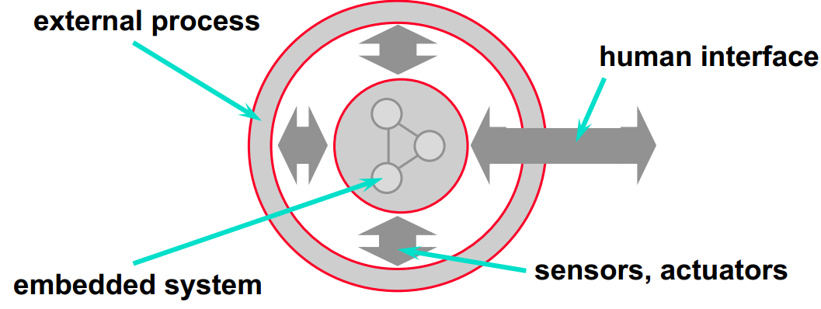

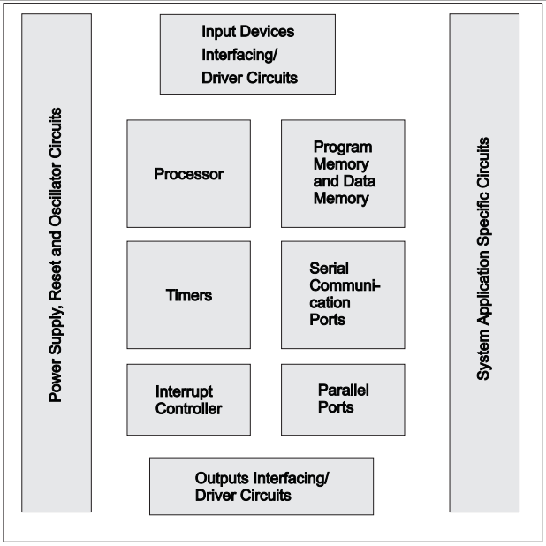
Examples of embedded systems
- a fire alarm is an embedded system; it will sense only smoke.
- Car as an integrated control-, communication and information system. ABS gear box motor

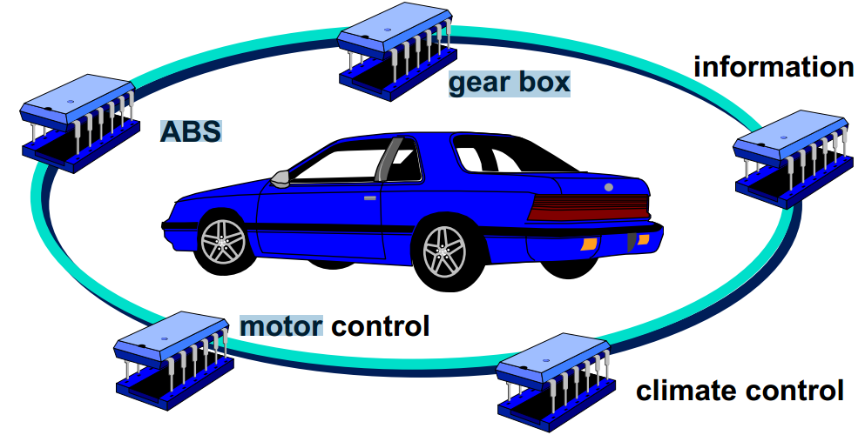
- Consumer electronics, for example MP3 Audio, digital camera, home electronics, … .
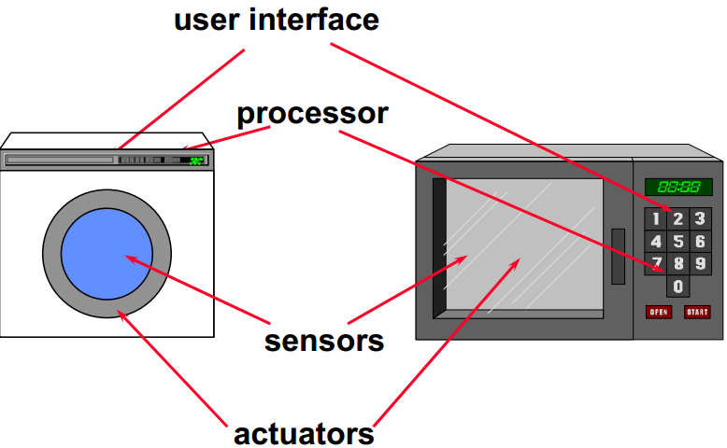
- Information systems, for example wireless communication (mobile phone, Wireless LAN, …), end-user equipment, router, …
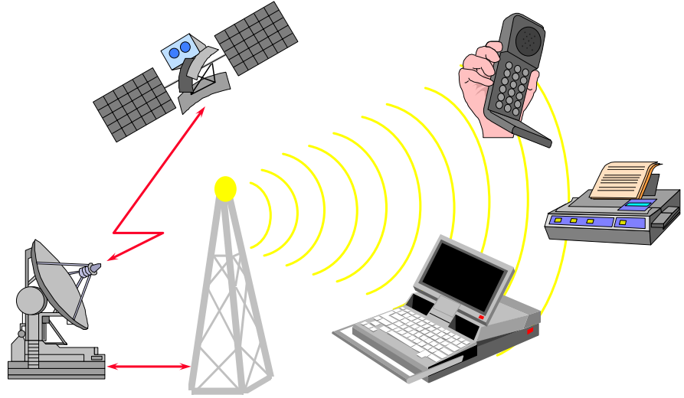
- Different production system like, brewery, coca cola, paper, cloth, Electronics and other a lot of fabrics are operated by embedded system
- Calculator, mobile, television, lift, equipment tracking system at laboratory, automatic door opening and closing which is available in our country Ethiopian around bole and so on… are example of embedded system
- Different types of robot are the result of embedded system
- Radar system, nuclear bomb, drone which is image and video capturing on space
Components of embedded system
Embedded system has three components:
- It has hardware.
Processors, Timers, Interrupt controller, I/O Devices, Memories, Ports, etc.
- It has application software.
Which may perform concurrently the series of tasks or multiple tasks?
- It has Real Time Operating system (RTOS)
That supervises the application software and provides mechanism to let the processor run a process as per scheduling by following a plan to control the latencies. RTOS defines the way the system works. It sets the rules during the execution of application program. A small scale embedded system may not have RTOS.
Characteristics of embedded system
Single-functioned – An embedded system usually performs a specialized operation and does the same repeatedly. For example: A pager always functions as a pager.
Tightly constrained – All computing systems have constraints on design metrics, but those on an embedded system can be especially tight. Design metrics is a measure of an implementation's features such as its cost, size, power, and performance. It must be of a size to fit on a single chip, must perform fast enough to process data in real time and consume minimum power to extend battery life.
Reactive and Real time – Many embedded systems must continually react to changes in the system's environment and must compute certain results in real time without any delay. Consider an example of a car cruise controller; it continually monitors and reacts to speed and brake sensors. It must compute acceleration or de-accelerations repeatedly within a limited time; a delayed computation can result in failure to control of the car.
Microprocessors based – It must be microprocessor or microcontroller based.
Memory – It must have a memory, as its software usually embeds in ROM. It does not need any secondary memories in the computer.
Connected – It must have connected peripherals to connect input and output devices.
HW-SW systems – Software is used for more features and flexibility. Hardware is used for performance and security.
Advantages
- Easily Customizable
- Low power consumption
- Low cost
- Enhanced performance
Disadvantages
- High development effort
- Larger time to market

Embedded systems
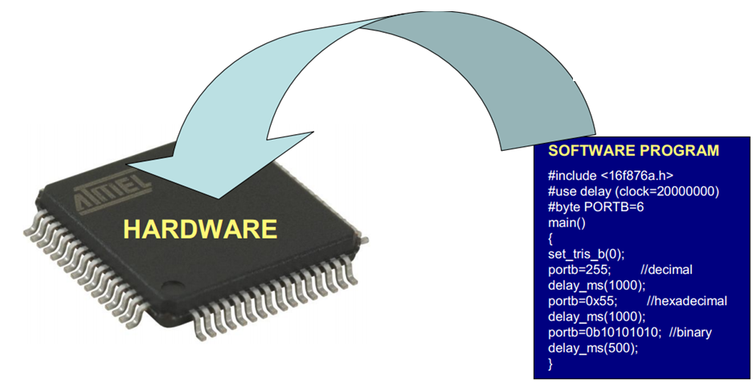
General purpose computing
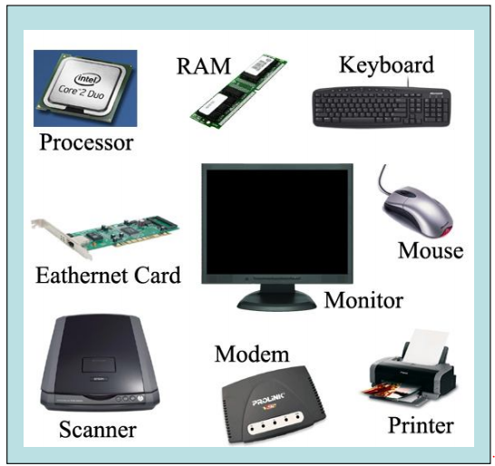
 | Embedded systems | General purpose computing
1 | Few applications that are known at design-time. | Broad class of applications.
2 | Not programmable by enduser. | Programmable by end user.
3 | Fixed run-time requirements (additional computing power not useful). | Faster is better.
Basic structure of embedded system

The following illustration shows the basic structure of an embedded system:
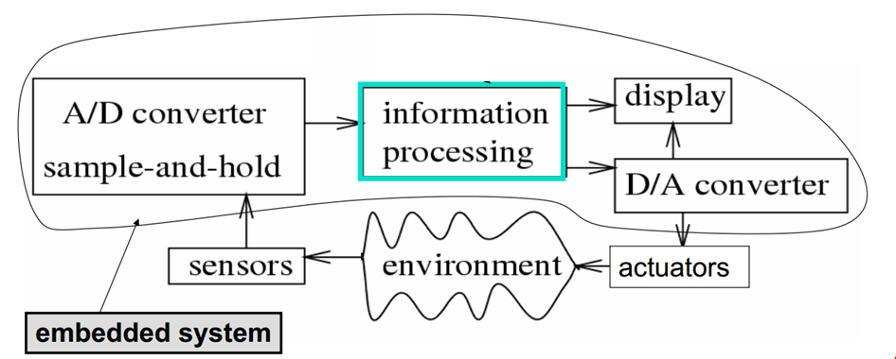
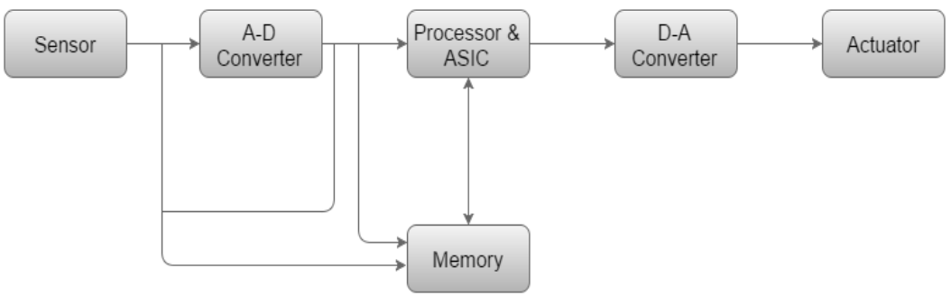
OR

Sensor – It measures the physical quantity and converts it to an electrical signal which can be read by an observer or by any electronic instrument like an A2D converter. A sensor stores the measured quantity to the memory.
A-D Converter – An analog-to-digital converter converts the analog signal sent by the sensor into a digital signal.
Processor & ASICs – Processors process the data to measure the output and store it to the memory.
D-A Converter – A digital-to-analog converter converts the digital data fed by the processor to analog data.
Actuator – An actuator compares the output given by the D-A Converter to the actual (expected) output stored in it and stores the approved output.
EMBEDDED SYSTEM CONSTRAINTS
An embedded system is software designed to keep in view three constraints:
- Available system memory
- Available processor speed
- The need to limit the power dissipation
When running the system continuously in cycles of wait for events, run, stop and wakeup.
What makes embedded systems different?

- Real-time operation
- Size
- Cost
- Time
- Reliability
- Safety
- Energy
- Security

CLASSIFICATIONS OF EMBEDDED SYSTEM
- Small Scale Embedded System
- Single 8 bit or 16bit Microcontroller.
- Little hardware and software complexity.
- They May even be battery operated.
- Usually “C” is used for developing this system.
- The need to limit power dissipation when system is running continuously.
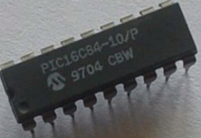
MEDIUM SCALE EMBEDDED SYSTEM
- Single or few 16 or 32 bit microcontrollers or Digital Signal Processors (DSP) or Reduced Instructions Set Computers (RISC).
- Both hardware and software complexity.
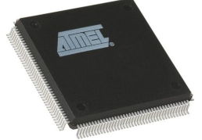
SOPHISTICATED EMBEDDED SYSTEM
- Enormous hardware and software complexity
- Which may need scalable processor or configurable processor and programming logic arrays?
- Constrained by the processing speed available in their hardware units.
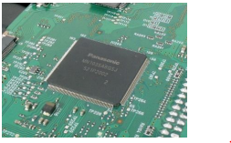

Chapter Two
Embedded Microcontroller
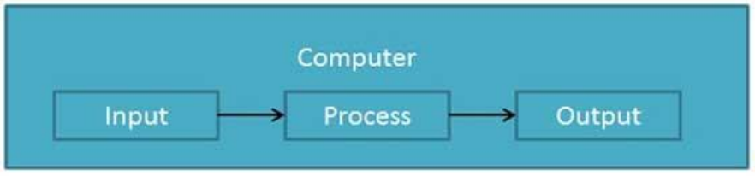
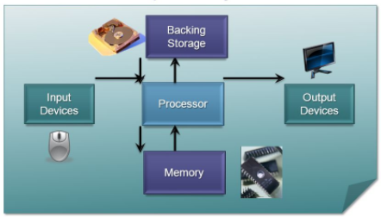
Processor
A Processor is the heart of the Embedded System.
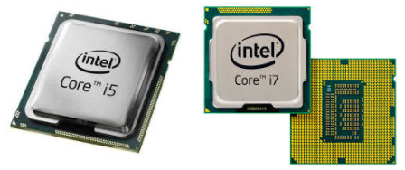

A processor has two essential units:
- Control Unit (CU)
- Execution Unit (EU)
The CU includes a fetch unit for fetching instructions from the memory. The EU has circuits that implement the instructions pertaining to data transfer operation and data conversion from one form to another.
The EU includes the Arithmetic and Logical Unit (ALU) and also the circuits that execute
instructions for a program control task such as interrupt, or jump to another set of instructions.
Types of processers
Processors can be of the following categories:
- General Purpose Processor (GPP)
- Microprocessor
- Microcontroller
- Embedded Processor
- Digital Signal Processor
- Media Processor
- Application Specific System Processor (ASSP)
- Application Specific Instruction Processors (ASIPs)
- GPP core(s) or ASIP core(s) on either an Application Specific Integrated Circuit (ASIC) or a Very Large Scale Integration (VLSI) circuit
Microprocessor
A microprocessor is a single chip semiconductor device also which is a computer on chip, but not a complete computer.
Its CPU contains an ALU, a program counter, a stack pointer, some working register, a clock timing circuit and interrupts circuit on a single chip.
To make complete microcomputer, one must add memory usually ROM and RAM, memory decoder, an oscillator and a number of serial and parallel ports.
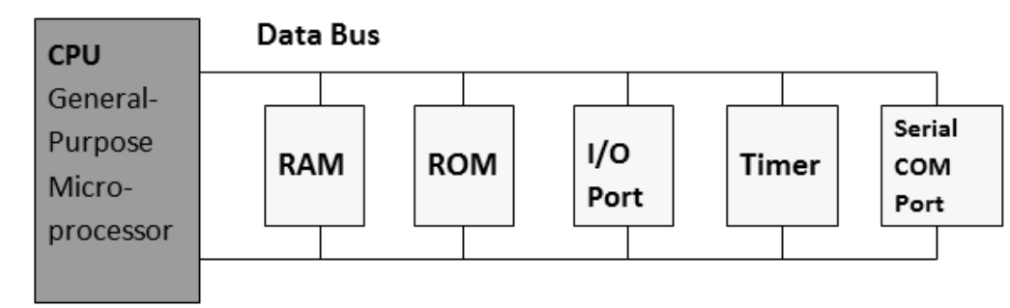
Microcontroller
A microcontroller is a functional computer system-on-a-chip. It contains a
processor, memory, and programmable input/output peripherals.
- Microcontrollers include an integrated CPU, memory (a small amount of RAM, program memory, or both) and peripherals capable of input and output.
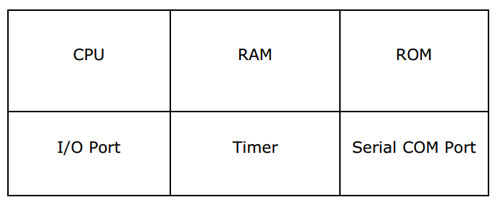
Various microcontrollers
Intel
8031,8032,8051,8052,8751,8752
pic
8-bit pic16, pic18, 16-bit dspic33 / pic24, pic16c7x
Motorola
mc68hc11
Microprocessor vs microcontroller
Microprocessor | Microcontroller
The functional blocks are ALU, registers, timing & control units | It includes functional blocks of microprocessors & in addition has timer, parallel i/o, RAM, EPROM, ADC & DAC
Bit handling instruction is less, One  or two type only | Many type of bit handling instruction
Rapid movements of code and data between external memory & MP | Rapid movements of code and data within MC
It is used for designing general purpose digital computers system | They are used for designing application specific dedicated systems

Embedded processor
Special microprocessors & microcontrollers often called, Embedded processors.
An embedded processor is used when fast processing fast context-switching & atomic
ALU operations are needed.
Examples: ARM 7, INTEL i960, AMD 29050.
Digital signal processor
DSP as a GPP is a single chip VLSI unit.
- It includes the computational capabilities of microprocessor and multiply & accumulate units (MAC).
- DSP has large number of applications such as image processing, audio, video & telecommunication processing systems.
- It is used when signal processing functions are to be processed fast.
Examples : TMS320Cxx, SHARC, Motorola 5600xx

Application specific system processor (assp)
ASSP is dedicated to specific tasks and provides a faster solution. An ASSP is used as an additional processing unit for running the application in place of using embedded software.
Examples: IIM7100, W3100A
Multi-processor system using (gpps)
- Multiple processors are used when a single processor does not meet the
needs of different task.
- The operations of all the processors are synchronized to obtain an optimum
performance.
Benefits of Microcontroller

- Faster speed

- Lower cost

- Easier and quicker development
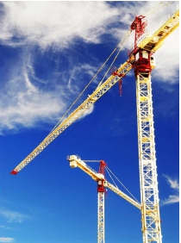

- Easy to coding
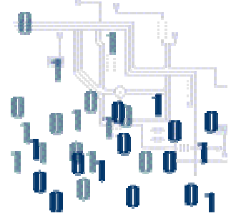

- Fast design and development

Chapter three

