Laboratory Manual for PIC18F458 Using Assembly Language

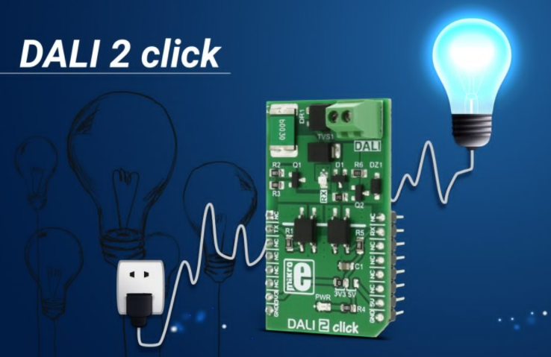

Prepared By: Misganaw A

Installations
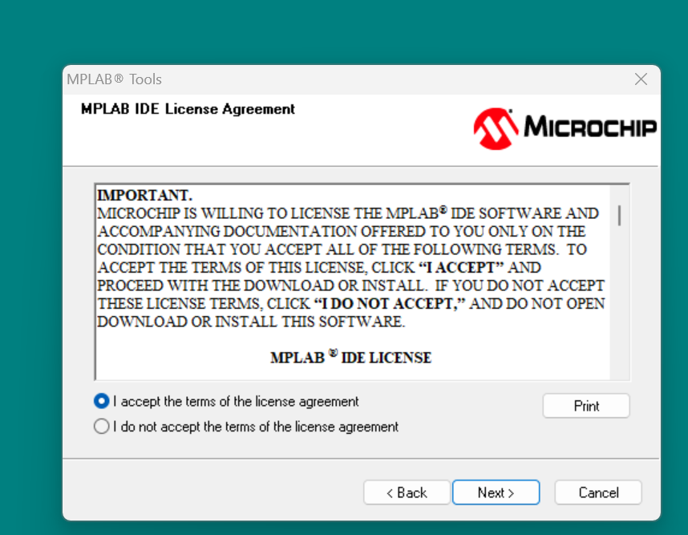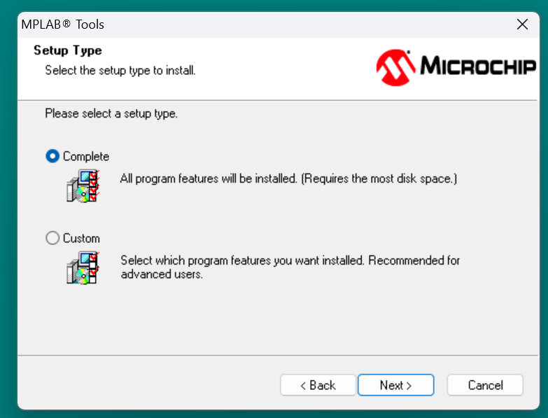

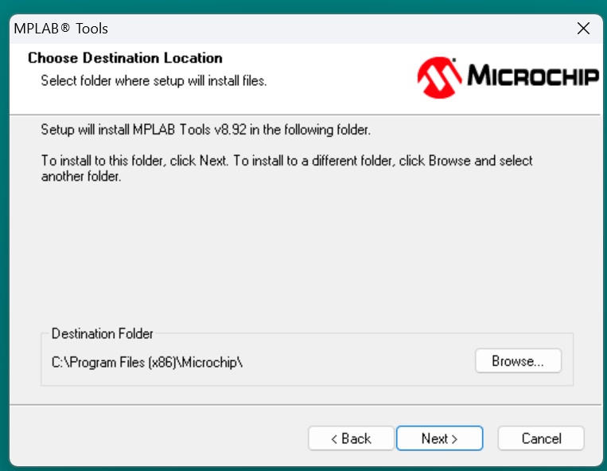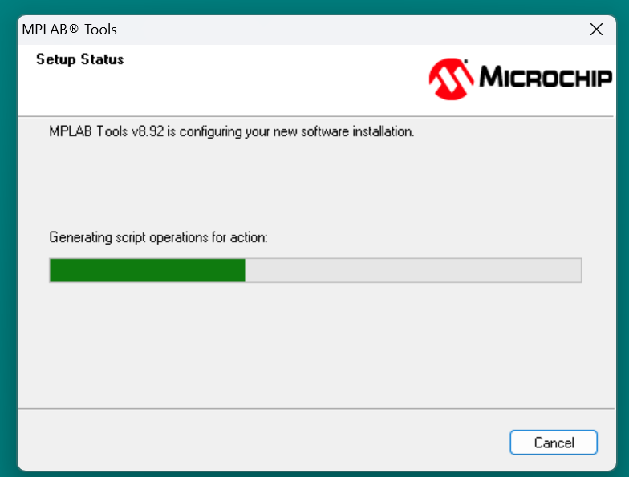

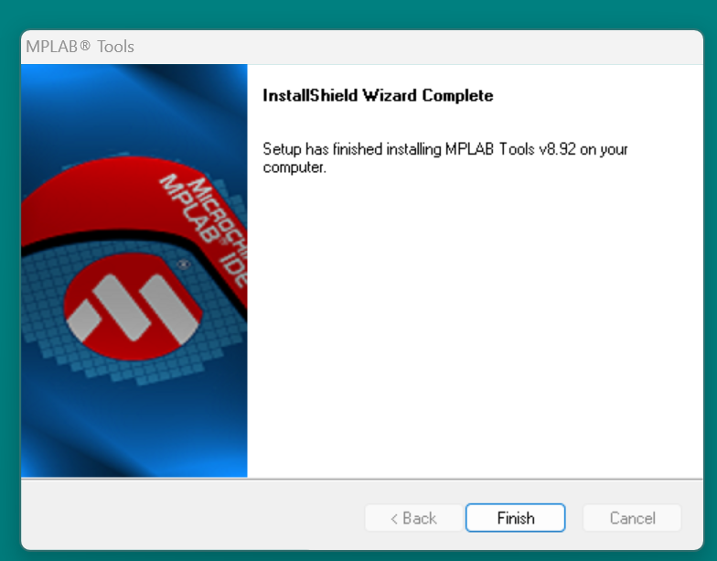

Introduction
The PIC18F458458 series of microcontrollers, developed by Microchip Technology, are widely used for embedded system applications. These microcontrollers have a rich instruction set, ample RAM and program memory, and various peripherals, which make them suitable for a broad range of tasks.
This manual is designed for students or engineers learning assembly language programming for the PIC18F458458 microcontroller. It includes a series of experiments with detailed explanations of the instructions, configurations, and hardware interfacing.

Objective
To develop a practical understanding of how to use assembly language to program the PIC18F458458 microcontroller and interface it with various external hardware, such as LEDs, switches, and motors.

Before starting writing any Assembly language, you have to first do two thing
- Crating .asm file and
- Creating a project and add the .asm file into the project.
Procedures to create .asm file
- Click on the file menu click on new. Then you will get the following screen.
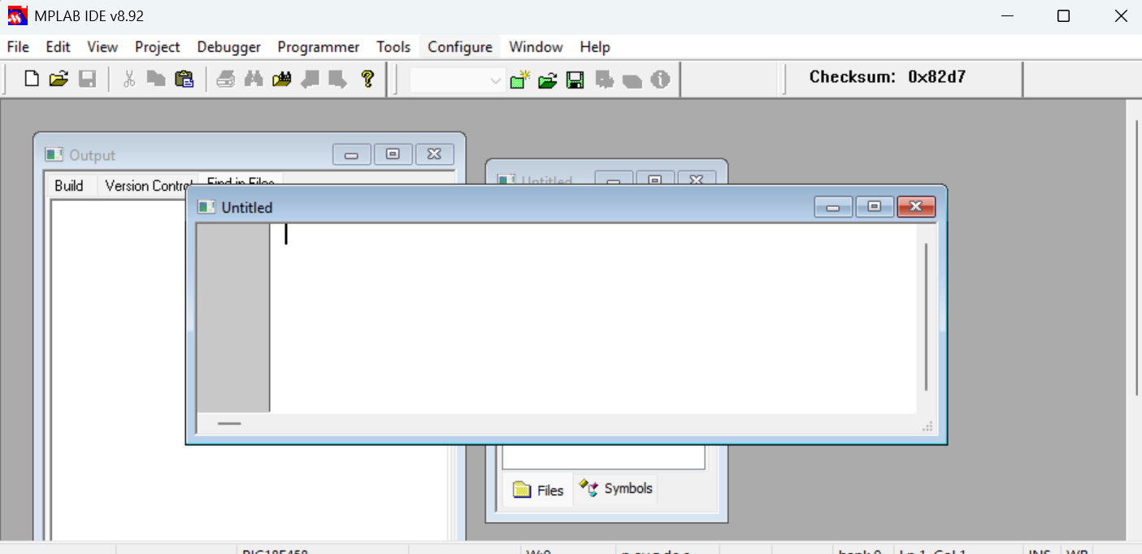
- In side the active dialogue window, write or put your assembly language program and press CTRL + S to save the .asm file. When creating a file, make sure that you add .asm extension. You can save the file any location in your computer.
Steps to create project
- Got project click on project wizard. You will get the following screen. When you click on next, you will get the right-side screen to select the type of PIC family.
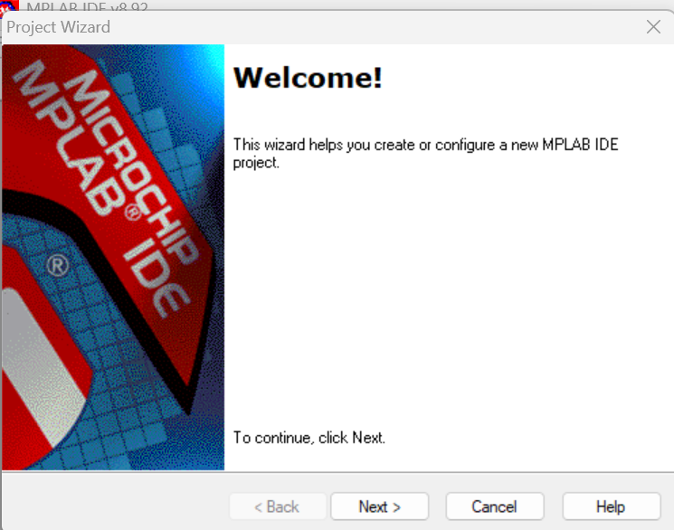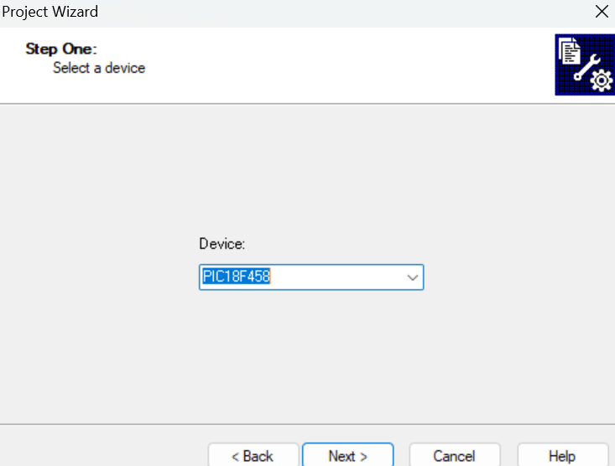
- Click next and you will get the following screen. Now simply click on next. You will get the right-side screen. Then select (rowse) the directory of folder where the projet will be saved. Remember that the .asm file and the project should be saved in the same folder. So, you have to select the folder where the .asm file was saved before.
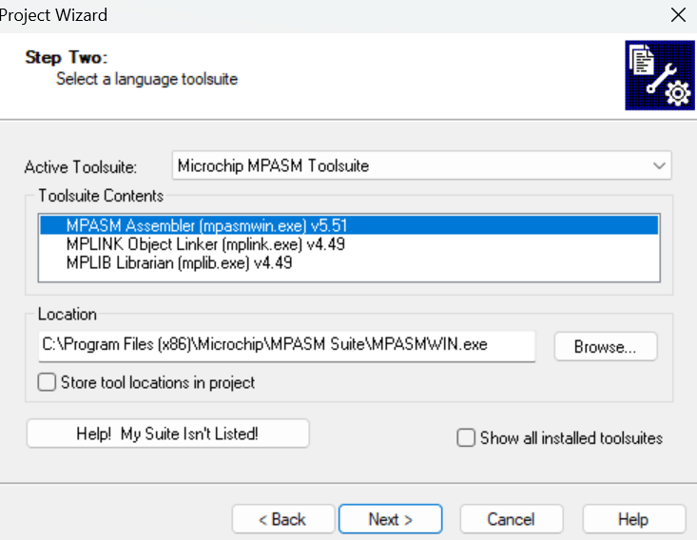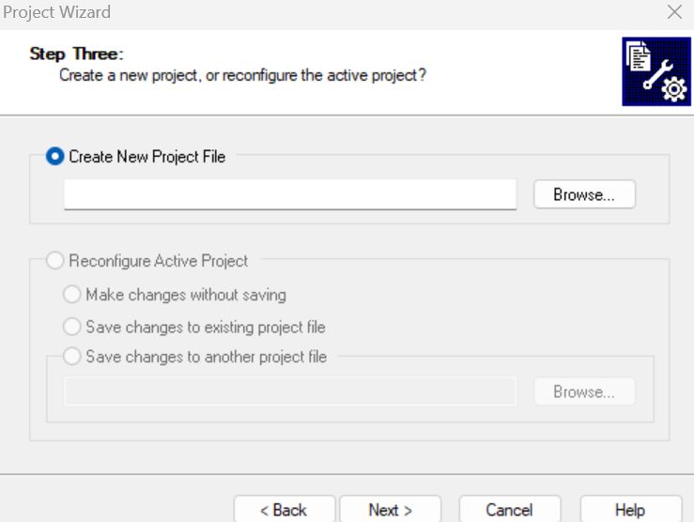
- Click on next and then you will get the following screen on which you will provide the project name. remember, you can give any name and adding extension is not necessary here. After giving the project name, do not forget clicking on Save button.
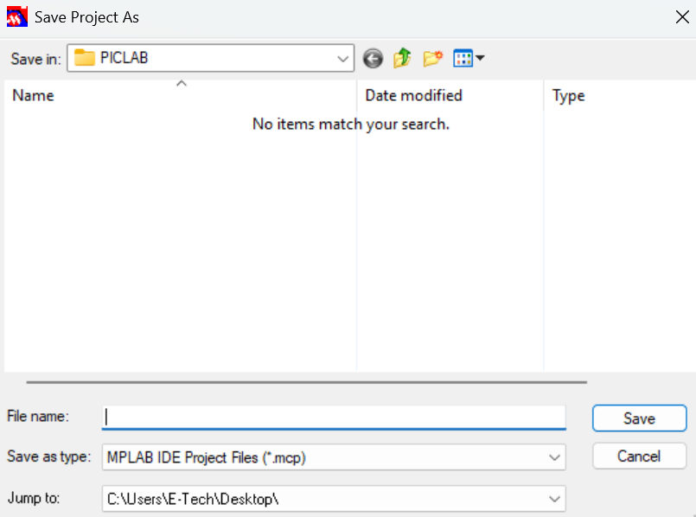
- While finishing the project creation, the following screen will be appeared. Select the .asm file and click on Add button. So, the file path will be appeared at the right Pannel. After that click on next then finish. Bravo, now you will successfully create your MPLAB project.
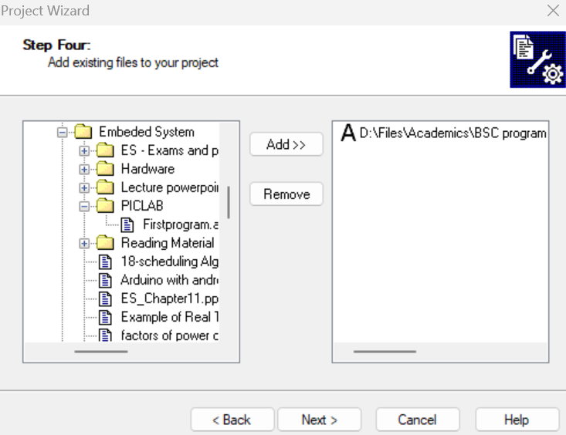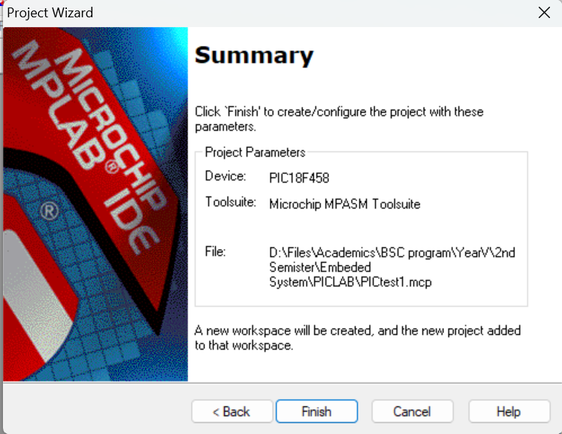
After completing your project setup, you will get the screen as follows. Double click on the .asm file, the file will be ready for assembly code writing or the code will be active if you already written the code.
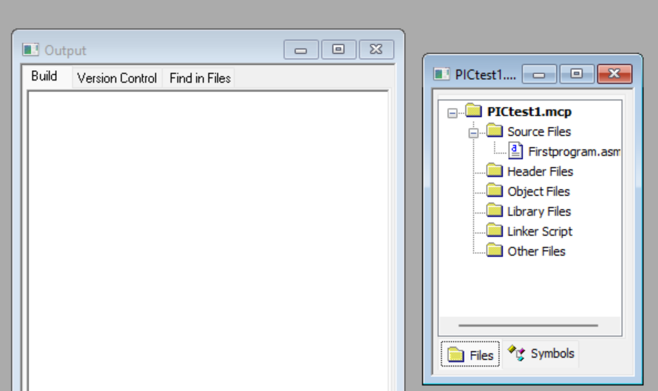
After you write the code, you have to make sure whether your code is correct or not by clicking on the make icon.
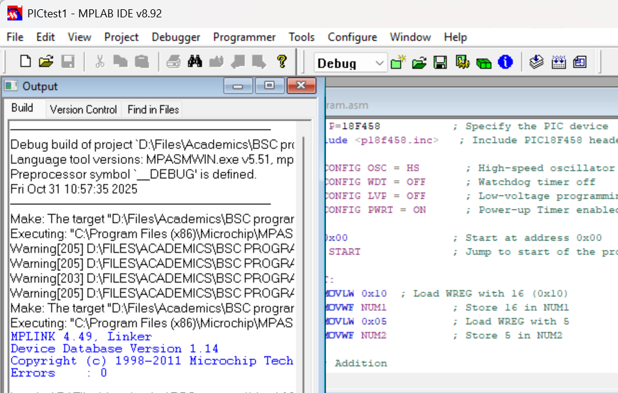
Watching the effect of instruction on simulator
After completing writing your assembly code, you have to follow the following procedure to see the effect of each assembly language instruction.
- Click on view click on watch. The you will get the following screen
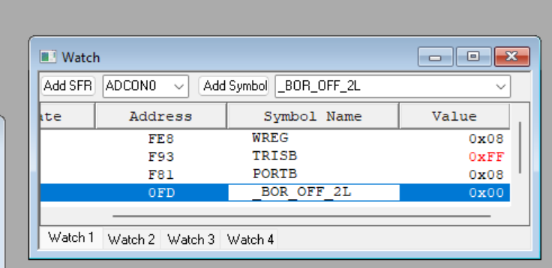
- Add any SFR. But it should be there in your assembly program, e.g, WREG, TRISB, PORTB…. etc.
- Add debugger. Click on debugger select tool the select MPLABSIM. When you select MPLABSIM, you will get the following menu

- The click again on debugger and click on run or press F9. Then you can see the effect of each instruction on watch window by controlling using the icons indicated in step 3.

Experiment 1: Introduction to PIC18F458458 Assembly Language Programming

Objective
- Learn the basic structure of an assembly program for PIC18F458.
- Understand the role of registers, special function registers (SFRs), and memory locations.
- Perform basic operations such as moving data between registers, performing simple arithmetic, and branching.

Required Tools
- MPLAB X IDE or MPLAB IDE v8
- Proteus Simulation Tool (or similar) for circuit simulation
- PIC18F458458 microcontroller

Procedure
- Basic Program Structure:
  - Open MPLAB IDE and create a new assembly project for PIC18F458.
  - Create a simple program that adds two numbers and stores the result in a memory

LIST P=18F458 ; Specify the PIC device
#include <p18f458.inc> ; Include PIC18F458 header file

CONFIG OSC = HS ; High-speed oscillator
CONFIG WDT = OFF ; Watchdog timer off
CONFIG LVP = OFF ; Low-voltage programming off
CONFIG PWRT = ON ; Power-up Timer enabled for stability

ORG 0x00 ; Start at address 0x00
GOTO START ; Jump to start of the program

START:
MOVLW 0x10 ; Load WREG with 16 (0x10)
MOVWF NUM1 ; Store 16 in NUM1
MOVLW 0x05 ; Load WREG with 5
MOVWF NUM2 ; Store 5 in NUM2

; Addition
MOVF NUM1, W ; Load NUM1 into WREG
ADDWF NUM2, W ; Add NUM2 to WREG, result in WREG
MOVWF RESULT ; Store the result in RESULT

NUM1 EQU 0x20 ; Define NUM1 at address 0x20
NUM2 EQU 0x21 ; Define NUM2 at address 0x21
RESULT EQU 0x22 ; Define RESULT at address 0x22

END ; End of program

2 ALU operation Using PIC18F458

Theory:
The Arithmetic and Logic Unit (ALU) of the PIC18F458 microcontroller performs basic arithmetic and logical operations. In assembly language, ALU operations are executed using specific instructions. These instructions manipulate data stored in the Working Register (WREG) and registers like FSR (File Select Register) or EECON (EEPROM Control Register).

Objective:
The objective of this experiment is to demonstrate and implement basic Arithmetic and Logical Unit (ALU) operations on the PIC18F458 microcontroller using assembly language. Students will learn how to program the PIC18F458 microcontroller to perform addition, subtraction, multiplication, division, AND, OR, XOR, and NOT operations using its built-in ALU.

Basic ALU Operations on PIC18F458:
- Addition (ADDWF, ADDFSR)
- Subtraction (SUBWF, SUBFSC)
- Multiplication (MUL, MULWF)
- Division (No direct instruction for division, but can be implemented using shifts and subtraction)
- AND (ANDWF)
- OR (IORWF)
- Exclusive OR (XOR) (XORWF)
- NOT (COMF)

Required Materials:
- PIC18F458 Microcontroller
- MPLAB IDE v8
- Proteus Simulation Software (Optional)
- Breadboard and PIC18F458 Development Board
- Jump wires and power supply

Experiment 2: Addition Operation Using ALU

2.1. Objective:
Perform a simple addition operation of two numbers stored in registers and store the result in another register.

Procedure:
- Initialize the WREG with the first operand (e.g., 5).
- Add a second operand (e.g., 3) to WREG.
- Store the result in PORTB for visual verification.

Assembly Code:
LIST P=18F458
#include <p18f458.inc>

ORG 0x00
GOTO START

START:
; Initialize PORTB as output
MOVLW 0x00 ; Set PORTB as output
MOVWF TRISB

; Load first operand (5) into WREG
MOVLW 0x05
MOVWF 0x20 ; Store in register 0x20

; Load second operand (3) into WREG
MOVLW 0x03
ADDWF 0x20, W ; Add 0x20 and WREG, store result in WREG

; Output result to PORTB
MOVWF PORTB ; Display result on PORTB

; End of program
GOTO $ ; Infinite loop

END

Explanation:
- ADDWF: Adds the contents of WREG with the contents of the register and stores the result in the WREG.
- The result is displayed on PORTB.
When we upload the .HEX FILE ON Proteus, we can get the following result.\
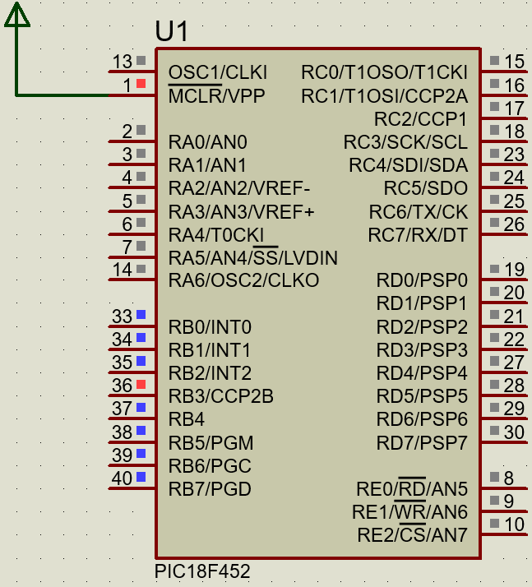

Experiment 2: Subtraction Operation Using ALU

Objective:
Perform a subtraction operation of two numbers stored in registers and store the result in another register.

Procedure:
- Initialize the WREG with the first operand (e.g., 8).
- Subtract the second operand (e.g., 4) from WREG.
- Store the result in PORTC.

Assembly Code:
LIST P=18F458
#include <p18f458.inc>

CONFIG OSC = HS ; High-speed oscillator
CONFIG WDT = OFF ; Watchdog timer off
CONFIG LVP = OFF ; Low-voltage programming off

ORG 0x00
GOTO START

START:
; Initialize PORTC as output
MOVLW 0x00 ; Set PORTC as output
MOVWF TRISC

; Load first operand (8) into WREG
MOVLW 0x08
MOVWF 0x20 ; Store in register 0x20

; Load second operand (4) into WREG
MOVLW 0x04
SUBWF 0x20, W ; Subtract 0x20 from WREG, store result in WREG

; Output result to PORTC
MOVWF PORTC ; Display result on PORTC

; End of program
GOTO $ ; Infinite loop

END

Explanation:
- SUBWF: Subtracts the contents of WREG from the contents of the register and stores the result in the WREG.
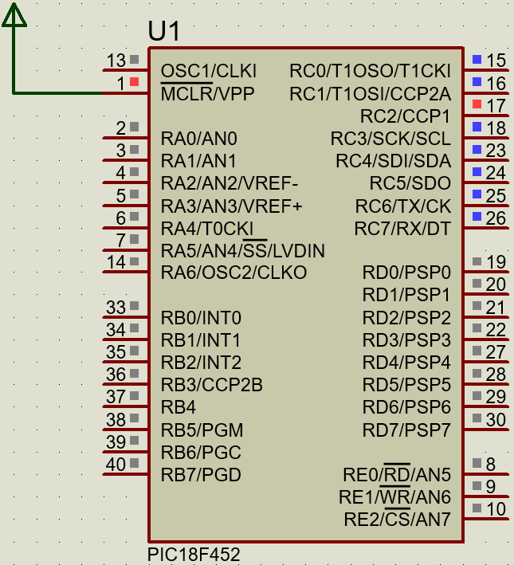

Experiment 3: AND Operation Using ALU

Objective:
Perform a bitwise AND operation on two operands.

Procedure:
- Load the first operand (e.g., 0x55) into WREG.
- Perform the AND operation with the second operand (e.g., 0x0F).
- Store the result in PORTB.

Assembly Code:
LIST P=18F458
#include <p18f458.inc>

ORG 0x00
GOTO START

START:
; Initialize PORTB as output
MOVLW 0x00 ; Set PORTB as output
MOVWF TRISB

; Load first operand (0x55) into WREG
MOVLW 0x55
MOVWF 0x20 ; Store in register 0x20

; Load second operand (0x0F) into WREG
MOVLW 0x0F
ANDWF 0x20, W ; Perform AND operation with 0x20 and WREG, store result in WREG

; Output result to PORTB
MOVWF PORTB ; Display result on PORTB

; End of program
GOTO $ ; Infinite loop

END

Explanation:
- ANDWF: Performs a bitwise AND operation between WREG and the contents of the register. The result is stored in WREG.
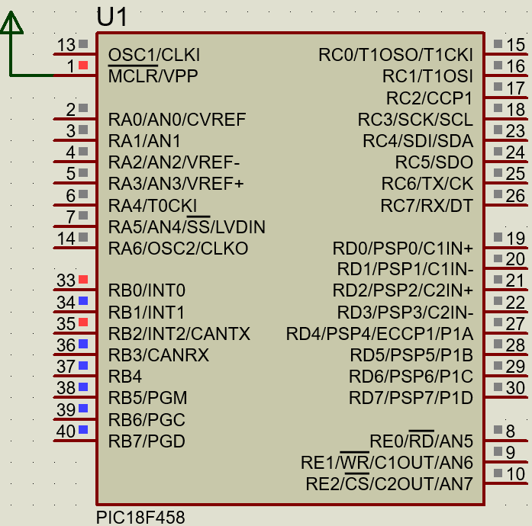

Experiment 4: OR Operation Using ALU

Objective:
Perform a bitwise OR operation on two operands.

Procedure:
- Load the first operand (e.g., 0x55) into WREG.
- Perform the OR operation with the second operand (e.g., 0x0F).
- Store the result in PORTB.

Assembly Code:
LIST P=18F458
#include <p18f458.inc>

ORG 0x00
GOTO START

START:
; Initialize PORTB as output
MOVLW 0x00 ; Set PORTB as output
MOVWF TRISB

; Load first operand (0x55) into WREG
MOVLW 0x55
MOVWF 0x20 ; Store in register 0x20

; Load second operand (0x0F) into WREG
MOVLW 0x0F
IORWF 0x20, W ; Perform OR operation with 0x20 and WREG, store result in WREG

; Output result to PORTB
MOVWF PORTB ; Display result on PORTB

; End of program
GOTO $ ; Infinite loop

END

Explanation:
- IORWF: Performs a bitwise OR operation between WREG and the contents of the register. The result is stored in WREG.
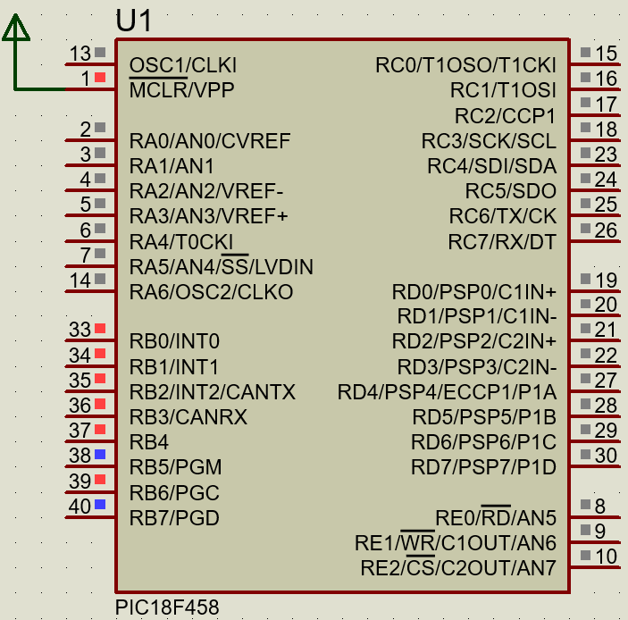

Exercise
- Write the assembly language program that can add 0x08 and 0x9 and store the result on PORT C and PORT D.
- Connect an LED on PORT B of PIC18F458458 microcontroller on Proteus and perform the following task?
- Write assembly language that first store 0xaa on WREG and copy it to PORTB.
- Export the .HEX file and load on PIC18F458458 that constructed ON Proteus.
- Observe the result. What change you observe and why that happen? Explain in detail.
- Write the assembly language program that can make XOR operation of 0x08 and 0x9

Experiment 5: Blinking an LED on PORTB

Objective
- Learn how to control output pins of the PIC18F458 to turn an LED on and off.
- Use the PORTB and TRISB registers to configure and control I/O pins.

Required Tools
- MPLAB X IDE or MPLAB IDE v8
- Proteus Simulation Tool
- LED and Resistor
- PIC18F458 microcontroller

Procedure
- Setup for Blinking LED:
  - Configure PORTB pins as output.
  - Turn PORTB,0 high to turn on the LED and low to turn it off.
LIST P=18F458
#include <p18f458.inc>

ORG 0x00 ; Start at program memory address 0x00
GOTO START ; Jump to START label
COUNT EQU 0x20

START:
MOVLW 0x00 ; Set WREG to 0 (turn off LED)
MOVWF TRISD ; Set PORTB as output (TRISB=0)

MAIN_LOOP:
BSF PORTD, 0 ; Set PORTB, 0 to 1 (turn on LED)
CALL DELAY ; Call delay subroutine
BCF PORTD, 0 ; Set PORTB, 0 to 0 (turn off LED)
CALL DELAY ; Call delay subroutine
GOTO MAIN_LOOP ; Repeat forever

DELAY:
MOVLW 0xFF ; Load delay counter
MOVWF COUNT ; Store in COUNT
DELAY_LOOP:
NOP ; No operation (does nothing)
DECFSZ COUNT, F ; Decrement COUNT, skip if zero
GOTO DELAY_LOOP ; Repeat until COUNT is zero
RETURN ; Return from DELAY subroutine

END
Compiling and Simulation:
- Compile and build the program in MPLAB.
- Simulate in Proteus to verify that the LED blinks on PORTD,0.
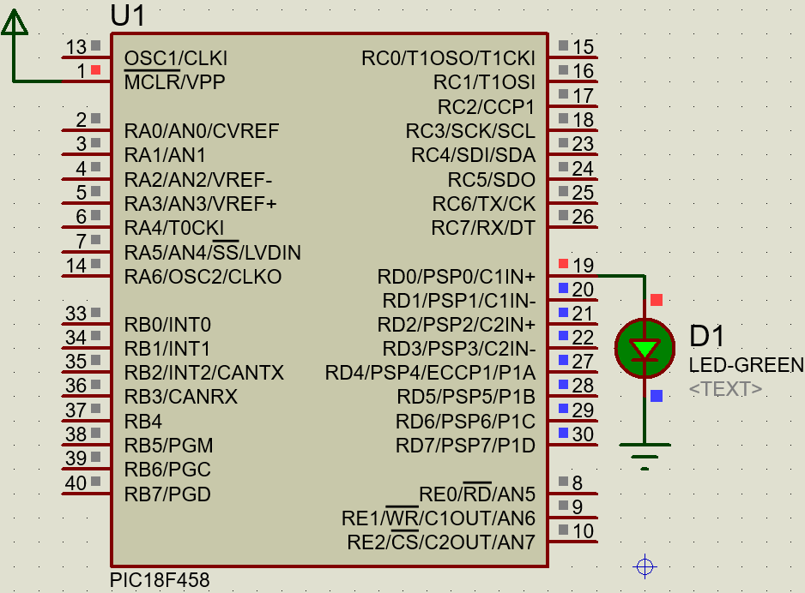

Experiment 6: Reading a Button Input

Objective
- Learn how to read input from a push-button switch connected to PORTB.
- Understand how to configure PORTB as an input and use PORTB,0 for a button press.

Required Tools
- MPLAB X IDE or MPLAB IDE v8
- Proteus Simulation Tool
- Push button and resistor
- PIC18F458 microcontroller

Procedure
- Reading Button Input:
  - Configure PORTB as an input.
  - Use PORTB,0 to read the button state and turn on the LED on PORTB,1 when the button is pressed.
Example Code:
LIST P=18F458
#include <p18f458.inc>

ORG 0x00 ; Start at address 0x00
GOTO START ; Jump to START label

START:
BSF TRISB,0 ; Set PORTB as input
BCF TRISB,1

MAIN_LOOP:
BTFSS PORTB, 0 ; Check if button on PORTB,0 is pressed
GOTO BUTTON_NOT_PRESSED
BSF PORTB, 1 ; Set PORTB,1 to turn on LED if button is pressed
GOTO MAIN_LOOP

BUTTON_NOT_PRESSED:
BCF PORTB, 1 ; Clear PORTB,1 to turn off LED if button is not pressed
GOTO MAIN_LOOP

END

Compiling and Simulation:
- Compile and load the program in MPLAB.
- Simulate the circuit in Proteus. Press the button connected to PORTB,0 to see the LED on PORTB,1 turn on.

Result
When the button is pressed, the LED on PORTB,1 will light up.
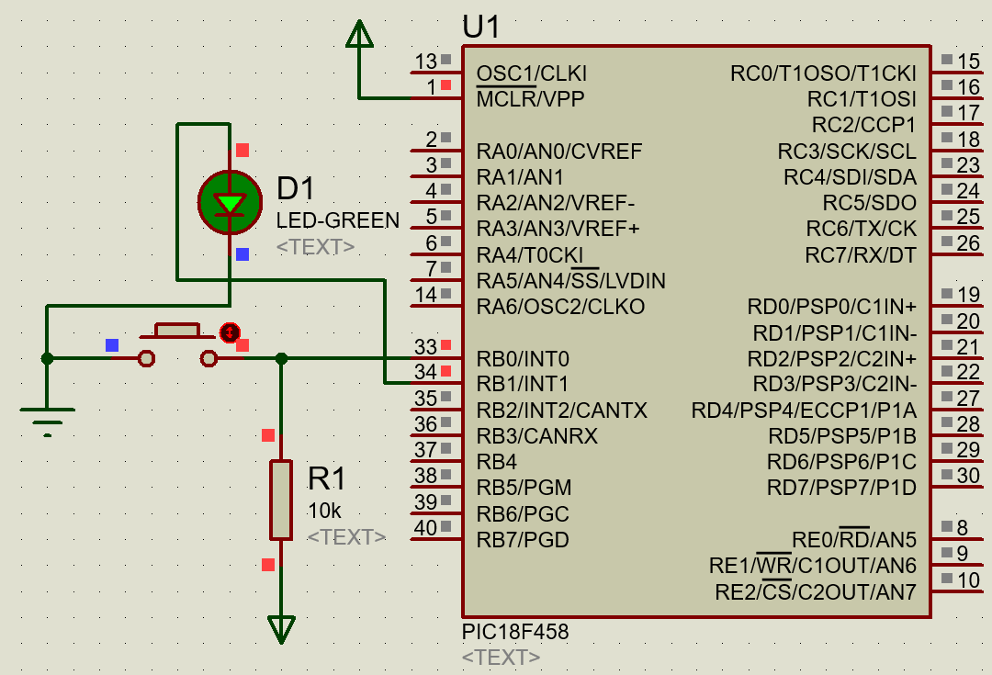

Experiment 7: Interfacing a Buzzer

Objective
- Learn how to control a Buzzer using the PIC18F458.
- Turn the buzzer on and off based on the input condition.

Required Tools
- MPLAB X IDE or MPLAB IDE v8
- Proteus Simulation Tool
- Buzzer
- PIC18F458 microcontroller

Procedure
- Control the Buzzer:
  - Use a PORTC pin to control the buzzer (turn on and off).
- Example Code to Turn the Buzzer On and Off:
LIST P=18F458
#include <p18f458.inc>

ORG 0x00 ; Start at address 0x00
GOTO START ; Jump to START label

START:
MOVLW 0x00 ; Configure PORTC as output
MOVWF TRISC
BSF TRISB,0
CLRF PORTC
BT_STATUS
BTFSS PORTB,0
GOTO BT_STATUS
GOTO MAIN_LOOP

MAIN_LOOP:
BSF PORTC, 0 ; Set PORTC,0 to high (turn on buzzer)
CALL DELAY
BCF PORTC, 0 ; Clear PORTC,0 to low (turn off buzzer)
CALL DELAY
GOTO BT_STATUS ; Repeat indefinitely

DELAY:
NOP ; No Operation for delay
NOP
RETURN ; Return from delay subroutine

END
- Simulation:
  - Simulate the buzzer turning on and off in Proteus.

Result
The buzzer should turn on and off with a delay.
