Chapter 1
- Look the following embedded system diagram the describe each components
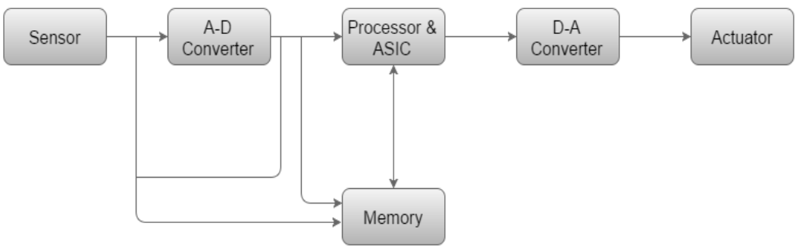
- Write some application examples of embedded system in the following area;
- your home and office
- industry
- space science
- robotics
Chapter two
- Suppose you are going to design an embedded system which can do the following
Detect the motion of incoming person inside the room
While detecting the motion room light will automatically glow if the room is dark
- List down the components to design this system
- Identify which is input, process and output component
- Write the function of each component for the system
- Design the architecture of the system
- Describe what embedded system will implemented using the following architecture
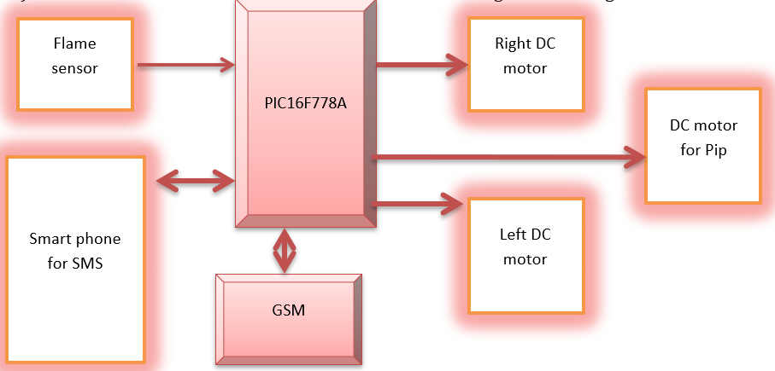
- Let you take Addis Ababa Bus Station and you want to do an embedded system to do the following task
- Read tag number of the incoming buses to the station and notify the passengers by using display attached on the station when the buses are inside the station
- If the bus outgoing from the station notifies the passengers as the bus is out
- And finally, passengers can see this entrance and excitation of bus to the station and from station respectively.
- What are the input components?
- What are the output components?
- And what is the function of each component
Chapter three
- Write an instruction to move value 34H in to WREG
- Why Microcontroller use MAX232 to perform Serial communication
- What is the function of SFR & what are Common SFR in PIC
- Up on power up what will be I/O port configured
- Write a test program for PIC18 chip to toggle all PORT B, PORTC and PORTD in each ¼ second of time delay
- Show a way to toggle RB7 continuously using PIC instruction
- What the following instruction will do
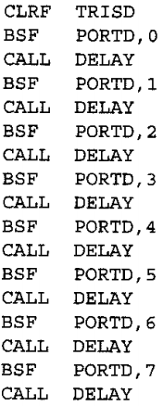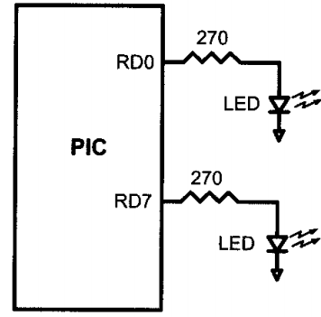
- Write a program to get 8 bit data from PORT C and then sent it to PORT B and PORT C
- Write a program to monitor bit RC3, when it is HIEHG send 55H to PORT D

