Debre Tabor University

Gafat Institute of Technology
Department of Electrical and Computer Engineering
Computer & network security worksheet 2

- What are the necessary things to encrypt and decrypt a given message or data?
- What you understand from the green padlock at the left side of the address bar of the browser?
- How digital signature solve the problem of Asymmetric key?
- How public key encryption solve the problem of symmetric key encryption?
- Let you say Abebe and Alemitu want to exchange encrypted data using Asymmetric key. Alemitu want to receive the data from Abebe. Who creates the pair of keys first?
- How authentication security service is achieved using digital signature?
- What is the advantage of using public key encryption?
- Why we need digital signature?
- What security objective is represented by the following figure.?
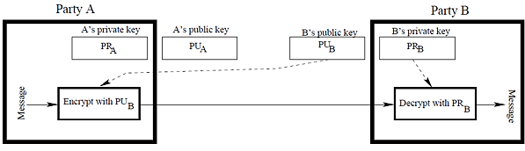
- What security objective are represented by the following figure?
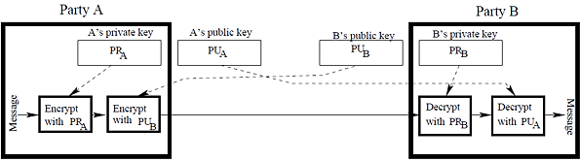
- Describe in detail about operation of digital Certificate?
- Describe in detail about operation of hash algorithm?
- Encrypt the message “Security” using substitution method. Take the secret key 5.
- Describe in detail about operation of DHKE algorithm?
- Describe in detail about operation of RSA algorithm?
- Encrypt the message “This is an awesome examination”. Use 6 columns by 5 rows table to write the original plain text and the secret key of 625413

Cipher text__________________________________________________________________
- If you have 32-bit secret key to encrypt the message, how many alternative keys will created?
- Let the value of P and Q are 11 and 5 respectively, find the value of the following unknown variables?
- n .........................
- ῲ .........................
- e .........................
- d .........................
- explain why self-signed certificate has the same functionality as commercial SSL?
- Write reasons for certificate revocation?

